
Charles Darwin University
PRT 681 | SOFTWARE PROJECT | ASSESSMENT 4 | SYDNEY GROUP 4

OraEarn handover report
Group name | Sydney Group 4
Group number | 4
Repository | PRT_681_SYDNEY_GROUP-4
Date | 16 October 2026
Name | Student ID | Role
Dharma Bahadur Budhathoki | S395172 | Scrum Master and lead developer
Jenish Gurung | S395321 | Business analyst and report writer
Krishna Sapkota | S395795 | Database administrator and tester
Suraj Khadka | S394949 | Data analyst and database administrator
This report is how we hand OraEarn over. I am Dharma Bahadur Budhathoki, S395172, and I was the Scrum Master and the lead developer for Sydney Group 4. Krishna Sapkota (S395795) looked after the database and the testing. Jenish Gurung (S395321) looked after the requirements and wrote a lot of the report. Under each heading you can see who wrote that part.

Unit and assessment | PRT 681 Software Project, Assessment 4 (40% of the unit). Submitted on Learnline in Week 12 (Sunday).
Group | Sydney Group 4
Product | OraEarn - earnings and shift tracking, expense management, savings goals, visa-hour compliance, and the Aura advisor
Repository | github.com/itsmekrishnaaaaaa/PRT_681_SYDNEY_GROUP-4 - branch main, application in oraEarn-WebApp/
Jira | https://students-team-dh8zehye.atlassian.net/jira/core/projects/EARN/board?filter=&groupBy=none
Team and roles | Dharma Bahadur Budhathoki (S395172) - Scrum Master and lead developer  Krishna Sapkota (S395795) - database administrator and tester  Jenish Gurung (S395321) - business analyst and requirements analyst
Date | 13 October 2026

Contents
Contents 3
Where each item of the assessment brief is answered 6
Quick start in eight steps 7
Who wrote what 9
Figures 10
1. URLs 14
1.1 Member folders, timesheets, and evidence 15
1.2 Local addresses after setup 17
2. Set up instructions 22
The following steps will be described for a new developer on the Windows platform and in the PowerShell environment. The three member document folders are in the root of the repository, and each of the listed commands is executed from within oraEarn-WebApp unless otherwise specified. The sections stack, architecture, auth, Git, first-run, and exception were written by Dharma. Krishna wrote the database, Entity Framework, connection-string, testing, and data-model sections. The dependency injection section was taken from Week 5 UML by Jenish. 22
2.1 Tools and versions 22
Install the tools from the links in oraEarn-WebApp/README.md and use a current version. PostgreSQL needs to be installed before the API will start cleanly. The first time you run scripts/setup.ps1 it checks that dotnet, node and npm are on the PATH, and it tries to start the PostgreSQL Windows service for you. 23
2.2 Libraries and versions 23
2.3 Architecture 25
A period filter and export on the dashboard analytics, a jobs filter with hourly rates, a shifts filter with a calendar, a live clock-in session with breaks, and a visa-hours card, an Expenses filter with user-defined expenses and payment methods, a Saving goal filter with allocation, progress; visa document upload while registering; an admin section for registration approvals and platform analytics, notifications based on the user’s data, and the Aura chat widget. The permanent visa hours rule was inspired by the 48-hour rule for student visas (TEQSA, 2023), and the live shift was made possible by SignalR (Microsoft, n.d.-d). 28
2.4 Authentication and authorisation 29
2.5 Git download process 33
2.6 Instructions and commands to set up the database 35
2.7 Entity Framework commands to set up 35
2.8 Connection strings setup 36
2.9 How to run the applications for the first time 38
2.10 Dependency injection 41
2.11 Exception handling 42
2.12 Unit testing 43
2.13 Class diagram and data model 45
3. Adding new features - guide 50
3.1 Create the task 50
3.2 Write the backend code 50
3.3 Add the new service using dependency injection 50
3.4 Add new libraries 51
3.5 Add the screen, the styles, and client-side validation 51
3.6 Unit testing 52
3.7 Comment and commit the work 52
4. Individual project contributions and Git evidence 55
4.1 Commit totals by author 55
4.2 Application code commits 56
4.3 Contribution by member 57
4.4 Commit message quality 59
4.5 Coding standards observed in the code base 60
4.6 Code comments 61
5. Software quality and structure 63
5.1 Structure and modular design 63
5.2 Non-functional requirements 64
5.3 Known limitations for the next team 64
Commits per member per week 64
6. Time management and weekly activity 66
Jira board evidence 72
7. Handover notes and known gaps 74
8. Test report - test cases and results 76
8.1 Test approach and environment 77
8.2 Automated test results 78
8.3 New automated test cases 81
8.4 System test cases (executed on the running application) 83
8.5 Defect log and observations 87
8.6 Requirements coverage and traceability 89
8.7 How to repeat this testing 90
8.8 Where the new tests and fixes are 90
9. Application walkthrough - screenshots with comments 92
References 102
Appendix A. Full commit history 103
Appendix B. Application screens 106
Appendix C. Code proof 127
Appendix D. More proof 134

Where each item of the assessment brief is answered
Written by: Jenish Gurung (S395321) - Business analyst (requirements traceability)

Brief item | Where | Note
URLs (git, project board, learning material, timesheets) | 1, 1.1, 1.2 | Jira is used instead of Trello
Tools and versions; libraries and versions | 2.1, 2.2
Architecture; authentication and authorisation | 2.3, 2.4 | Figures 1 to 4
Git download process | 2.5
Database setup; Entity Framework; connection strings | 2.6, 2.7, 2.8
First run; dependency injection; exception handling | 2.9, 2.10, 2.11 | Figures 7 to 9
Unit testing; class diagram and data model | 2.12, 2.13, 8 | Figures 5, 6, 10 to 12
Adding a feature: task, code, DI service, libraries, JavaScript library, styles, client validation, tests, commit | 3.1 to 3.7 | Worked example: mileage log
Individual contribution, Git commenting, coding standards | 4.1 to 4.6, Appendix A
Software quality and structure | 5, 8
Weekly activity and time management | 6
Screenshots with comments | 2.9, 8.2, 9 | Figures 7 to 21

Quick start in eight steps
Written by: Dharma Bahadur Budhathoki (S395172) - Scrum Master and lead developer

Step | Command or action | Expected result
1 | git clone https://github.com/itsmekrishnaaaaaa/PRT_681_SYDNEY_GROUP-4.git | Repository on disk; work in oraEarn-WebApp
2 | .\scripts\setup.ps1 | Tools checked, config files created, packages restored
3 | cd backend; .\run.ps1 | API on 5203; database created and seeded
4 | cd frontend; .\run.ps1 | React app on 5173
5 | Open http://localhost:5173 | Login page
6 | alice@oraearn.local / User123! or admin@oraearn.local / Admin123! | Dashboard, or the admin area
7 | dotnet test backend\OraEarn.Api.Tests\OraEarn.Api.Tests.csproj | Green baseline (25 on main, 49 with the patch)
8 | Read the Jobs folder, then features/jobs | The pattern every feature copies

Who wrote what
Section | Title | Written by | Role
1 | URLs and project links | Jenish Gurung (S395321) | Business analyst
2.1 - 2.5, 2.9, 2.11 | Tools, libraries, architecture, auth, Git, first run, exceptions | Dharma Bahadur Budhathoki (S395172) | Lead developer
2.6 - 2.8, 2.12, 2.13 | Database, EF Core, connection strings, unit testing, data model | Krishna Sapkota (S395795) | DBA and tester
2.10 | Dependency injection | Jenish Gurung (S395321) | Requirements / DI UML
3.1, 3.3 | Create the task, register a service | Jenish Gurung (S395321) | Business analyst
3.2, 3.4, 3.5, 3.7 | Write code, libraries, UI, commit | Dharma Bahadur Budhathoki (S395172) | Lead developer
3.6 | Unit testing a new feature | Krishna Sapkota (S395795) | Tester
4 | Individual contributions | Each member, own subsection | All three
5 | Software quality and structure | Dharma Bahadur Budhathoki (S395172) | Architect
6 | Time management | Each member, plus Jenish on coordination | All three
7 | Handover notes | All three, by role | All three
8 | Test report: approach, automated and system test cases, defects | Krishna Sapkota (S395795) | Tester
8.6 | Requirements coverage and traceability | Jenish Gurung (S395321) | Requirements analyst
8.5 fixes | Defect fixes reviewed for architecture fit | Dharma Bahadur Budhathoki (S395172) | Lead developer
9 | Application walkthrough - screenshots with comments | Krishna Sapkota (S395795), comments by role | All three
Front | Status note; brief-to-section map; quick start | Krishna / Jenish / Dharma, each marked | All three

Figures
Figure 1. System architecture. Both actors reach the product through the web frontend, which calls the API over HTTPS with a JWT. Inside ... 26
Figure 2. Use case diagram. The student worker owns the day-to-day use cases; the administrator only logs in and approves new users; the ... 27
Figure 3. System flow. Registration creates a pending account; the administrator approves or rejects it; only an approved user receives a... 30
Figure 4. Sequence diagram for register, approve, and log in. The alternative block at the bottom shows the two login outcomes: an approv... 31
Figure 5. Data model as built. Every user-owned row hangs off ApplicationUser (ASP.NET Identity); shifts belong to a job; expenses belong... 46
Figure 6. Initial conceptual ERD (Week 4), before normalisation and before the model was reconciled with ASP.NET Identity. Kept here deli... 49
Figure 7. http://localhost:5173 on first run. The login page is the only public route; the hint under the button shows the seeded demo ac... 39
Figure 8. Signed in as alice@oraearn.local. The dashboard is populated by the demo seeder: net balance, earnings, expenses, savings targe... 40
Figure 9. http://localhost:5203/swagger after defect DEF-03 was fixed: 55 operations, with the Authorize button for a JWT. Before the fix... 41
Figure 10. dotnet test on 13 October 2026 after the fixes. Orange names are black-box API tests and white names are white-box unit tests;... 79
Figure 11. The run that found DEF-02. Both tests expect HTTP 400 for invalid input; the API returned 200 OK for an empty category title a... 81
Figure 12. DEF-03 as found: 'Failed to load API definition - Internal Server Error /swagger/v1/swagger.json'. The API log named the cause... 89
Figure 13. Pending user refused (TC-AUTH-02). Comment (Jenish): this is NFR-7.3 - admin approval is required before a new user can access... 93
Figure 14. Shift calendar for a student-visa user. Comment (Dharma): the visa panel, the live clock-in bar, and the monthly summary all r... 94
Figure 15. 48-hour rule enforced on save (TC-VISA-01). Comment (Krishna): the server rejects the shift, not just the form - the API retur... 95
Figure 16. Expenses with category filters (TC-EXP-03). Comment (Krishna, DBA): the payment method column comes from the shared PaymentMet... 96
Figure 17. Client-side validation (TC-EXP-01). Comment (Krishna): the form already blocked -50, which is why DEF-02 was invisible in norm... 97
Figure 18. Admin dashboard (TC-ADM-03). Comment (Jenish): this covers FR-7.6 and NFR-8.1 - platform-wide analytics and role assignment, v... 98
Figure 19. AI registration review with Aura offline (TC-ADM-01). Comment (Dharma): RegistrationApprovalAdvisorService fell back to its lo... 99
Figure 20. Savings goals (TC-GOAL-01). Comment (Jenish): FR-6.4 and FR-6.5 - progress, remaining amount, and the hours of work needed to ... 100
Figure 21. Registration form (TC-REG-03). Comment (Jenish): the form captures every field NFR-7.2 lists - visa type, residency status, wo... 101
Figure 22. Jira project EARN, list view (top of the board). All 136 issues are Stories with priority Medium and status Done; the Created ... 19
Figure 23. Jira project EARN, later rows. Work is spread across the three members: Dharma on the Aura and admin application stories, Kris... 20
Figure 24. Jira project EARN, week 4 to 6 stories. Krishna owns the ERD, class diagram, DFD and shift and job test stories (EARN-105, 106... 70
Figure 25. Issue detail for EARN-144 (Week 7 timesheets and meeting log). Labels show group4, scrum-master-dharma, se-timesheet and week-... 71
Figure 26. Jobs, the feature slice used as the pattern. Comment: the hourly rate on the job is what a shift is paid. 53
Figure 27. Timesheet for Dharma Bahadur Budhathoki (S395172), weeks 4 to 12. Comment: week 4 is 5.5 hours and each later week is 6 hours. 72
Figure 28. EARN board on 16 October 2026. Comment: Idea, To Do, and In Progress are empty. DB on a card is Dharma Bahadur Budhathoki (S39... 19
Figure 29. GitHub repository PRT_681_SYDNEY_GROUP-4 on main. Comment: the browser only calls the API. It does not talk to Python or Postg... 21
Figure 30. The repository after clone. Comment: development happens in oraEarn-WebApp, which holds frontend, backend, and ai-advisor. 34
Figure 31. Jobs on a phone. 54
Figure 32. ApplicationDbContext, the tables as built. 47
Figure 33. Login. 107
Figure 34. Show password on the login form. 109
Figure 35. Registration. 110
Figure 36. Visa fields on the registration form: visa type, work rights, expiry, and the document upload. 111
Figure 37. Dashboard for alice@oraearn. 112
Figure 38. The same dashboard on a phone. 113
Figure 39. Jobs on a wide screen. 114
Figure 40. Jobs on a phone. 115
Figure 41. Add a job. 116
Figure 42. Shift calendar. 117
Figure 43. Shifts on a phone. 118
Figure 44. Logging a shift. 119
Figure 45. Expenses. 120
Figure 46. Add an expense. 121
Figure 47. Expense list after the rows are saved. 123
Figure 48. Savings goals. 124
Figure 49. Add a savings goal. 125
Figure 50. My timesheet, Dharma Bahadur Budhathoki (S395172). 126
Figure 51. Packages used. 128
Figure 52. Program.cs, the API startup. 129
Figure 53. AuthController, register and login. 130
Figure 54. ShiftsController, clock-in and the calendar. 131
Figure 55. VisaComplianceService, the 48-hour rule. 132
Figure 56. LoginPage.tsx, the show-password control. 133
Figure 57. Live API calls. 135
Figure 58. Health check in Swagger. 136
Figure 59. Admin routes in Swagger. 137
Figure 60. Aura, the Python advisor. 138
Figure 61. Aura health check. 139
Figure 62. Demo data for Alice. 140
Figure 63. ShiftService.CreateAsync. 141
Figure 64. The 48-hour reject in code. 142
Figure 65. Sequence for saving a shift. 143
Figure 66. Class sketch of the main tables. 144

Figure | Title | Source
1 | System architecture - clients, API modules, data stores | Krishna Sapkota (S395795)
2 | Use case diagram - actors and system scope | Krishna Sapkota (S395795)
3 | System flow - registration, approval, and day-to-day use | Krishna Sapkota (S395795)
4 | Sequence diagram - register, approve, and log in | Krishna Sapkota (S395795)
5 | Data model as built (third normal form) | Group, from docs/OraEarn-ERD.png
6 | Initial conceptual ERD (Week 4) | Krishna Sapkota (S395795)
7 - 9 | First run: login page, dashboard, Swagger | Captured by Krishna Sapkota, 13 Oct 2026
10 - 12 | Test evidence: 49/49 passing run, failing run before fixes, Swagger defect | Captured by Krishna Sapkota, 13 Oct 2026
13 - 21 | Application walkthrough screenshots | Captured by Krishna Sapkota, 13 Oct 2026
22 - 25 | Jira project EARN: board list and issue detail | Captured 15 Oct 2026

1. URLs
Written by: Jenish Gurung (S395321) - Business analyst
I have the board, the team channel and the links to the learning materials in a single spot, so a new developer doesn't have to ask around to find the work. Individuals provided their own folder and timesheet link. There is no public production URL - it's a local application. Jira usage is adhering to Atlassian (n.d.).

What | URL | What a new developer uses it for
Git repository (main) | github.com/itsmekrishnaaaaaa/PRT_681_SYDNEY_GROUP-4 | Source code, setup scripts, migrations, and the member folders. Clone this. The application lives in oraEarn-WebApp.
Jira project EARN (task tracking) | Open EARN issues, newest first | The current work queue. Site students-team-dh8zehye.atlassian.net, project key EARN. Jira is used in place of Trello on this project.
Microsoft Teams | SYD-Group4 channel | Group coordination, meeting notes, and file sharing. Sign in with the university account.
Learning materials | Learnline unit site (PRT 681), plus learn.microsoft.com/aspnet/core, learn.microsoft.com/ef/core, react.dev, postgresql.org/docs | Weekly unit content, and the reference documentation for the stack this project actually uses.
Learnline submission | Unit Learnline site, Assessment 4, Submit Here | Official submission of the software and this handover document.

1.1 Member folders, timesheets, and evidence
Each member keeps their timesheets and weekly evidence in their own folder at the repository root. These folders are the primary evidence for individual contribution and time management.

Member | Folder on GitHub | Timesheet and evidence files
Krishna Sapkota (S395795) | Krishna_sapkota_S395795 | Individual timesheet (weeks 4 onward), OraEarn User Manual, ERD, sequence diagram, use case diagram, system flow and architecture diagrams, DBA and tester role research, Week 4 DBA progress report.
Jenish Gurung (S395321) | Jenish_Gurung_s395321 | IndividualTimesheet_JenishGurung_s395321.xlsx plus Week 7 and Week 8 timesheets, BRD, SRS draft, UML set (dependency injection, security, mapping, end to end), BA backlog, IT role research, traceability matrix.
Dharma Bahadur Budhathoki (S395172) | (s395172) Dharma_Bahadur_Budhathoki | Individual timesheets (weeks 4 to 8), project proposal, project canvas, problem and solution boards, normalisation ERD, modular monolith research, backend setup screenshots, Week 7 meeting log.

1.2 Local addresses after setup
Service | Address | Notes
React frontend (Vite dev server) | http://localhost:5173 | The only address a user opens
ASP.NET Core API | http://localhost:5203 | Start this first; it creates the database
Swagger UI | http://localhost:5203/swagger | Development environment only
Health check | http://localhost:5203/health | Returns {"status":"ok"}
SignalR shift hub | http://localhost:5203/hubs/shifts | Live shift updates
Aura advisor | http://localhost:8000 | Optional Python service
PostgreSQL | localhost:5432 | Database oraearn, created automatically

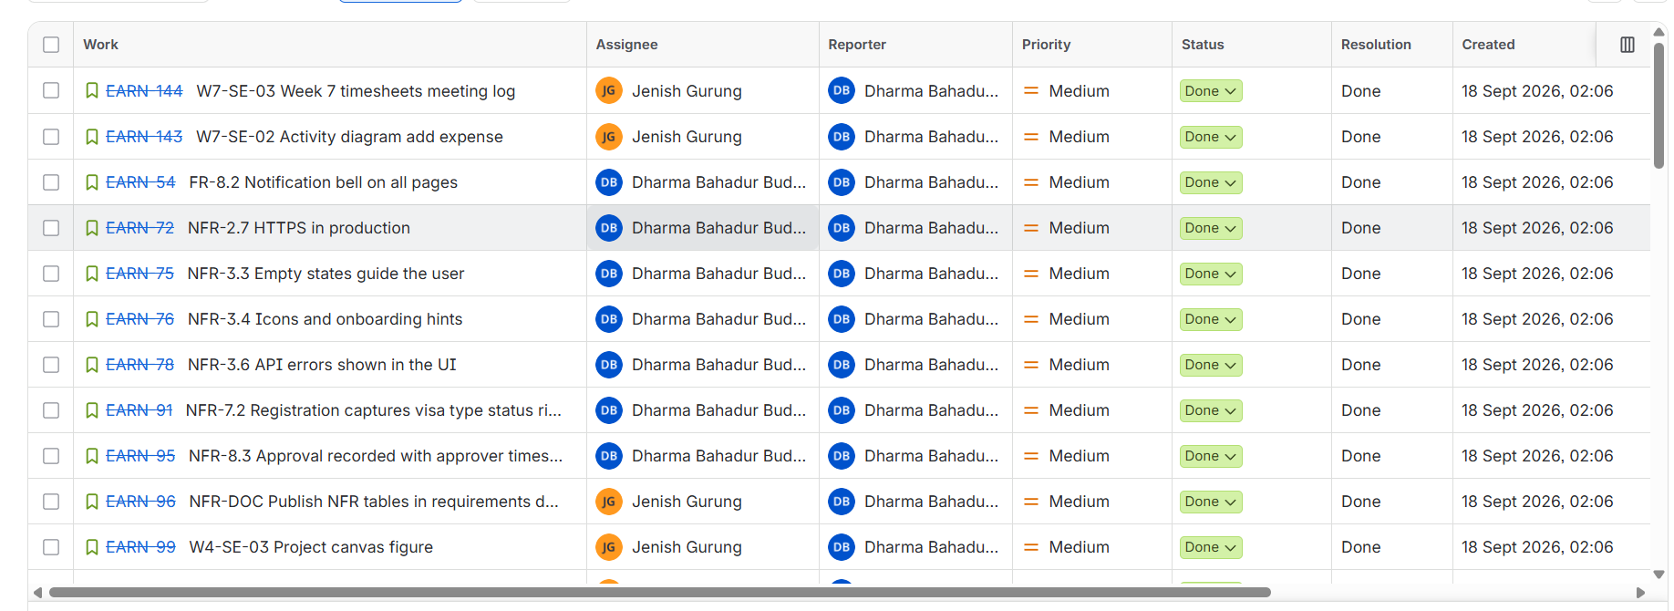
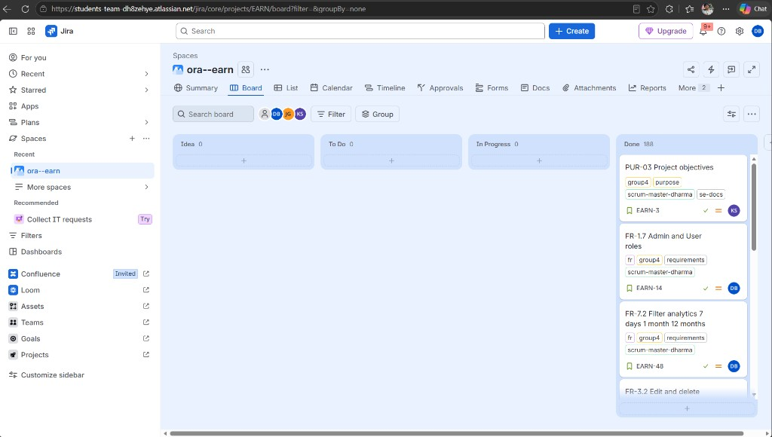
Figure 28. EARN board on 16 October 2026. Comment: Idea, To Do, and In Progress are empty. DB on a card is Dharma Bahadur Budhathoki (S395172).
Figure 22. Jira project EARN, list view (top of the board). All 136 issues are Stories with priority Medium and status Done; the Created column shows 18 Sep 2026, 02:06 for every row, so the backlog was loaded in one batch (see Jira board evidence in section 6). Comment: keys carry the requirement or week code, for example FR-8.2 and W7-SE-03, so each story traces to a requirement or a weekly deliverable.
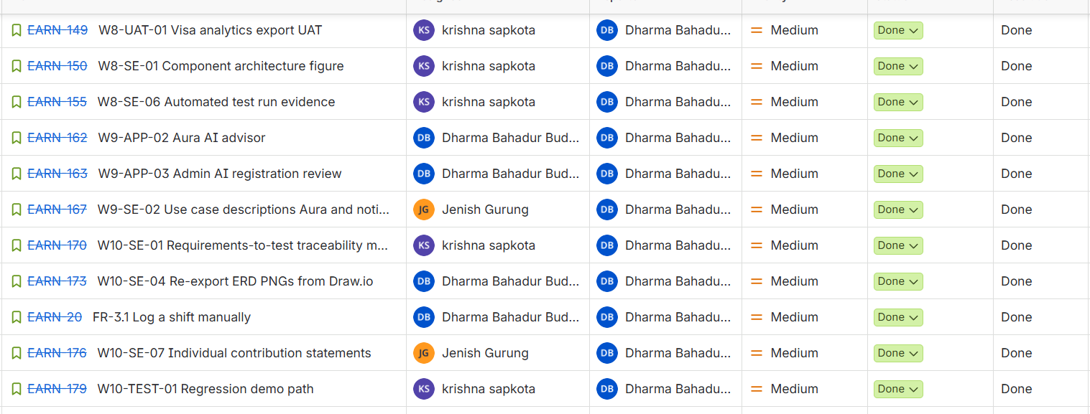
Figure 23. Jira project EARN, later rows. Work is spread across the three members: Dharma on the Aura and admin application stories, Krishna on the traceability matrix and ERD exports, Jenish on use case descriptions and the individual contribution statements. Comment: the assignee column is the quickest way to see who owns what.

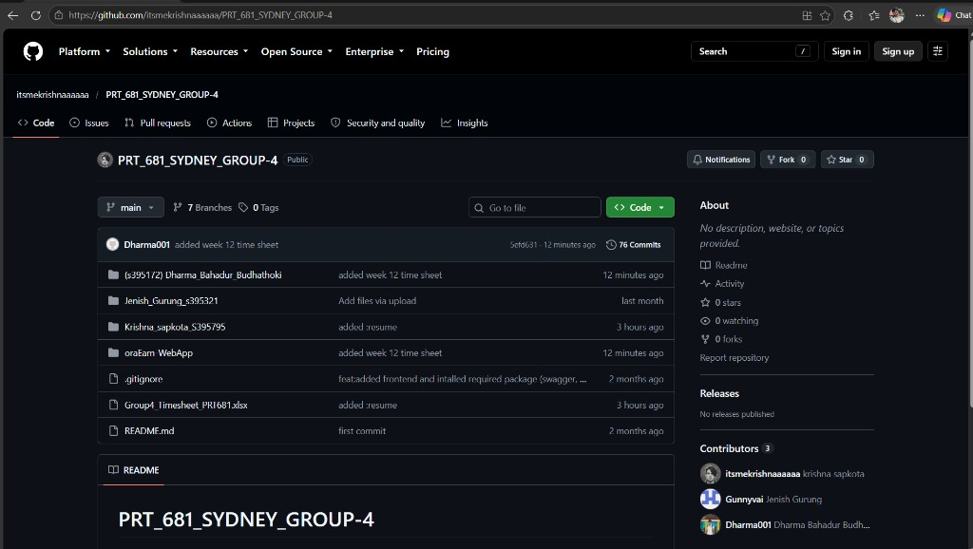
Figure 29. GitHub repository PRT_681_SYDNEY_GROUP-4 on main. Comment: the browser only calls the API. It does not talk to Python or PostgreSQL.

2. Set up instructions

The following steps will be described for a new developer on the Windows platform and in the PowerShell environment. The three member document folders are in the root of the repository, and each of the listed commands is executed from within oraEarn-WebApp unless otherwise specified. The sections stack, architecture, auth, Git, first-run, and exception were written by Dharma. Krishna wrote the database, Entity Framework, connection-string, testing, and data-model sections. The dependency injection section was taken from Week 5 UML by Jenish.

2.1 Tools and versions
Written by: Dharma Bahadur Budhathoki (S395172) - Scrum Master and lead developer

Tool | Version used by this project | How to check
.NET SDK | 10 - both projects target net10.0 | dotnet --version
Node.js | 20 or newer | node --version
npm | Bundled with Node.js | npm --version
PostgreSQL | 16 or newer, listening on port 5432 | Services panel, a service named postgresql*
Python | 3.11 or newer - needed only for the Aura advisor | python --version
Git | Any current Git for Windows | git --version
EF Core CLI | 10.0.x, matching the packages. Install only when adding migrations | dotnet ef --version
IDE | Visual Studio 2022, Cursor, or VS Code with C# and React tooling | -

Install the tools from the links in oraEarn-WebApp/README.md and use a current version. PostgreSQL needs to be installed before the API will start cleanly. The first time you run scripts/setup.ps1 it checks that dotnet, node and npm are on the PATH, and it tries to start the PostgreSQL Windows service for you.

2.2 Libraries and versions
Written by: Dharma Bahadur Budhathoki (S395172) - Scrum Master and lead developer

Backend - backend/OraEarn.Api/OraEarn.Api.csproj
Package | Version | Role
Microsoft.AspNetCore.Authentication.JwtBearer | 10.0.11 | Validates access tokens on every request
Microsoft.AspNetCore.Identity.EntityFrameworkCore | 10.0.11 | Users, roles, and password hashing
Npgsql.EntityFrameworkCore.PostgreSQL | 10.0.3 | PostgreSQL provider for EF Core
Microsoft.EntityFrameworkCore.Design | 10.0.11 | Design-time tooling for migrations
Microsoft.EntityFrameworkCore.InMemory | 10.0.11 | Database used by the test suite
Swashbuckle.AspNetCore | 8.1.4 | Swagger UI, Development only

Test project - backend/OraEarn.Api.Tests
xunit 2.9.3, xunit.runner.visualstudio 3.1.4, Microsoft.NET.Test.Sdk 17.14.1, Microsoft.AspNetCore.Mvc.Testing 10.0.11, and Microsoft.EntityFrameworkCore.InMemory 10.0.11.

Frontend - frontend/package.json
They are declared as caret ranges; If you change any dependency, commit package-lock.json with the specific change. The references include: React (Meta Platforms, n.d.), Vite (Vite, n.d.) and Tailwind CSS (Tailwind Labs, n.d.).

Library | Range | Role
react, react-dom | ^19.2.8 | UI runtime
react-router-dom | ^7.18.2 | Routing and the route guards
vite | ^8.2.0 | Dev server and production build
typescript | ~6.0.2 | Type checking - tsc -b runs as part of the build
axios | ^1.19.0 | HTTP client with bearer token and refresh interceptors
@microsoft/signalr | ^10.0.11 | Live shift hub connection
tailwindcss, @tailwindcss/vite | ^4.3.3 | Styling
@radix-ui/react-dialog, -label, -select, -separator, -slot | see package.json | Accessible primitives behind the shared UI components
class-variance-authority, clsx, tailwind-merge | see package.json | Component variants and safe class merging
jspdf, jspdf-autotable, xlsx | see package.json | Dashboard export to PDF and Excel
lucide-react | ^1.31.0 | Icon set
oxlint | ^1.75.0 | Linting - npm run lint

Aura advisor - ai-advisor/requirements.txt
FastAPI 0.115.0 or newer, Uvicorn 0.32.0 or newer with standard extras, and Pydantic 2.10.0 or newer. The advice is rule based, so no model API key is required and the service costs nothing to run. See FastAPI (n.d.).

2.3 Architecture
Written by: Dharma Bahadur Budhathoki (S395172) - Scrum Master and lead developer
In week 5 I looked at microservices and then dropped that idea. There are only three of us, and we would have spent the weeks on deployment instead of the product. I kept OraEarn as one API, with a folder for each feature. The React app only calls that API. The API owns the rules, and it is the only part that talks to PostgreSQL. When someone is signed in, the API can send that person's own data to the Python advisor and pass the reply back. The browser never opens port 8000 or port 5432. Krishna (S395795) drew the pictures below from this setup. I used Fowler's monolith-first argument for the decision (Fowler, 2015).
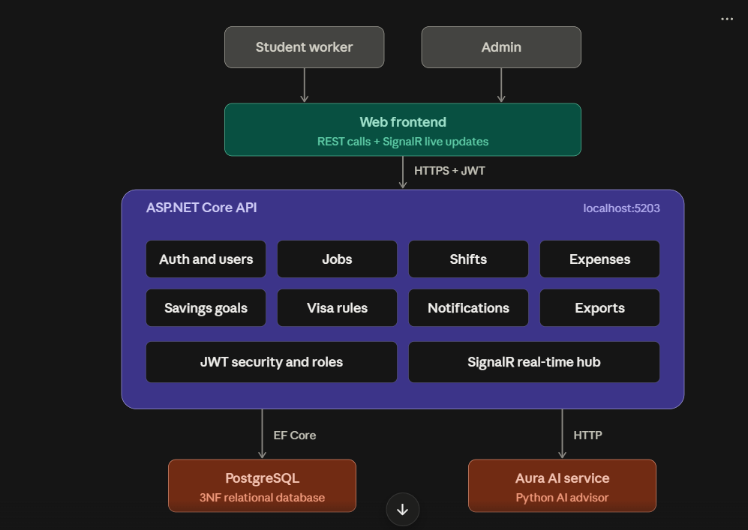
Figure 1. System architecture. Both actors reach the product through the web frontend, which calls the API over HTTPS with a JWT. Inside the API each box is a module folder. EF Core reaches PostgreSQL; plain HTTP reaches the Aura advisor.
The two actors and the scope of the system are shown below. Note that Aura appears as an external actor: it supports the product but the product does not depend on it to function.
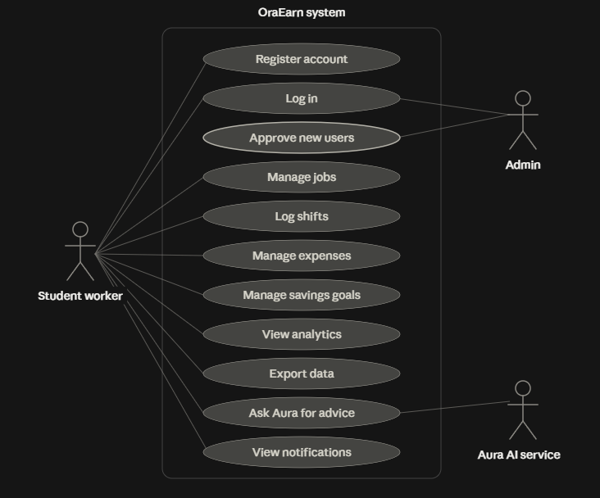
Figure 2. Use case diagram. The student worker owns the day-to-day use cases; the administrator only logs in and approves new users; the Aura AI service participates in advice.

Inside the API
Under backend/OraEarn.Api I gave each part of the product its own folder: Auth, Jobs, Shifts, Expenses, SavingsGoals, Analytics, Notifications, VisaCompliance, Admin, AiAdvisor, Users, and Constants. A normal feature folder has four kinds of file.

File kind | Example | Responsibility
Entity | Jobs/Job.cs | Database shape, plus any pure calculation such as Shift.Calculate
DTOs | Jobs/JobDtos.cs | Request and response records. The entity is never returned to the client
Service | Jobs/JobService.cs | Validation, EF Core queries, and business rules. Always filters by the caller's user id
Controller | Jobs/JobsController.cs | HTTP only: route, authorisation attribute, and status codes

A few files sit outside those folders because every feature needs them. Data/ApplicationDbContext.cs is the one Entity Framework model. Data/DbSeeder.cs and Data/DemoDataSeeder.cs put in the roles, the payment methods, and the demo people. Extensions/ServiceCollectionExtensions.cs is where I register the services. Extensions/WebApplicationExtensions.cs creates the database and runs the migrations. I kept Program.cs short on purpose: configuration, the order of the middleware, the controllers, the shift hub, the health check, and the migration on startup.

Inside the frontend

The routes are in frontend/src/App.tsx. Each screen lives in frontend/src/features, and a feature has an api.ts, a page, and a components folder. Things I did not want to copy into every screen are in frontend/src/shared: api/client.ts is the Axios instance and the token refresh, then layout, ui (button, card, dialog, table, select, tabs), form-field (the validation hook, the checks, and the error under the box), components (page header, stat cards, empty state), types, and utils. Login, register, the route guards, and the auth context are in frontend/src/auth.

Feature set

A period filter and export on the dashboard analytics, a jobs filter with hourly rates, a shifts filter with a calendar, a live clock-in session with breaks, and a visa-hours card, an Expenses filter with user-defined expenses and payment methods, a Saving goal filter with allocation, progress; visa document upload while registering; an admin section for registration approvals and platform analytics, notifications based on the user’s data, and the Aura chat widget. The permanent visa hours rule was inspired by the 48-hour rule for student visas (TEQSA, 2023), and the live shift was made possible by SignalR (Microsoft, n.d.-d).

2.4 Authentication and authorisation
Written by: Dharma Bahadur Budhathoki (S395172) - Scrum Master and lead developer. Security model reviewed with Jenish Gurung (S395321).
I built the accounts with ASP.NET Identity. ApplicationUser extends IdentityUser, and there are only two roles, Admin and User, named in Constants/Roles.cs. The password rule in ServiceCollectionExtensions is at least 8 characters, with an upper-case letter, a lower-case letter, and a digit. I did not require a symbol. Five bad sign-in attempts lock the account for 15 minutes, and the email has to be unique. I followed Jenish's week 5 security drawing for this. Microsoft documents Identity (n.d.-e), the tokens follow JWT (Jones et al., 2015), and OWASP Foundation (n.d.) is the extra reading if you want to tighten it later.
A new person can register, but they cannot use the app until an admin approves them. If you forget that, login looks broken even when the password is right.
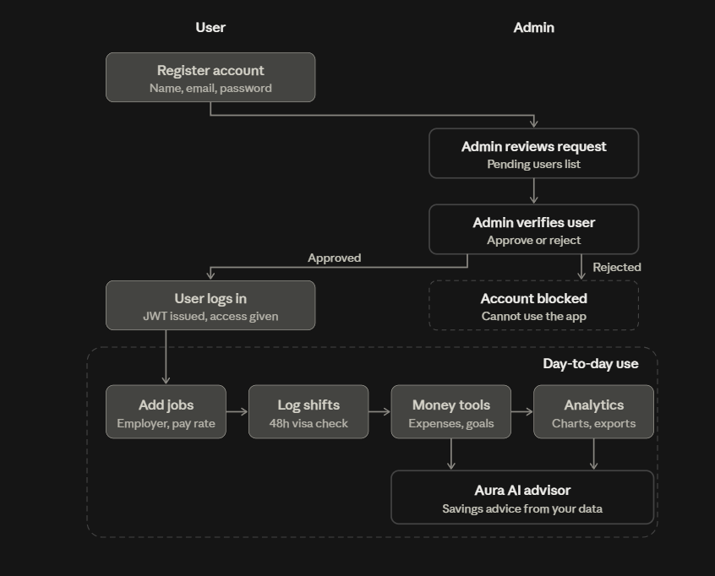
Figure 3. System flow. Registration creates a pending account; the administrator approves or rejects it; only an approved user receives a JWT and reaches the day-to-day features. A rejected account is blocked.
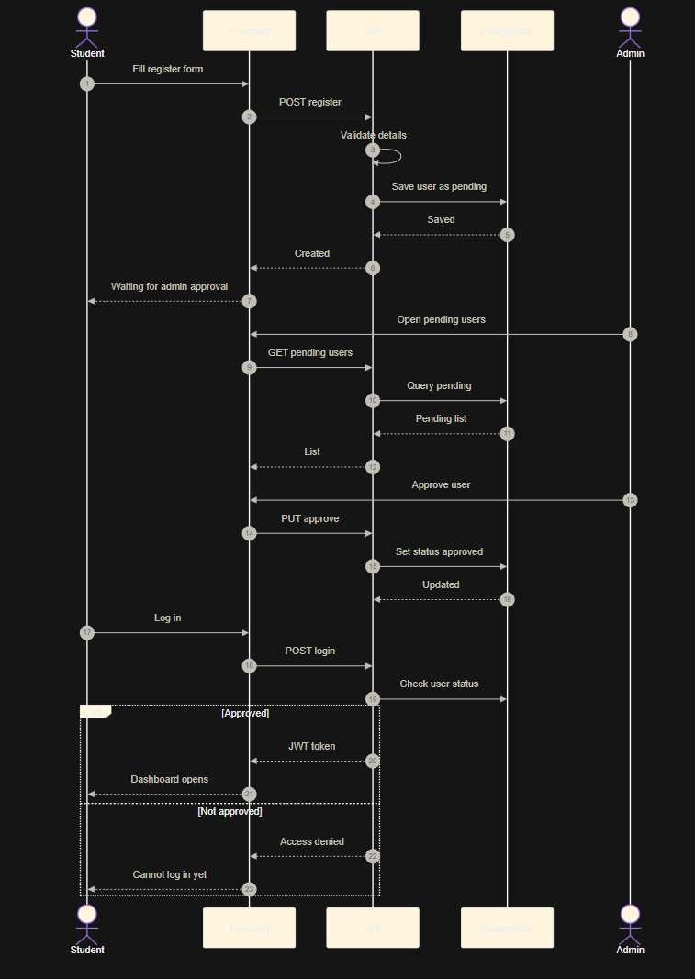
Figure 4. Sequence diagram for register, approve, and log in. The alternative block at the bottom shows the two login outcomes: an approved user receives a JWT and the dashboard opens, while an unapproved user is denied access.

Token flow
- POST /api/auth/login returns a JWT access token valid for 15 minutes and a refresh token valid for 7 days. The refresh token and its expiry are stored on the user row.
- The React client stores both in localStorage under the key auth.
- shared/api/client.ts attaches Authorization: Bearer <token> to every request.
- On a 401 it calls POST /api/auth/refresh once, stores the new pair, and replays the original request. A single shared promise prevents parallel refreshes.
- POST /api/auth/logout revokes the refresh token on the server.

Registration and approval
POST /api/auth/register accepts multipart form data including the visa document, with a 6 MB request size limit. VisaDocumentStorageService writes the file, and the user row keeps the stored path and the original file name. New accounts begin with ApprovalStatus = Pending. RegistrationApprovalAdvisorService can ask Aura for a review summary, which is saved in AiReviewSummary as advice only - the administrator makes the decision, and the outcome is recorded in ApprovedAt and ApprovedByUserId.

Authorisation rules
Surface | Rule
Register, login, refresh, health | [AllowAnonymous]
Jobs, shifts, expenses, categories, savings, notifications, analytics, /api/auth/me | [Authorize]. The controller reads the user id from ClaimTypes.NameIdentifier and the service filters every query by it, so one user cannot read another user's rows
AdminController | [Authorize(Roles = Roles.Admin)]
SignalR /hubs/shifts | Accepts the token as the access_token query value, handled by the OnMessageReceived JWT event, because a browser cannot set headers on a WebSocket handshake
React routes | ProtectedRoute requires a session and redirects admins to /admin; AdminRoute requires the Admin role; GuestRoute keeps a signed-in user off the login and register pages

Development accounts
Created only when Seed:DemoData is true, which is the Development setting.

Role | Email | Password
User | alice@oraearn.local | User123!
Admin | admin@oraearn.local | Admin123!

These are local demo credentials only. Production must set Seed__DemoData=false and provide Seed__AdminEmail and Seed__AdminPassword. The signing key is validated at startup: Jwt:Secret must be at least 32 characters, and the development placeholder is rejected outside Development.

2.5 Git download process
Written by: Dharma Bahadur Budhathoki (S395172) - Scrum Master and lead developer
- Install Git for Windows and sign in to a GitHub account that has access to the group repository.
- Clone the main branch:
git clone https://github.com/itsmekrishnaaaaaa/PRT_681_SYDNEY_GROUP-4.git
cd PRT_681_SYDNEY_GROUP-4
git checkout main
git pull
- Open oraEarn-WebApp in the IDE. The solution file is OraEarn.slnx; the frontend is opened as a folder.
- Never commit appsettings.Local.json, frontend/.env, node_modules, bin, obj, or the Python .venv. These are already listed in .gitignore.
- Branch per Jira issue before editing, using the issue key in the branch name.
- Commit with a message that states what changed and why, push, then open a pull request and paste the link on the Jira issue.
git checkout -b EARN-12-prevent-overlapping-shifts
git add <specific paths>
git commit -m "feat(shifts): block overlapping shifts so visa hours stay accurate (EARN-12)"
git push -u origin EARN-12-prevent-overlapping-shifts
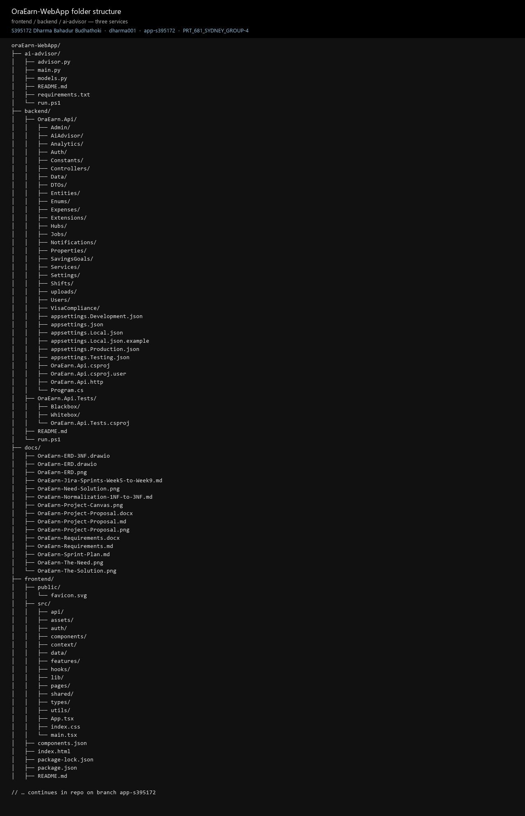
Figure 30. The repository after clone. Comment: development happens in oraEarn-WebApp, which holds frontend, backend, and ai-advisor.

2.6 Instructions and commands to set up the database
Written by: Krishna Sapkota (S395795) - Database administrator
Note that in this project, I have only mentioned PostgreSQL as the DB since we don't use SQLServer. The database can be generated for you. On startup, WebApplicationExtensions.The oraearn database does not exist, but if it doesn't, then EnsureDatabaseExistsAsync connects to the maintenance database postgres and creates the oraearn database if it doesn't exist. Then a series of EF Core migrations are run, and then the database is seeded. View PostgreSQL Global Development Group (n.d.).Install PostgreSQL 16 or newer and note the postgres superuser password.
- Confirm the service is running and accepting connections on localhost:5432.
- If the password is not 12345, set it in appsettings.Local.json (section 2.8) before the first run.
- Start the API once. It creates the database, the Identity tables, and the OraEarn tables, then seeds roles and payment methods.
- To inspect the data afterwards, connect with pgAdmin or psql:
psql -h localhost -p 5432 -U postgres -d oraearn
\dt
select "Title", "HourlyRate" from "Jobs";
\q
Seeded reference data: the roles Admin and User, and the payment methods Card, Cash, Bank Transfer, and Other. Visa documents are stored on the file system rather than as database blobs; the user row keeps the path.

2.7 Entity Framework commands to set up
Written by: Krishna Sapkota (S395795) - Database administrator
Routine setup needs no EF commands at all. With Database:ApplyMigrations true (the default), Program.cs calls ApplyMigrationsAndSeedAsync on every start except in the Testing environment. Starting the API is the database setup step. EF Core migrations are documented in Microsoft (n.d.-b).
Migrations already committed, in backend/OraEarn.Api/Data/Migrations:

Migration | Purpose
20260815061620_InitialCreate | Identity tables plus the first OraEarn schema
20260823104300_NormalizeTo3NF | Normalisation to third normal form, including payment method as its own table
20260907124526_AddPendingModelChanges | Visa compliance, approval, and advisor fields

Install the CLI only when you change the model:
dotnet tool install --global dotnet-ef
dotnet tool update --global dotnet-ef

cd oraEarn-WebApp
dotnet ef migrations add AddMileageEntry --project backend/OraEarn.Api --startup-project backend/OraEarn.Api
dotnet ef database update --project backend/OraEarn.Api --startup-project backend/OraEarn.Api
Useful extras:
dotnet ef migrations list --project backend/OraEarn.Api
dotnet ef migrations remove --project backend/OraEarn.Api # only if not yet applied or shared
dotnet ef migrations script --project backend/OraEarn.Api -o migrate.sql
Rules the next team should keep: commit the generated migration files together with ApplicationDbContextModelSnapshot.cs; never edit a migration that has already been applied to a shared database, add a new one instead; and remember that tests never touch PostgreSQL, because the Testing environment switches the context to EF Core InMemory.

2.8 Connection strings setup
Written by: Krishna Sapkota (S395795) - Database administrator
There is no .env file in the backend. There is a layered configuration using JSON and environment variables. Program.cs adds appsettings.Local.json is last, and creates it from example on first run if it does not exist, thus preventing any changes with other teammates.
Priority (as established during testing). Because appsettings.Local.json is loaded after the environment variables have been loaded into the framework, and takes precedence over an environment variable with the same key. I have changed the ConnectionStrings__DefaultConnection to the port 5433, but the API's connection string remained 5432 since the default one was created automatically in the local file. There are two things that need to be changed: First, change the database in appsettings on your machine:Not in an environment variable, just Local.json on a server, ensure that there is no appsettings.If Local.json or .example file is not deployed, then it silently overwrites the production connection string (logged as OBS-03 in section 8.5).

File | Purpose
appsettings.json | Declares the shape of every setting. The JWT secret and the CORS origin list are intentionally empty here.
appsettings.Development.json | Local defaults: host localhost, database oraearn, username postgres, password 12345, a development JWT secret, CORS origin http://localhost:5173, demo seed on, and Aura at http://localhost:8000.
appsettings.Local.json | Your machine only, git-ignored, loaded last. Copy from appsettings.Local.json.example. This is the file to edit for your own host, port, database, username, or password.
appsettings.Testing.json | Test settings. The context uses EF Core InMemory with the name from Testing:InMemoryDatabase.
appsettings.Production.json plus environment variables | Production. Real secrets come from the host environment, never from Git.
frontend/.env | Copied from .env.example by run.ps1. Only two keys: VITE_API_URL and VITE_HUB_URL.

To point at a different PostgreSQL instance, edit only the local file:
{
"ConnectionStrings": {
"DefaultConnection": "Host=localhost;Port=5432;Database=oraearn;Username=postgres;Password=YOUR_PASSWORD"
}
}
The frontend environment file only needs changing if the API moves off port 5203:
VITE_API_URL=http://localhost:5203/api
VITE_HUB_URL=http://localhost:5203/hubs/shifts
On a hosted API, set these environment variables. The double underscore expresses nesting:
ConnectionStrings__DefaultConnection=Host=...;Port=5432;Database=oraearn;Username=...;Password=...
Jwt__Secret=<32 or more characters>
Cors__AllowedOrigins__0=https://app.your-domain.com
Seed__DemoData=false
Seed__AdminEmail=admin@your-domain.com
Seed__AdminPassword=<strong password>
If the connection string is missing, the secret is too short, or the CORS list is empty, the API fails at startup with a message naming the setting. A PostgreSQL connection failure is wrapped in a message that points directly at appsettings.Local.json.
If port 5432 is already taken by another PostgreSQL install whose password you do not know, you do not need to touch it. Run a second instance on another port and put that port in appsettings.Local.json. This is exactly how the system was tested for section 8, using the portable PostgreSQL 17.6 binaries with no installer:
$pg = "C:\pgportable\pgsql\bin"
& "$pg\initdb.exe" -D C:\pgportable\data -U postgres --pwfile=pw.txt -A scram-sha-256 -E UTF8
& "$pg\pg_ctl.exe" -D C:\pgportable\data -o "-p 5433" -l pg.log start
# appsettings.Local.json -> Host=localhost;Port=5433;Database=oraearn;Username=postgres;Password=12345

2.9 How to run the applications for the first time
Written by: Dharma Bahadur Budhathoki (S395172) - Scrum Master and lead developer
Run the setup script once, from oraEarn-WebApp:
.\scripts\setup.ps1
It checks the required tools, starts the PostgreSQL service when present, creates frontend/.env and appsettings.Local.json from their examples, runs npm install, runs dotnet restore, and creates the Aura virtual environment and installs its requirements when Python is available.
Then start the services, each in its own terminal, in this order:
# Terminal 1 - API (start first, it creates the database)
cd backend
.\run.ps1 # dotnet run --urls http://localhost:5203

# Terminal 2 - React app
cd frontend
.\run.ps1 # npm run dev

# Terminal 3 - Aura advisor (optional)
cd ai-advisor
.\run.ps1 # uvicorn main:app --reload --port 8000
Verification checklist for a first run:
- The API console shows migrations applied with no exception.
- http://localhost:5203/health returns {"status":"ok"}.
- http://localhost:5203/swagger lists the controllers (Development only). (on an unpatched main this fails with a 500 - DEF-03, fixed by the section 8.8 patch).
- http://localhost:5173 loads the login page.
- Signing in as alice@oraearn.local / User123! opens the dashboard with demo data, and admin@oraearn.local / Admin123! opens the admin area.
Aura is optional. Savings chat and registration review need it for a full answer, and everything else works without it. The HTTPS launch profile also exposes https://localhost:7102, but the documented local path is HTTP on 5203 so that the seeded CORS origin matches the Vite dev server.
The three captures below are from a real first run on 13 October 2026 against an empty PostgreSQL database. The API created the oraearn database, applied every migration, and seeded the demo accounts on its first start.
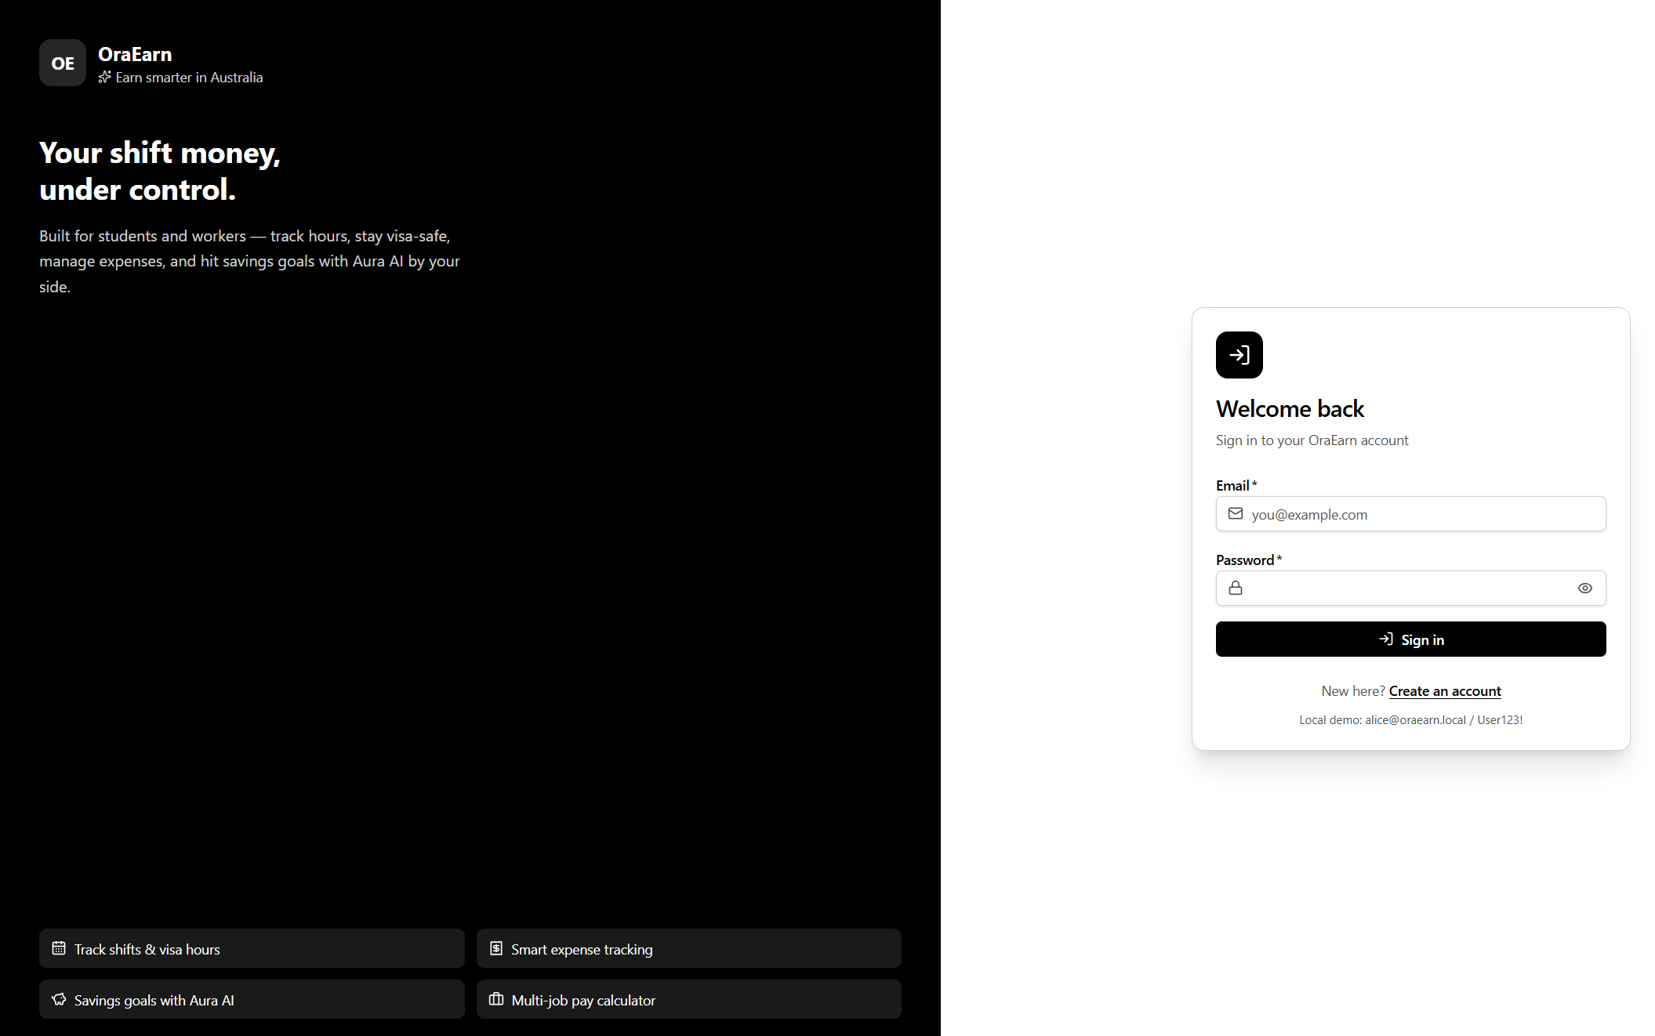
Figure 7. http://localhost:5173 on first run. The login page is the only public route; the hint under the button shows the seeded demo account. Comment (Dharma): if this page loads but sign-in fails with a network error, the API on 5203 is not running or CORS does not list 5173.
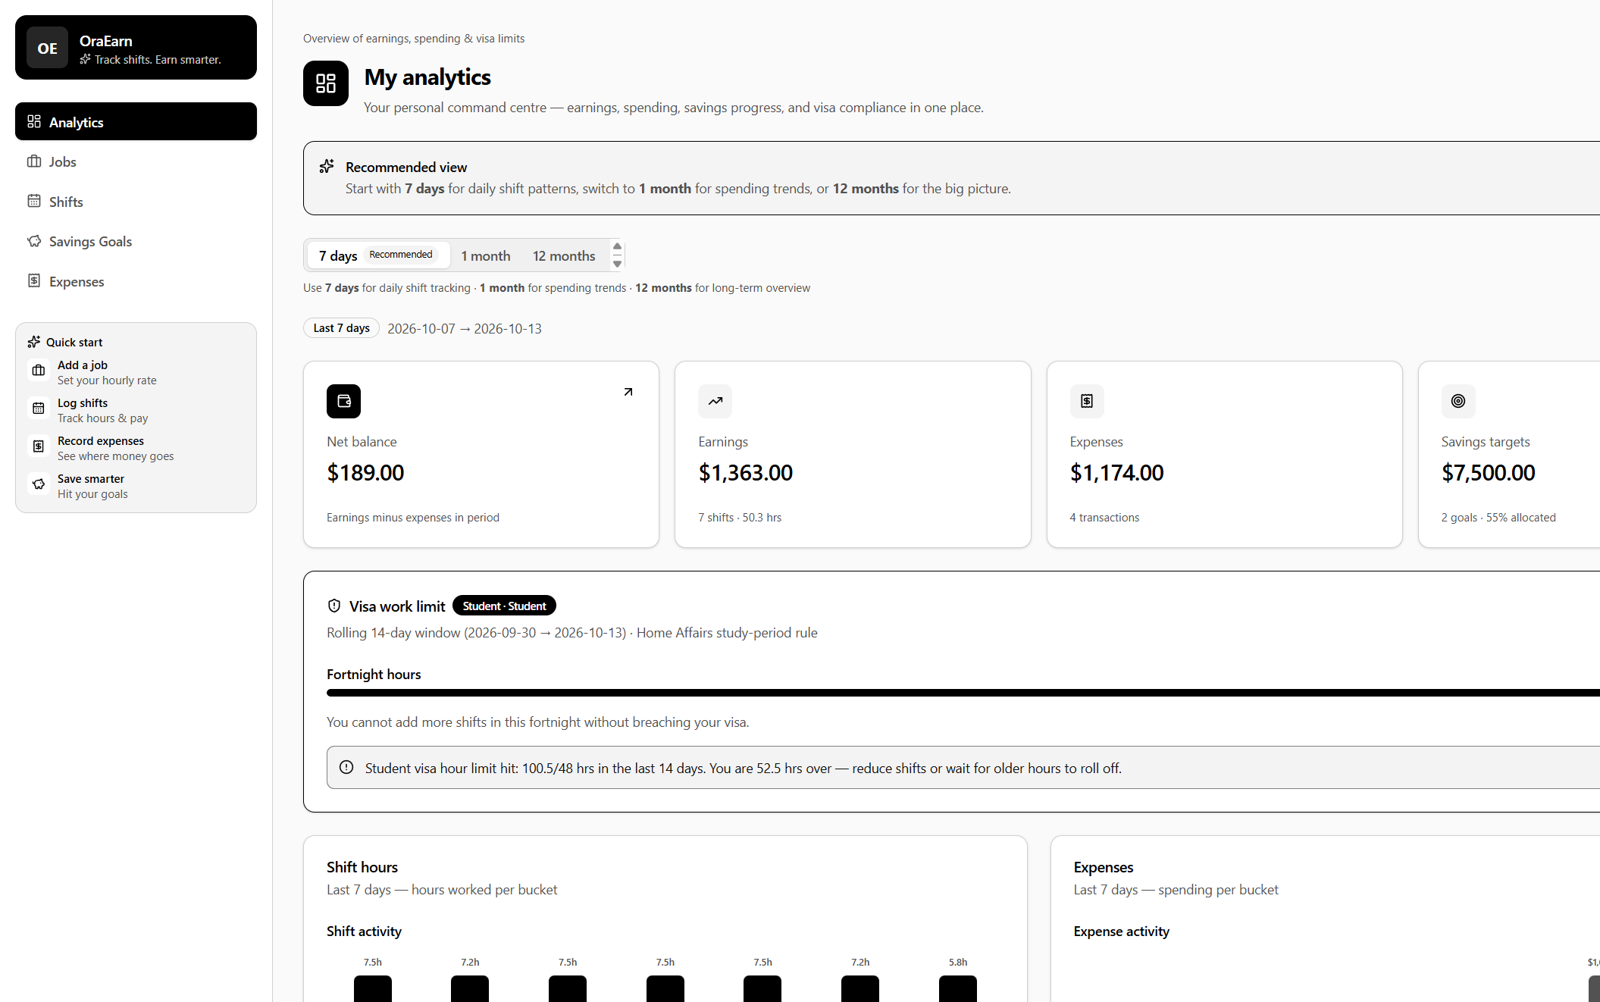
Figure 8. Signed in as alice@oraearn.local. The dashboard is populated by the demo seeder: net balance, earnings, expenses, savings targets, and the visa work-limit panel. Comment (Krishna): the panel already shows 100.5 of 48 hours because the seeder inserts shifts directly and bypasses the visa rule - expected for demo data, see OBS-01.
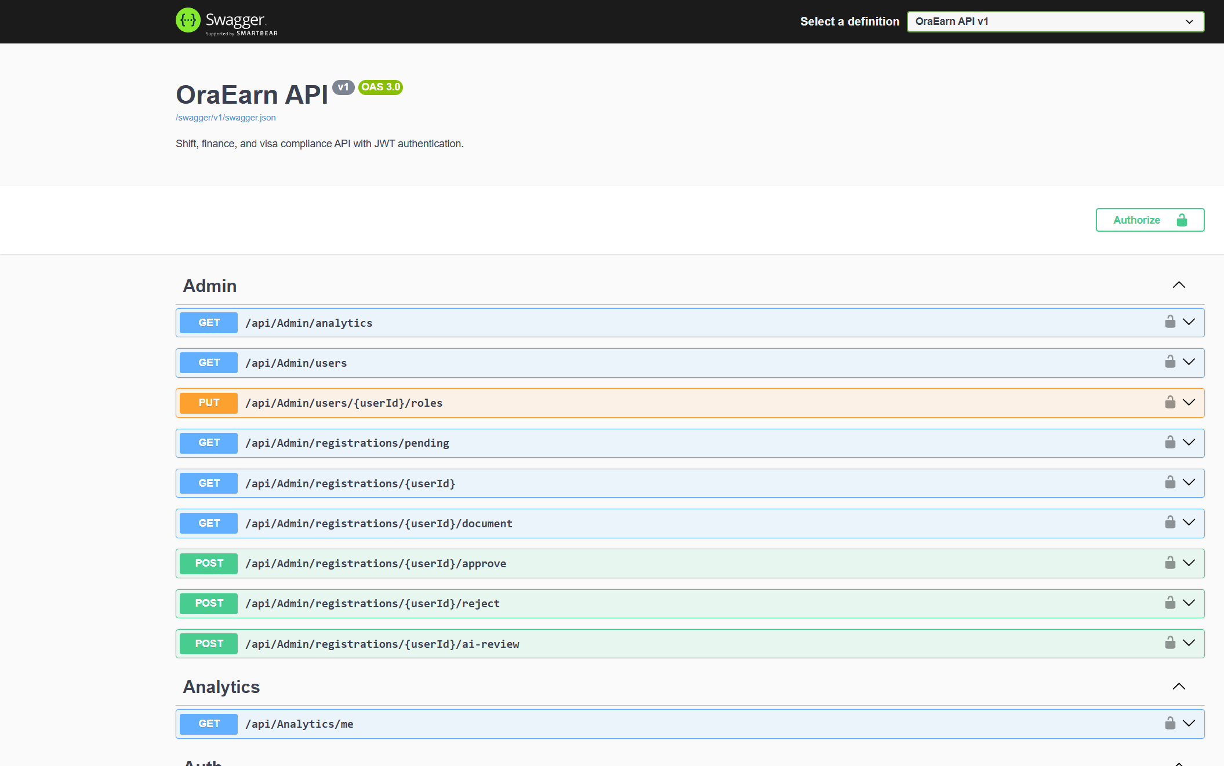
Figure 9. http://localhost:5203/swagger after defect DEF-03 was fixed: 55 operations, with the Authorize button for a JWT. Before the fix this page showed 'Failed to load API definition' (Figure 12), so a new developer could not use Swagger at all.

2.10 Dependency injection
Written by: Jenish Gurung (S395321) - Business analyst. From the Week 5 DI UML; implementation by Dharma.
In Week 5, I was able to design the wiring of OraEarn application services. There must be one composition root to register services, to have controllers wired as primary constructors that take services from there, and there must be no new Service() calls from inside a controller. Dharma implemented it, placing the composition root in AddApplicationServices in Extensions/ServiceCollectionExtensions.cs, which is called once from Program.cs. Controllers have their dependencies injected into the primary constructor, as in public class JobsController(JobService jobService) : ControllerBase. The default service container is described in Microsoft (n.d.-c).

Lifetime | Registered
Scoped (one per request) | ApplicationDbContext, AuthService, TokenService, JobService, ShiftService, ActiveShiftSessionService, ShiftNotificationService, ExpenseCategoryService, ExpenseService, SavingsGoalService, SavingsGoalAnalyticsService, SavingsAdvisorService, AdminService, AnalyticsService, NotificationService, VisaComplianceService, RegistrationApprovalAdvisorService, RegistrationApprovalService, VisaDocumentStorageService
Typed HTTP client | PythonAdvisorClient via AddHttpClient, so handlers and sockets are pooled instead of creating a new HttpClient per call
Options (bound configuration) | JwtSettings from the Jwt section and AiAdvisorSettings from the AiAdvisor section, injected as IOptions<T>
Framework | Identity with ApplicationUser and IdentityRole, JWT bearer authentication, authorisation, controllers with a JSON string-enum converter, Swagger in Development, SignalR, and the CORS policy named Frontend

There are two conventions I want you to follow. First, a new service is invisible until it is registered via that mean. Second, a controller must never call new JobService(...) directly. Since services get ApplicationDbContext through the constructor, white-box tests can create a service with an in-memory context and no web host, which is essentially what the test project does.

2.11 Exception handling
Written by: Dharma Bahadur Budhathoki (S395172) - Scrum Master and lead developer
I did not put try/catch in every controller. Failures go through one path so the HTTP status is the same no matter which feature threw.

Situation | Response | Where
Invalid input, such as an empty job title or a non-positive hourly rate | 400 with { "message": ... } | The service throws ArgumentException; the controller catches it
Row not found, or owned by another user | 404 | The service returns null; the controller returns NotFound()
Bad credentials or an expired refresh token | 401 with a message | AuthController
Missing user id on an authorised call | 401 | UnauthorizedAccessException from the controller's GetUserId
Unhandled exception outside Development | Problem Details, no stack trace | AddProblemDetails() plus UseExceptionHandler()
Misconfiguration: connection string, short JWT secret, development secret in production, empty CORS list | Startup failure naming the setting | ServiceCollectionExtensions
PostgreSQL unreachable on start | InvalidOperationException naming the file to fix | WebApplicationExtensions

If the JWT secret or the allowed front-end origin is missing, the API refuses to start. I would rather it stop on the first line than run with a weak signing key. In Development you still get the developer exception page, which is what I wanted while we were debugging.
On the client Axios discards any non-2xx response. Forms propagate the API message via setFormError, and field-level issues are rendered below the control via FormField and FieldError. Refresh interceptor is configured to skip /auth/login and /auth/refresh, preventing a scenario, where an invalid password could cause an infinite refresh loop, and a request is retried only once.

2.12 Unit testing
Written by: Krishna Sapkota (S395795) - Tester
From the tester role I treat this suite as the baseline a new developer must keep green. Run it from oraEarn-WebApp: Test framework: xUnit.net (n.d.).
dotnet test backend\OraEarn.Api.Tests\OraEarn.Api.Tests.csproj
The project is xunit based. It shipped with 21 test methods (25 test cases when counting the theory rows) and I added 24 more tests during handover testing, a total of 49 passing (section 8.2). No test touches PostgreSQL, so the test suite can run on a clean machine without any database set up. The five new files are marked new. The 24 new tests are in the handover patch (section 8.8), until it is merged, main has the original 25 test cases, and dotnet test reports 25.

Test file | Style | What it protects
new Whitebox/VisaComplianceServiceTests | White box | 48-hour fortnight rule: non-student exempt, near-limit at 44 h, 14-day window edge, exactly 48 h allowed, over 48 h rejected, error-severity notification
new Whitebox/ExpenseServiceTests | White box | Budget calculator and zero-income edge case, category ownership, default payment method, summary by category, cross-user delete blocked
new Blackbox/ExpensesApiTests | Black box | 401 without token, create and summarise, unknown category, negative amount (DEF-02), empty category title (DEF-02)
new Blackbox/ShiftsApiTests | Black box | Overnight shift pay over HTTP, same start and end rejected, job owned by someone else rejected
new Blackbox/RegistrationAndAdminApiTests | Black box | Multipart registration becomes Pending and blocks login, password mismatch, invalid Australian phone, 403 for a standard user on the admin API
Whitebox/JobServiceValidationTests | White box | An empty title and a non-positive hourly rate both throw ArgumentException
Whitebox/ShiftCalculateTests | White box | Shift.Calculate hours, break deduction, rounding, and a shift crossing midnight
Whitebox/SavingsGoalLogicTests | White box | Remaining amount, progress percentage, and the Pending / InProgress / Completed status
Whitebox/UserAnalyticsBuilderTests | White box | Dashboard totals built from shifts and expenses
Whitebox/RegistrationApprovalAdvisorTests | White box | The registration advice rules
Blackbox/AuthApiTests | Black box | Register, login, and token behaviour over real HTTP
Blackbox/JobsApiTests | Black box | The jobs endpoints, including the authorisation requirement
Blackbox/OraEarnWebApplicationFactory | Harness | Boots the API in the Testing environment against EF Core InMemory

To add a test, copy the closest existing file. White-box tests build a context with a unique database name per test so that tests cannot interfere with each other:
private static ApplicationDbContext CreateDb()
{
var options = new DbContextOptionsBuilder<ApplicationDbContext>()
.UseInMemoryDatabase($"JobServiceTests-{Guid.NewGuid()}")
.Options;
return new ApplicationDbContext(options);
}
Treat a change as unfinished if a new rule has no test, or if dotnet test is red. Also run npm run lint in frontend, and remember that npm run build runs tsc -b and will fail the build on a type error.

2.13 Class diagram and data model
Written by: Krishna Sapkota (S395795) - Database administrator
I designed the data model to third normal form. Payment method is stored as a separate table rather than a string in each expense row. Shift hours and money earned are computed and saved so that changing a job's hourly rate does not affect historical reports. Money and percentage columns have explicit precision. The editable source is oraEarn-WebApp/docs/OraEarn-ERD-3NF.drawio and the normalisation walkthrough is docs/OraEarn-Normalization-1NF-to-3NF.md. Jenish's mapping UML in Week 5 aligns the entities with the API DTOs.
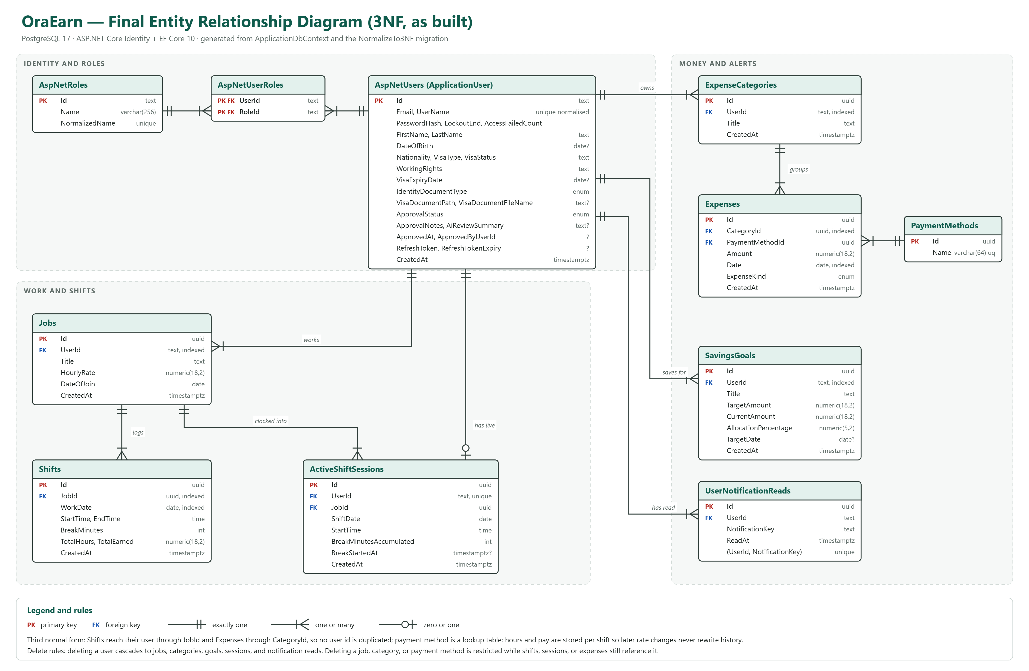
Figure 5. Data model as built. Every user-owned row hangs off ApplicationUser (ASP.NET Identity); shifts belong to a job; expenses belong to a category and a payment method; deletes are restricted wherever history must survive.
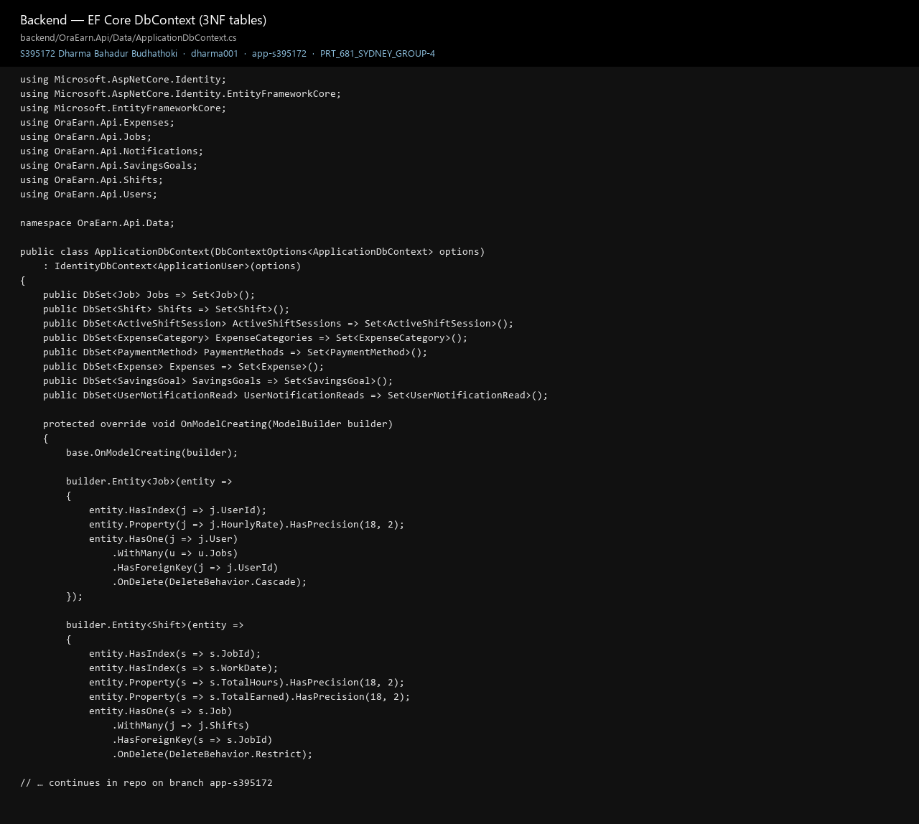
Figure 32. ApplicationDbContext, the tables as built. A shift stores JobId, not UserId. The hourly rate lives on the job.

Entity | Important fields | Relationships and rules
ApplicationUser | Identity fields plus first and last name, date of birth, nationality, visa type, visa status, working rights, visa expiry, identity document type, visa document path and file name, approval status, approval notes, AI review summary, approved at, approved by, refresh token and expiry, created at | Owns jobs, expense categories, savings goals, and at most one active shift session
Job | Title, hourly rate (precision 18,2), date of join | Many per user, cascade on user delete. Indexed on UserId
Shift | Work date, start time, end time, break minutes, total hours and total earned (both 18,2) | Many per job, restricted on job delete so earnings history cannot vanish. Indexed on JobId and WorkDate. Shift.Calculate handles the overnight case and rounds to two decimals
ActiveShiftSession | Shift date, start time, accumulated break minutes, break started at | Unique index on UserId, so a user cannot be clocked in twice. Restricted on job delete
ExpenseCategory | Title | Many per user, cascade on user delete, restricted while expenses reference it. Indexed on UserId
PaymentMethod | Name, unique, maximum length 64. Seeded with Card, Cash, Bank Transfer, and Other | A shared lookup table - this is the third normal form change. Restricted on delete
Expense | Amount (18,2), date, expense kind | One category and one payment method. Indexed on CategoryId and Date
SavingsGoal | Title, target amount, current amount (18,2), allocation percentage (5,2), optional target date | Many per user, cascade on user delete. RemainingAmount, ProgressPercent, and Status are computed properties, not stored columns
UserNotificationRead | Notification key, read at | Unique per user and key. Notifications are derived from the user's data, so only the read state is persisted

For reference, the conceptual ERD that I have created for week 4 is demonstrated below. The easiest way to explain what has happened to the schema is to compare the two drawings: Budget has been incorporated into savings goals and analytics, Break has become break minutes on the shift plus the accrued break on the active session, Employer has been reduced to the job record, and VisaHourRecord has become a calculation in VisaComplianceService over the shifts that already exist instead of a duplicated table.
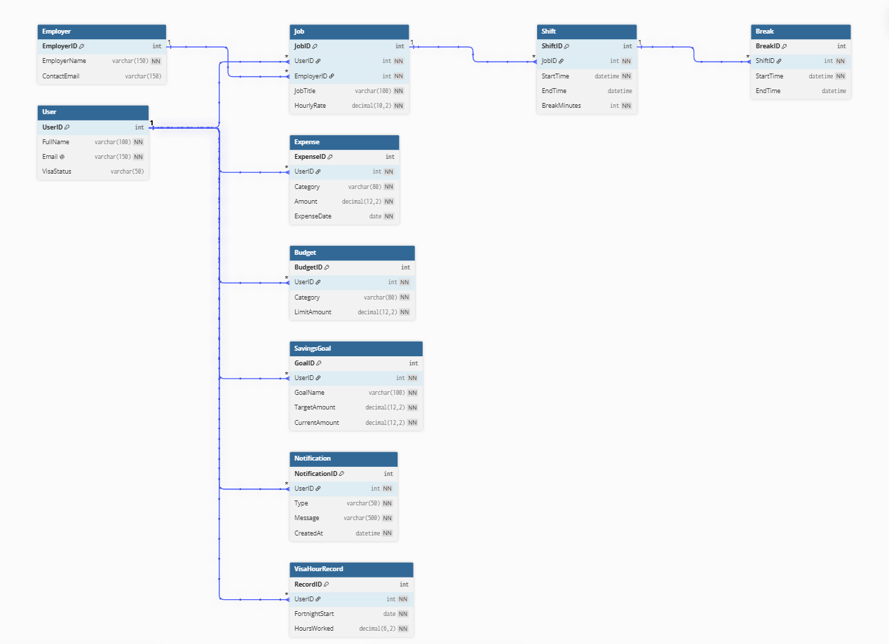
Figure 6. Initial conceptual ERD (Week 4), before normalisation and before the model was reconciled with ASP.NET Identity. Kept here deliberately, so the next team can see which early entities were merged or replaced and why.

Class shape of a feature slice
Jobs is the reference example, and every other feature follows it:
Backend Job (entity)
JobRequest / JobResponse (DTO records)
JobService - validation, EF queries, filters by user id
JobsController - [Authorize], routes, status codes

Frontend features/jobs/api.ts - typed calls on the shared Axios client
features/jobs/components/JobModal.tsx - form and client-side validation
features/jobs/JobsPage.tsx - list, state, actions
Additional diagrams in the repository: the use case, sequence, system flow, and architecture diagrams in Krishna_sapkota_S395795 (Figures 1 to 4 and 6 of this document), and UML for dependency injection, security, mapping, and end-to-end flow in Jenish_Gurung_s395321/week5.

3. Adding new features - guide
Add a feature by duplicating the jobs vertical slice. Here is a worked example of such an implementation, which is a mileage log, so names are easily swapped out. Do not add another architecture in conjunction with this one. Jenish wrote the task and DI steps. Dharma wrote the code, library, UI, and commit steps. Krishna wrote the test step.

3.1 Create the task
Written by: Jenish Gurung (S395321) - Business analyst
- Create an issue in Jira project EARN. State the user need, the acceptance checks, and the intended API shape.
- Add it to the current sprint, set an estimate, and assign it. Keep the issue updated as the work progresses rather than only at the end - the assessment rubric scores the level of detail on the board.
- Branch from an up-to-date main: git checkout -b EARN-00-mileage.

3.2 Write the backend code
Written by: Dharma Bahadur Budhathoki (S395172) - Scrum Master and lead developer
- Create the folder backend/OraEarn.Api/Mileage.
- MileageEntry.cs: a Guid Id, the owning UserId, the fields, CreatedAt, and a navigation property to ApplicationUser.
- In Data/ApplicationDbContext.cs add the DbSet and a configuration block in OnModelCreating. Index the user id, set the decimal precision, and choose cascade or restrict on purpose.
- MileageDtos.cs: request and response records. Never return the entity.
- MileageService.cs: the constructor takes ApplicationDbContext. Throw ArgumentException with a readable message for invalid input, and filter every query by the caller's user id.
- MileageController.cs: [ApiController], [Authorize], route api/[controller], the service in the primary constructor, and the same status code pattern as JobsController.
- Add the migration and apply it, as in section 2.7.
public DbSet<MileageEntry> MileageEntries => Set<MileageEntry>();

builder.Entity<MileageEntry>(entity =>
{
entity.HasIndex(m => m.UserId);
entity.Property(m => m.DistanceKm).HasPrecision(18, 2);
entity.HasOne(m => m.User)
.WithMany()
.HasForeignKey(m => m.UserId)
.OnDelete(DeleteBehavior.Cascade);
});

3.3 Add the new service using dependency injection
Written by: Jenish Gurung (S395321) - Business analyst
Register it in Extensions/ServiceCollectionExtensions.cs, beside the other scoped services:
services.AddScoped<MileageService>();
If the feature calls another process, register a typed client the way PythonAdvisorClient is registered with AddHttpClient, and bind any configuration through a settings class and services.Configure<T> rather than reading IConfiguration inside business code. Restart the API and confirm the endpoints appear in Swagger.

3.4 Add new libraries
Written by: Dharma Bahadur Budhathoki (S395172) - Scrum Master and lead developer
A backend package: Platform documentation: Microsoft (n.d.-a).
dotnet add backend/OraEarn.Api package SomePackage --version 10.0.11
A JavaScript library, from frontend:
npm install some-library
npm install -D some-dev-tool
Commit the manifest changes - OraEarn.Api.csproj, or package.json together with package-lock.json - so that every machine installs the same versions. Prefer what is already here (Axios, React Router, Tailwind, Radix, jsPDF, SheetJS, SignalR) before adding another dependency, and say in the pull request why a new one is needed.

3.5 Add the screen, the styles, and client-side validation
Written by: Dharma Bahadur Budhathoki (S395172) - Scrum Master and lead developer
- frontend/src/features/mileage/api.ts using the shared client. VITE_API_URL already ends in /api, so the call is api.get<Mileage[]>('/mileage').
- MileagePage.tsx plus components/MileageModal.tsx. Reuse PageHeader, StatCard, EmptyState, and the shared/ui components so the new screen matches the rest of the product.
- Styling is Tailwind utility classes. Shared tokens and the colour scheme live in frontend/src/index.css - change colours there rather than hard-coding hex values in a component, and do not add a second CSS framework.
- Client-side validation uses shared/form-field. Render each control inside FormField so the message appears under the input, and pass the API message to setFormError when the server rejects the request. Client validation is for fast feedback only; the service must still validate.
- Register the route in App.tsx inside the ProtectedRoute and Layout parents, and add the navigation entry in shared/layout/Layout.tsx.
const { errors, validate, clearError, setFormError } = useFormValidation<'distanceKm' | 'date'>();

const ok = validate(() => ({
distanceKm: required(form.distanceKm) ?? positiveNumber(form.distanceKm),
date: required(form.date),
}));
if (!ok) return;

3.6 Unit testing
Written by: Krishna Sapkota (S395795) - Tester
Add backend/OraEarn.Api.Tests/Whitebox/MileageServiceTests.cs modelled on JobServiceValidationTests, covering at least one rejected input and one successful create. If the HTTP contract matters, add a black-box test using OraEarnWebApplicationFactory. Then run both checks:
dotnet test backend\OraEarn.Api.Tests\OraEarn.Api.Tests.csproj
cd frontend; npm run lint; npm run build

3.7 Comment and commit the work
Written by: Dharma Bahadur Budhathoki (S395172) - Scrum Master and lead developer. Close the Jira issue with Jenish.
Add a comment when the name does not say why. A visa-hour rule, a delete that is blocked, a total we store instead of calculating, or a rounding choice are the sort of lines I mean. Do not comment the next line just to say what it already says.
git status
git add backend/OraEarn.Api/Mileage backend/OraEarn.Api/Data
backend/OraEarn.Api/Extensions/ServiceCollectionExtensions.cs
backend/OraEarn.Api.Tests/Whitebox/MileageServiceTests.cs
frontend/src/features/mileage frontend/src/App.tsx frontend/src/shared/layout/Layout.tsx

git commit -m "feat(mileage): record travel distance against earnings (EARN-00)"
git push -u origin EARN-00-mileage
Open a pull request, put the link on the Jira issue, and ask one of the others to read it. Move the issue to Done after it is merged. If the feature added a tool, a setting, or a table, write that into this handover so the next person is not guessing.
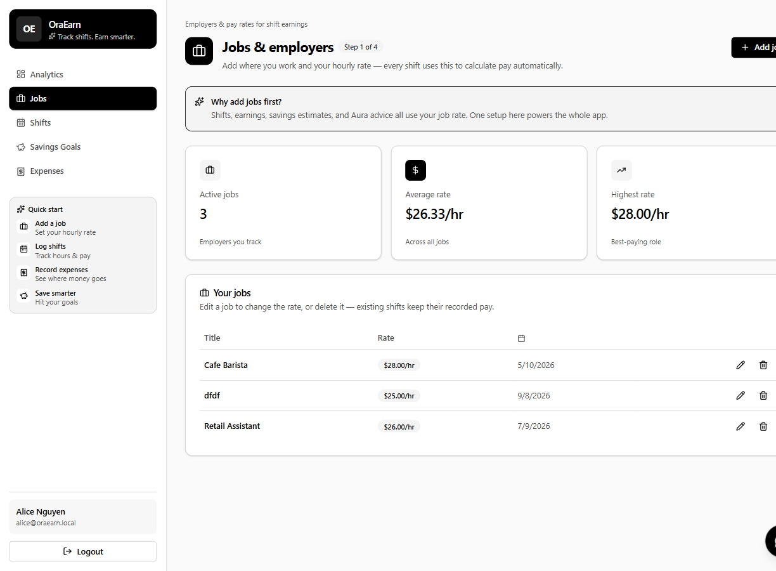
Figure 26. Jobs, the feature slice used as the pattern. Comment: the hourly rate on the job is what a shift is paid.
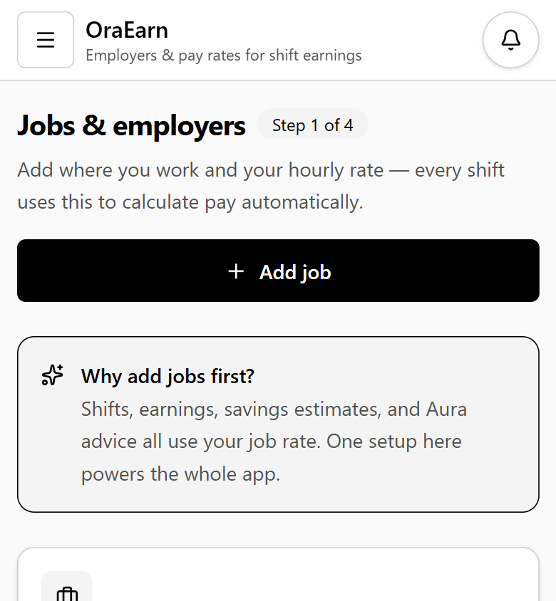
Figure 31. Jobs on a phone. Same screen as Figure 26. The wide table becomes a single column, and the menu moves into the button at the top.

4. Individual project contributions and Git evidence
Git totals compiled by Krishna Sapkota (S395795). Each member wrote their own contribution below.
Evidence in this section comes from the repository itself, so a marker can verify every figure. I produced the commit counts with git shortlog -sn, and the history in Appendix A with:
git log --pretty=format:"%h | %an | %ad | %s" --date=short

4.1 Commit totals by author
78 commits on main, from 11 August 2026 to 16 October 2026.

Git author name | Commits | Member
krishna sapkota | 32 | Krishna Sapkota (S395795)
Jenish Gurung | 22 | Jenish Gurung (S395321)
Dharma001 | 22 | Dharma Bahadur Budhathoki (S395172)
Dharma Bahadur Budhathoki | 2 | The same member, second identity - pull request merges #2 and #3
Total | 78 | Dharma's two identities total 24 commits

4.2 Application code commits
Ten commits changed files under oraEarn-WebApp. These are the commits that built the product, and all of them were authored under the Dharma001 identity.

Commit | Date | Message | Size
64bec00 | 2026-08-23 | feat: added frontend and installed required packages (Swagger, PostgreSQL, Entity Framework) | 46 files, +8,303
03bfdeb | 2026-08-23 | feat: added week 5 research, work-done screenshots, individual meeting log | evidence files
65f5f81 | 2026-09-01 | feat: added Auth DTO and User, started database connection setup | 5 files, +46 / -3
6ace869 | 2026-09-08 | feat: added application | 234 files, +18,790 / -6,462
d60cba0 | 2026-09-08 | feat: added application | timesheet files
9aa5f3b | 2026-09-15 | feat: updated timesheet | timesheet
00ab4e2 | 2026-09-18 | feat: centralised the frontend colour scheme | 23 files, +109 / -102
a5ae67d | 2026-09-18 | feat: fixed responsiveness of the application | 26 files, +272 / -145
c523e0b | 2026-09-18 | feat: added show-password button on the login page | 1 file, +14 / -4
b6bbc20 | 2026-09-18 | fix: improved CRUD UI for jobs, expenses, and savings goals | 8 files, +1,027 / -511

Two pull requests were merged into main (#2 and #3, both from the branch app-s395172), so the application work entered the main branch through review rather than by direct push.

4.3 Contribution by member

Krishna Sapkota (S395795) - DBA and tester - 32 commits
Written by: Krishna Sapkota (S395795)
My role was database administrator and tester. I created the repository (92d2397, 11 August 2026) and then owned the data model, the test view of the API, and the diagrams this handover uses.
- Role: database administrator and tester, plus technical documentation.
- Data model: the OraEarn ERD (Figure 6) and the normalisation review that produced the third normal form model now in docs/OraEarn-ERD-3NF.drawio and the migration NormalizeTo3NF (Figure 5).
- Design artefacts: the architecture diagram, use case diagram, sequence diagram, and system flow diagram reproduced as Figures 1, 2, 3, and 4 of this document.
- User-facing documentation: OraEarn User Manual.html.
- Role research: DBA role research and tester role research (week 6).
- Handover testing (13 October 2026): ran the whole system against a fresh PostgreSQL database, wrote 24 new automated tests (49 in total, all passing), executed 31 system test cases traced to the requirement IDs, and found and fixed three defects - a parallel-start crash in Program.cs, missing server-side validation on expenses and categories, and Swagger failing to generate (section 8).
- Handover sections I wrote: 2.6, 2.7, 2.8, 2.12, 2.13, 3.6, 4.1, 4.2, 4.6, sections 8 and 9, and the tester notes in section 7.
- Git evidence: commits from 2026-08-11 (92d2397 first commit, which created the repository) through to 2026-10-13.

Jenish Gurung (S395321) - Business analyst and requirements analyst - 22 commits
Written by: Jenish Gurung (S395321)
My contribution concerned business analyst activities. I handled the unit brief, developed it into a BRD and SRS, maintained the backlog in Jira project EARN, and produced the document that describes the links between the pieces to help Dharma implement against a written contract.
- Role: business analyst and requirements analyst.
- Requirements: OraEarn_BRD.docx and OraEarn_SRS_Draft_Week4.docx, reconciled in week 7 as Week_7_SRS_BRD_Reconciliation.docx.
- Architecture documentation: the UML set for dependency injection, security, mapping, and end-to-end flow (week 5). The security and dependency injection diagrams correspond to sections 2.4 and 2.10 of this document.
- Traceability: Week_8_Traceability_Matrix.xlsx linking requirements to delivery, plus the problem statement and objectives.
- Backlog and handover: Week6_BA_Backlog.md, week 6 and 7 reports, plus sections 1, 2.10, 3.1, 3.3, and coordination in section 6.
- Git evidence: commits from 2026-08-25 to 2026-09-17, with each week's work in its own weekN folder.

Dharma Bahadur Budhathoki (S395172) - Scrum Master and lead developer - 24 commits
Written by: Dharma Bahadur Budhathoki (S395172) - Scrum Master and lead developer
I was the Scrum Master and the lead developer. I picked the stack, set up the API, and built the screens and the services that Krishna modelled and Jenish specified. I also ran the meetings and kept the board moving.
- Role: Scrum Master and lead developer.
- Architecture: I wrote the modular monolith research (ResearchOnmodularMonolithicArchitecture.png). That is the structure in section 2.3, together with the week 4 stack research.
- Backend: I scaffolded the API with Swagger, Npgsql, and Entity Framework, then added the Auth DTOs, the user model, and the database connection.
- The app itself went in on 8 September 2026. After that I shared the colours, fixed the phone layout, made create and edit easier on jobs, expenses, and savings, and added the show-password button.
- At the start I wrote the proposal, the canvas, and the problem and solution boards, and I kept the ERD after we normalised it.
- My commits run from 17 August 2026 to 16 October 2026. The early messages use feat: and fix:, and two of them went in through pull requests. In October I updated the home page, added the week 11 meeting, the week 12 timesheet, and the readme.

4.4 Commit message quality
Written by: Dharma Bahadur Budhathoki (S395172) and Krishna Sapkota (S395795)
If you read the log from the top you can see two habits. Some messages say what changed. Some were uploaded on the GitHub website and only say that something was added.

Style | Roughly | Assessment
Conventional prefixes - feat: and fix: with a description | 11 commits | Good practice. A reader can tell what changed and why. These are all of the application-code commits.
Add files via upload, Create <folder>, Delete <file> | about 50 commits | Generated automatically by the GitHub web interface when documents and timesheets are uploaded through the browser. They carry no information about the change.

If you take this over, commit from a clone on your own machine and write the message yourself. Uploading the file on the website is how we lost the useful messages. Something like docs(dba): add the ERD after the week 5 check is enough, and put the EARN key in the message when you have one. That shape is Conventional Commits (n.d.). Linking Jira to GitHub would have made this section much easier to write.

4.5 Coding standards observed in the code base
Written by: Dharma Bahadur Budhathoki (S395172) - Scrum Master and lead developer
This is how I laid the code out. Please keep the same shape, so the next change still looks like the rest of the app.

Area | Convention
C# naming | PascalCase for types, members, and file names; camelCase for locals and parameters; DTO records named for their purpose, such as JobRequest and JobResponse
C# language level | Nullable reference types and implicit usings enabled; primary constructors on controllers and services; collection expressions ([]); expression-bodied members for simple properties
Folder layout | One folder per business area holding the entity, DTOs, service, and controller. No generic Models, Helpers, or Utils dumping grounds
Controllers | Thin. No EF Core query and no business rule in a controller. Authorisation by attribute, never by an if-statement on the role
Services | Own validation and queries; always scope by user id; throw ArgumentException for invalid input
Money and time | decimal with explicit precision for money, never double; DateOnly and TimeOnly for dates and times of day; DateTime.UtcNow for timestamps
TypeScript and React | Function components; type aliases for props and payloads; one feature folder per area with its own api.ts; the path alias @/ for src; named exports
Styling | Tailwind utility classes with tokens in index.css. Colours were deliberately centralised in commit 00ab4e2 - keep them there
Secrets | No secret in Git. Local settings go in the ignored appsettings.Local.json; production values come from environment variables
Lint and build | oxlint for the frontend; npm run build type-checks with tsc -b before bundling

4.6 Code comments
Written by: Krishna Sapkota (S395795) - Tester
As tester I measured comments on the current tree, excluding generated migrations: 74 C# files and about 4,700 lines with only 9 comment lines; 81 TypeScript and TSX files and about 5,700 lines with 49 comment lines. The code is mostly self-documenting due to naming and the consistent folder pattern, and the comments that do exist are of the right type - explaining intent, rather than explaining code. A nice example is in shared/api/client.ts:
// Never retry auth bootstrap endpoints - avoids refresh deadlocks.
if (url.includes('/auth/refresh') || url.includes('/auth/login')) {
return Promise.reject(error);
}
Krishna counted 9 comment lines in the C# before the handover comments. Those comments are now on: Shift.Calculate (why the end time rolls to the next day, and why the result is rounded and stored); VisaComplianceService (where the fortnight limit comes from); the OnDelete(DeleteBehavior.Restrict) choices in ApplicationDbContext (which history must survive a delete); the startup validation in ServiceCollectionExtensions (why a weak JWT secret fails the boot); and SavingsAdvisorService (the shape of the context sent to Aura). XML documentation on every public method is still not there. Swagger would show it if it is added later.

5. Software quality and structure
Written by: Dharma Bahadur Budhathoki (S395172) - Scrum Master and lead developer
I counted the code I actually wrote, not the migrations Entity Framework generated and not the packages we installed. It came to about 4,700 lines of C# in 74 files, about 5,700 lines of TypeScript and TSX in 81 files, and 211 lines of Python in 3 files. On main there are 21 automated test methods (25 cases). With Krishna's section 8.8 patch that becomes 49. That is roughly 10,600 lines of application code. His extra tests found three defects, and I checked each fix against the rules below before I was happy with it (section 8.5).

5.1 Structure and modular design
We stayed with one API. That was the week 5 decision. Each feature has its own folder, so the jobs code is not mixed with the expenses code, but we still ship one application. Aura sits apart only because it is Python and it only gives advice. Saving a shift does not go through it.
- The layers are the same in every feature. The controller takes the HTTP call, the service holds the rules, the entity is the shape of the row, and the DTOs are what we send back to React. Once you have read Jobs, the other folders feel familiar.
- A service gets what it needs in the constructor, and I register all of that in one file. I can test a service with an in-memory database without starting the website. React only knows the API address. The Python call sits behind PythonAdvisorClient, so a different advisor would not force me to rebuild the screen.
- I tried not to copy the same helper into every feature. The Axios client does the token and the refresh. shared/ui and shared/form-field do the look of the page and the error under a field. Data/QueryExtensions.cs holds the query shapes we kept writing twice.
- The calls down to the database are async. Services do not keep one user's data in fields between requests. Live shift updates go out through SignalR, so the page is not asking the server every few seconds. Login is a JWT, so the API is not storing a session. The dashboard date filter and the export share AnalyticsPeriod instead of each one doing its own date maths.

5.2 Non-functional requirements
Concern | How the product addresses it
Reliability | Database creation and migrations are applied on start up to ensure that the environment is correctly setup relative to the model. Misconfiguration will cause boot to fail with a named setting rather than failing per request. /health can be used to perform an uptime check. Restricted deletes are in place to protect earnings and expense history. The unique index on ActiveShiftSession.UserId ensures that it is not possible to clock in twice at the database level as well as in application code.
Correctness of money | decimal with precision 18,2 every money column, 5,2 for allocation percentage, and Round in 2 decimals in Shift.Calculate. The hours and earnings are stored as they are calculated, thus changing a job rate will not recalculate earnings. The overnight shift example is tested and covered by a test.
Performance | Indexes on every foreign key and on the columns reports filter by (Shift.WorkDate, Expense.Date). Asynchronous EF Core everywhere. A pooled typed HttpClient for Aura. Analytics are computed on the server and returned as a shaped DTO rather than shipping rows of data to the browser. Vite code-splits the production build.
Security | Identity password hashing with a real policy and lockout; short-lived access tokens with server-side refresh revocation; role attributes on the admin surface; every user query scoped by the token's user id; an explicit CORS allow-list; HSTS, HTTPS redirection, and forwarded headers outside Development; a request size limit on the upload; and a startup refusal to run with a weak or placeholder signing key. Aura is internal-only and can require an X-Aura-Key header in production.
Maintainability | One repeated feature pattern, a single composition root, no secrets in source, linting and type-checking in the build, and a test suite that needs no database.
Usability | Route guards that send each role to the right landing page, inline field validation with an error summary, empty states and a quick-start guide, dashboard export to PDF and Excel, a responsive layout, and a centralised colour scheme.

5.3 Known limitations for the next team
- The tokens sit in localStorage. That was the simple way to stay signed in, and any script on the page can read them. If this went on a public server, I would move the refresh token to an http-only cookie first.
- The five comments from section 4.6 are in the code: Shift.Calculate, the 48-hour limit, the Restrict deletes, the JWT secret check, and the Aura context.
- The first tests were mostly the calculations and the login. There were 21 of them. Section 8 adds expenses, categories, visa hours, shifts over HTTP, registration, and the admin checks. Notifications, the savings-goal endpoints, clock-in and clock-out, and SignalR still only have the manual cases.

Commits per member per week
Written by: Jenish Gurung (S395321) - Business analyst. Counts taken from Appendix A.
Commit counts reflect the time when work was added to the repository but do not indicate how hard the work was. Hours spent on the task are recorded in the time sheets of each member (section 1.1) which represents a measurement of the time management. Documents inserted via the GitHub web interface are considered commits in this context.

Period | Dates (2026) | Krishna | Jenish | Dharma | All
Weeks 3-4 | 11-17 Aug | 9 | 0 | 2 | 11
Week 5 | 18-31 Aug | 0 | 8 | 2 | 10
Week 6 | 1-6 Sep | 0 | 7 | 1 | 8
Week 7 | 7-14 Sep | 6 | 3 | 2 | 11
Week 8 | 15-21 Sep | 0 | 4 | 8 | 12
Weeks 9-10 | 22 Sep - 12 Oct | 14 | 0 | 1 | 15
Weeks 11-12 | 13-16 Oct | 3 | 0 | 8 | 11
Total | 11 Aug - 16 Oct | 32 | 22 | 24 | 78

- No continuous integration. dotnet test and npm run lint are run by hand. A GitHub Actions workflow on pull requests would enforce both.
- Visa documents on local disk. Acceptable for a local build, but a hosted deployment needs object storage and a retention policy, because these are identity documents.
- Notifications are derived. Only the read state is stored. If the product later needs a notification history or email delivery, that becomes a real table.

6. Time management and weekly activity
Timeline compiled by Jenish Gurung (S395321). Each member confirms their own weeks below.
Hours spent on each task are represented in each individual's time sheet (see section 1.1), as provided within those spreadsheets. These are the primary source of evidence, which is referenced, but not repeated, here. I have reconstructed the project delivery timeline based upon the dates on which the respective commits were made, for purposes of cross-referencing with those timesheets.

Week | Dates (2026) | Delivered, evidenced by commits
Week 3-4 | 11-17 Aug | Repository created (92d2397). Project proposal, problem and solution boards, technology stack research. DBA work started, Week 4 progress report and the first timesheets.
Week 5 | 23-26 Aug | Backend scaffold with Swagger, PostgreSQL, and Entity Framework (64bec00, 46 files). Modular monolith research. BRD and SRS draft. ERD after normalisation.
Week 6 | 1-2 Sep | Auth DTOs, user model, and database connection (65f5f81). UML set for dependency injection, security, mapping, and end-to-end flow. Week 5 concept briefing.
Week 7 | 7-8 Sep | Main application delivery (6ace869, 234 files, +18,790 lines): features, tests, Aura, and setup scripts. BA and requirements-analyst reports. DBA role research.
Week 8 | 15-18 Sep | Quality pass: centralised colours, responsive layout, CRUD usability, show-password control (00ab4e2, a5ae67d, c523e0b, b6bbc20). Two pull requests reviewed and merged. Week 7 and 8 timesheets, traceability matrix, problem statement and objectives.
Week 9-10 | 29 Sep - 6 Oct | Tester role research, consolidated timesheets for weeks 4 to 8, user manual, and the remaining diagrams - use case, sequence, system flow, and architecture.
Week 11-12 | 13 Oct | Final timesheet consolidation and this handover document for Assessment 4.

Commits have occurred in 9 different weeks between week 33 and week 42 in 2026. That's a steady stream of work throughout the year leading up to the deadline. Architecture and database decisions were made in weeks 5 and 6 before the big delivery in week 7, and week 8 was focused on quality over scope.

Krishna Sapkota (S395795) - my weeks
Written by: Krishna Sapkota (S395795) - DBA and tester
I have logged hours in Krishna_sapkota_S395795 timesheets. Weeks 3 to 4 were spent on working with the repository and first ERD. In week 5, I performed normalisation. In week 6, I researched the DBA role. Weeks 9 to 10 were spent on tester research, user manual, and Figures 1 to 4. In week 12, I conducted system testing on 13 October (sections 8 and 9), my handover sections, and final timesheet.

Jenish Gurung (S395321) - my weeks
Written by: Jenish Gurung (S395321) - Business analyst
I worked on the Jenish_Gurung_s395321 timesheets, including the Week 7 and Week 8 timesheets. Weeks 4 to 5: BRD, SRS, and UML. In week 6, I focused on the BA backlog. In week 7, I did the SRS and BRD reconciliation and traceability matrix and problem statement. I used Jira EARN and SYD-Group4 channel as the coordination points.

Dharma Bahadur Budhathoki (S395172) - my weeks
Written by: Dharma Bahadur Budhathoki (S395172) - Scrum Master and lead developer
My hours are in the folder (s395172) Dharma_Bahadur_Budhathoki, and the week 7 meeting log is in there too. Week 4 was the proposal and the stack research. Week 5 was getting the API to build. Week 6 was auth and connecting the database. Week 7 was the main application commit. Week 8 was the screen tidy-up and the two pull requests. The workbook in that folder runs through week 12, and the picture is Figure 27.

Coordination practices used
Written by: Jenish Gurung (S395321)
- Jira project EARN for sprint planning and task tracking, with the sprint plan recorded in docs/OraEarn-Jira-Sprints-Week5-to-Week9.md and docs/OraEarn-Sprint-Plan.md. The board itself was populated on 18 Sep 2026 and closed in batches on 6 and 13 Oct (see Jira board evidence above).
- Microsoft Teams channel SYD-Group4 for day-to-day coordination, with a meeting log kept in week 7.
- GitHub pull requests for the application branch, so code entered main after review.
- Per-member weekly folders, so each member's weekly output and timesheet is separately verifiable.

Risks handled during the project
- Schema churn - resolved by normalising to third normal form in week 5 and capturing it as a migration, so later work built on a stable model. Figures 5 and 6 show the before and after.
- Local environment differences - resolved with scripts/setup.ps1 and the git-ignored appsettings.Local.json, so one teammate's database password never breaks another machine.
- Dependency on an AI service - resolved by making Aura optional and rule based, so no API key, running cost, or network outage can block the product.

Sprint plan used on the Jira board
Written by: Jenish Gurung (S395321) - Business analyst and Scrum coordination
I have planned five one-week sprints, each with a goal, epics, and stories including acceptance criteria that trace into the requirement IDs given. All the story text, sub-tasks, and hour split are detailed in the files docs/OraEarn-Jira-Sprints-Week5-to-Week9.md. The acceptance criteria from that file are the source of several of the system test cases given in section 8.4, for instance OE-401's 'Alice blocked, Bob not blocked'. The dates given in this table are taken from that plan file, the EARN board was loaded on 18 Sep so it does not show these sprints as they happened.

Sprint | Dates (2026) | Sprint goal | Stories | Points
1 - Foundation | 17-21 Aug | Register and log in with JWT; admin approval; 3NF ERD agreed | OE-101 to OE-104 | 16
2 - Work and shifts | 24-28 Aug | Jobs and shifts, clock in/out, live calendar | OE-201 to OE-204 | 18
3 - Money | 31 Aug - 4 Sep | Expenses, budget calculator, savings goals | OE-301 to OE-303 | 12
4 - Compliance and insight | 7-11 Sep | 48-hour visa rule enforced; analytics and export | OE-401 to OE-403 | 13
5 - Intelligence and handoff | 14-18 Sep | Notifications, Aura, admin AI review, documentation pack | OE-501 to OE-505 | 18

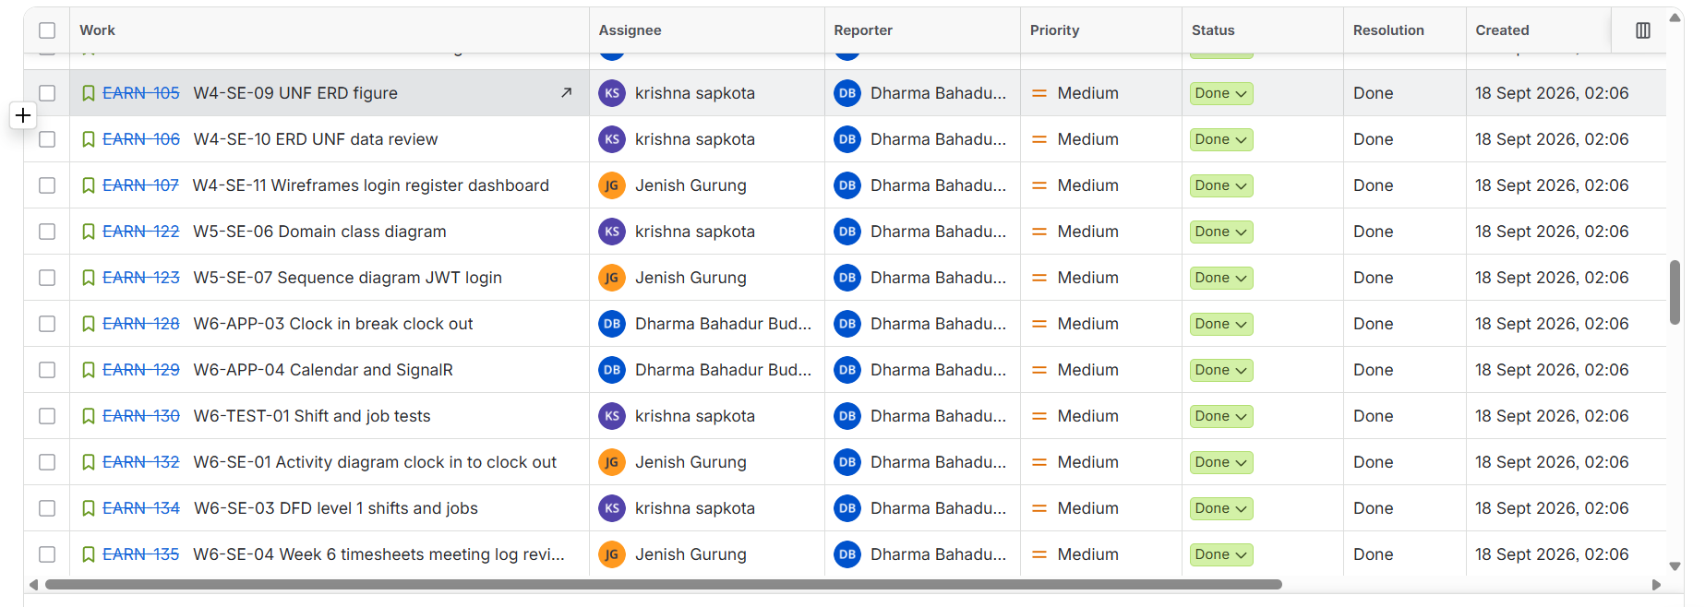
Figure 24. Jira project EARN, week 4 to 6 stories. Krishna owns the ERD, class diagram, DFD and shift and job test stories (EARN-105, 106, 122, 130, 134); Jenish owns the wireframes, sequence and activity diagrams (EARN-107, 123, 132); Dharma owns the clock-in and calendar application stories (EARN-128, 129).
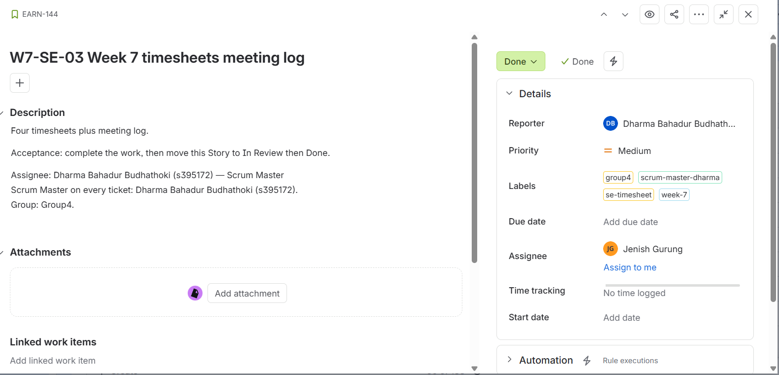
Figure 25. Issue detail for EARN-144 (Week 7 timesheets and meeting log). Labels show group4, scrum-master-dharma, se-timesheet and week-7, and the description holds an acceptance line. Comment: the Jira time-tracking field is empty ("No time logged") and the issue has no due date, because hours were recorded in the members' timesheet workbooks, not in Jira.
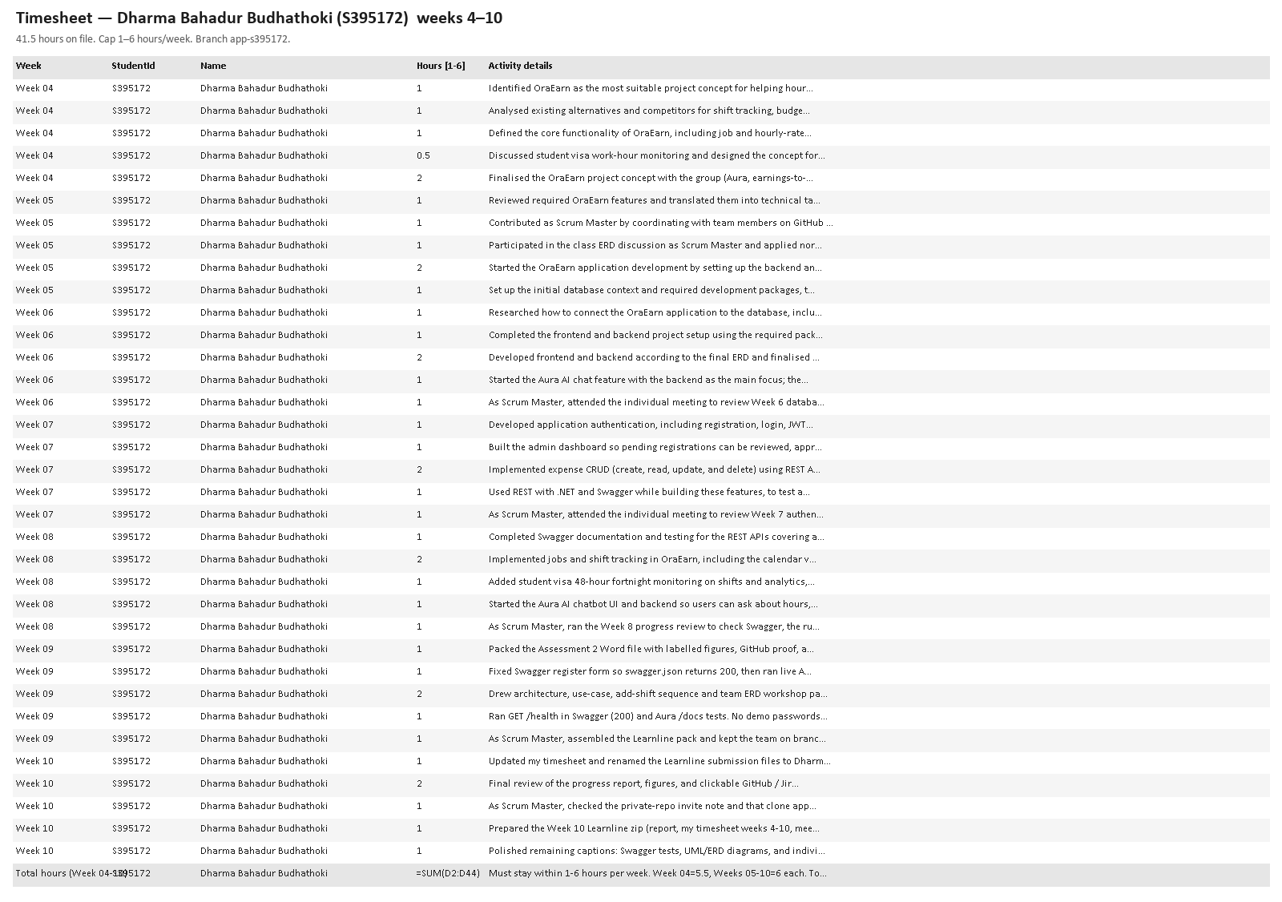
Figure 27. Timesheet for Dharma Bahadur Budhathoki (S395172), weeks 4 to 12. Comment: week 4 is 5.5 hours and each later week is 6 hours.

Jira board evidence
Written by: Jenish Gurung (S395321) - Business analyst. Figures taken from the Jira report exported on 15 Oct 2026.
The EARN project comprises 136 stories. All are Stories with priority Medium and status Done, and Dharma is the reporter across all. 132 were created at the same minute on 18 Sep 2026 (02:06) and four later that morning, and so, as a backlog, the board was loaded on 18 Sep rather than accumulated week by week. The stories were then closed in two batches, 27 on 6 Oct and around 100 on 13 Oct, plus a few on 18 Sep. Thus while Jira is evidence of delivery and ownership, it is not evidence of weekly planning. Weekly activity is evidenced by the timesheets, the meeting logs, the member folders and the commit history (Appendix A). Only one issue has a due date, and three are unassigned (EARN-184 and two others).

Assignee | Issues | Share | Typical work
Dharma Bahadur Budhathoki | 63 | 46% | Application stories, FR and NFR items, Aura
Jenish Gurung | 37 | 27% | Requirements, diagrams, meeting logs, figure packs
Krishna Sapkota | 33 | 24% | ERD, tests, UAT, traceability, test evidence
Unassigned | 3 | 2% | Documentation housekeeping
Total | 136 | 100%

Story group (key prefix) | Issues | Meaning
W4 | 15 | Week 4: proposal, canvas, requirements, use cases, ERD, wireframes, Jira set-up
W5 | 18 | Week 5: architecture, tests, class and sequence diagrams
W6 | 10 | Week 6: clock in and out, calendar and SignalR, shift tests, diagrams
W7 | 9 | Week 7: savings goals, money tests and UAT, data dictionary
W8 | 16 | Week 8: visa rule, export, visa and analytics tests, test plan
W9 | 9 | Week 9: Aura advisor, admin AI review, notification tests
W10 | 15 | Week 10: figure pack, UAT sign-off, traceability, timesheets
FR | 9 | Functional requirement stories (for example FR-8.2 notification bell)
NFR | 35 | Non-functional requirement stories (security, performance, usability)
Total | 136

What the next team should do differently
Create each issue when the work starts, not afterwards. Use sprints with start and end dates, set real priorities and due dates, log time or link the timesheet row, assign every issue to one person, and put the EARN key in every commit message so that Jira and Git tell the same story.

7. Handover notes and known gaps

First day for a new developer
Written by: Dharma Bahadur Budhathoki (S395172) - Scrum Master and lead developer
- Read oraEarn-WebApp/README.md, then section 2 of this document.
- Run scripts/setup.ps1, start the three services, and sign in with both demo accounts.
- Run dotnet test to confirm a clean baseline.
- Read Jobs end to end - entity, DTOs, service, controller - then features/jobs. That is the pattern for everything else.
- Open the EARN board and read a few of the stories in Done before you add anything. When you do start new work, put the new issue key in the branch name.

Before any public deployment
Written by: Krishna Sapkota (S395795) - Database administrator
- Set ConnectionStrings__DefaultConnection, a strong Jwt__Secret of at least 32 characters, and Cors__AllowedOrigins__0.
- Set Seed__DemoData=false with a real Seed__AdminEmail and Seed__AdminPassword. The demo accounts in section 2.4 must never exist in production.
- Build the frontend with the live VITE_API_URL and VITE_HUB_URL.
- Keep PostgreSQL and Aura off the public internet. If Aura is deployed, set AURA_ENV=production to disable its docs and set AURA_API_KEY so the API must send X-Aura-Key.
- Move visa document storage to object storage and define a retention policy, since these are identity documents.

Priority backlog recommended to the next team
Written by: Jenish Gurung (S395321) - Business analyst
- The comments named in section 4.6 are already in the code. The next team does not need to add those five.
- Add a GitHub Actions workflow running dotnet test, npm run lint, and npm run build on every pull request.
- Apply Assessment4/code-changes/krishna-testing-and-defect-fixes.patch (section 8.8), then add automated tests for notifications, savings-goal endpoints, and clock-in/out - the areas section 8.6 marks as system-tested only.
- Move the refresh token to an http-only cookie.
- Standardise commit messages and Git identities, and commit documents from a clone rather than the GitHub web uploader.
Sydney Group 4 wrote this handover from the current state of main, each member covering their own role, so a new developer can install, run, understand, and extend OraEarn without needing to contact the original team.

8. Test report - test cases and results
Written by: Krishna Sapkota (S395795) - Tester. Traceability (8.6) by Jenish Gurung; fix review (8.5) by Dharma Bahadur Budhathoki.
As tester I did not want this handover to describe tests that nobody had run. On 13 October 2026 I cloned main, ran the existing suite, wrote new automated tests for the untested modules, started the full system against a fresh PostgreSQL database, and executed system test cases through the browser and the REST API. Every result in this section is from that session.

8.1 Test approach and environment
Level | How it was run | Tool
Unit (white box) | Services constructed directly with an EF Core InMemory context; no web host, no database | xunit 2.9.3
API (black box) | Real HTTP requests to the API hosted in-process by OraEarnWebApplicationFactory in the Testing environment | Microsoft.AspNetCore.Mvc.Testing 10.0.11
System | Full stack running: API on 5203, React on 5173, PostgreSQL 17.6. Exercised through the browser UI and with scripted REST calls | Chromium (Cursor browser), PowerShell, curl
Static | Frontend lint and production build, including the TypeScript type check | oxlint, tsc -b, Vite 8.2.1

Environment item | Value
Operating system | Windows 11 (10.0.26200), PowerShell 5.1
.NET SDK / runtime | 10.0.401 / net10.0
Node / npm | Node with npm 10.8.3; npm install from the committed lock file
Database | PostgreSQL 17.6 portable binaries on port 5433 (port 5432 was occupied by an unrelated instance), empty database oraearn created by the API
Test data | Demo seeder accounts: admin@oraearn.local, alice@oraearn.local (student visa), bob@oraearn.local (citizen), carol@oraearn.local, david.pending@oraearn.local (pending)
Not available | Python, so the Aura service was offline. This also tested the rule-based fallback the app is meant to use when Aura is down

8.2 Automated test results
Final run, after the fixes in section 8.5: 49 test cases, 49 passed, 0 failed, 6.1 seconds - 30 white-box and 19 black-box. The run order in the picture is alphabetical by class.
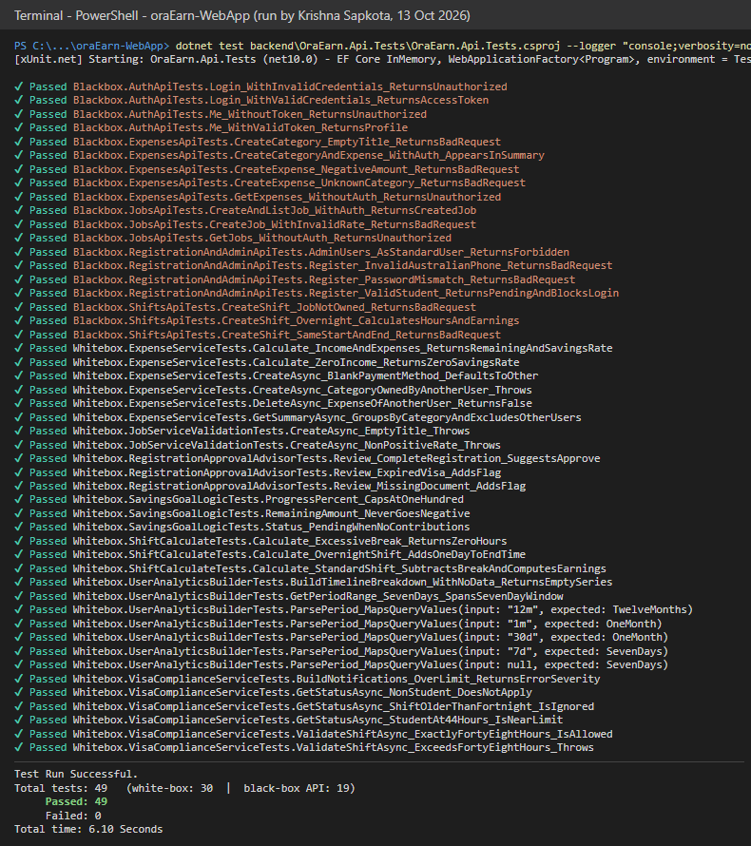
Figure 10. dotnet test on 13 October 2026 after the fixes. Orange names are black-box API tests and white names are white-box unit tests; the summary at the bottom is the line a new developer checks before every commit.

Run | When | Result | What it showed
Baseline | Before any change | 24 / 25 passed | The original suite had one intermittent failure: DEF-01, a startup race between two test hosts
New tests added | After writing 24 tests | 47 / 49 passed | Two new tests failed on purpose: the API accepted a negative expense and an empty category title (DEF-02)
After fixes | After DEF-01, DEF-02, DEF-03 | 49 / 49 passed | All defects closed; the suite also passes from a clean checkout with no appsettings.Local.json

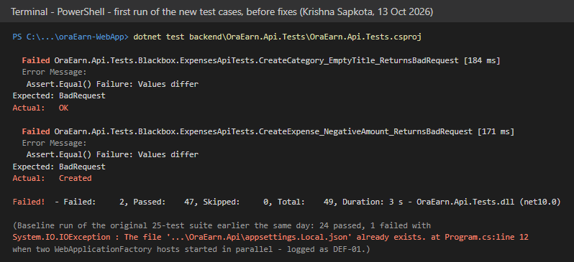
Figure 11. The run that found DEF-02. Both tests expect HTTP 400 for invalid input; the API returned 200 OK for an empty category title and 201 Created for an expense of -50. The grey note records the baseline failure that became DEF-01.
Static checks on the frontend: npm run lint reports 0 errors and 6 warnings (five fast-refresh export warnings and one missing useEffect dependency in RegistrationApprovals.tsx), and npm run build succeeds, producing a 271 KB main bundle (89 KB gzipped).

8.3 New automated test cases
Each new test is named Method_Condition_ExpectedResult so the name alone states the test case. Requirement IDs refer to docs/OraEarn-Requirements.md.

ID | Test method | Req. | Expected result | Result
UT-01 | VisaCompliance.GetStatusAsync_NonStudent_DoesNotApply | FR-4.1 | Citizen is not limited | Pass
UT-02 | VisaCompliance.GetStatusAsync_StudentAt44Hours_IsNearLimit | FR-4.3 | 44 h -> near limit, 4 h remaining | Pass
UT-03 | VisaCompliance.GetStatusAsync_ShiftOlderThanFortnight_IsIgnored | FR-4.1 | A shift 14 days ago is outside the window | Pass
UT-04 | VisaCompliance.ValidateShiftAsync_ExceedsFortyEightHours_Throws | FR-4.2 | 45 h + 4 h rejected | Pass
UT-05 | VisaCompliance.ValidateShiftAsync_ExactlyFortyEightHours_IsAllowed | FR-4.2 | Boundary: 44 h + 4 h accepted | Pass
UT-06 | VisaCompliance.BuildNotifications_OverLimit_ReturnsErrorSeverity | FR-8.1 | One visa_limit_exceeded error | Pass
UT-07 | ExpenseService.Calculate_IncomeAndExpenses_... | FR-5.7 | 2000 income, 1000 spent -> 50% | Pass
UT-08 | ExpenseService.Calculate_ZeroIncome_ReturnsZeroSavingsRate | FR-5.7 | No divide-by-zero; rate 0 | Pass
UT-09 | ExpenseService.CreateAsync_CategoryOwnedByAnotherUser_Throws | NFR-2.3 | Cannot file into another user's category | Pass
UT-10 | ExpenseService.CreateAsync_BlankPaymentMethod_DefaultsToOther | FR-5.2 | Blank method becomes 'Other' | Pass
UT-11 | ExpenseService.GetSummaryAsync_GroupsByCategory... | FR-5.6 | Totals per category, other user excluded | Pass
UT-12 | ExpenseService.DeleteAsync_ExpenseOfAnotherUser_ReturnsFalse | NFR-2.3 | Row survives a foreign delete | Pass
API-01 | ExpensesApi.GetExpenses_WithoutAuth_ReturnsUnauthorized | NFR-2.1 | 401 | Pass
API-02 | ExpensesApi.CreateCategoryAndExpense_WithAuth_AppearsInSummary | FR-5.1, 5.2 | 201, amount in summary | Pass
API-03 | ExpensesApi.CreateExpense_UnknownCategory_ReturnsBadRequest | FR-5.2 | 400 | Pass
API-04 | ExpensesApi.CreateExpense_NegativeAmount_ReturnsBadRequest | FR-5.2 | 400 | Fail -> Pass (DEF-02)
API-05 | ExpensesApi.CreateCategory_EmptyTitle_ReturnsBadRequest | FR-5.1 | 400 | Fail -> Pass (DEF-02)
API-06 | ShiftsApi.CreateShift_Overnight_CalculatesHoursAndEarnings | FR-3.3 | 22:00-06:00, 30 min break -> 7.5 h, 225.00 | Pass
API-07 | ShiftsApi.CreateShift_SameStartAndEnd_ReturnsBadRequest | FR-3.1 | 400 | Pass
API-08 | ShiftsApi.CreateShift_JobNotOwned_ReturnsBadRequest | NFR-2.3 | 400 | Pass
API-09 | RegistrationAdmin.Register_ValidStudent_ReturnsPendingAndBlocksLogin | FR-1.1, NFR-7.3 | 200 Pending, then login 401 'pending' | Pass
API-10 | RegistrationAdmin.Register_PasswordMismatch_ReturnsBadRequest | FR-1.1 | 400 'do not match' | Pass
API-11 | RegistrationAdmin.Register_InvalidAustralianPhone_ReturnsBadRequest | FR-1.1 | 400 'Australian phone' | Pass
API-12 | RegistrationAdmin.AdminUsers_AsStandardUser_ReturnsForbidden | NFR-2.4 | 403 | Pass

8.4 System test cases (executed on the running application)
These were executed on the full stack with the seeded data. 'UI' cases were run in the browser; 'API' cases were run as scripted REST calls against the same running API. Where a screenshot exists, the figure number is given.

ID | Req. | Steps and test data | Expected | Actual | Status
TC-AUTH-01 | FR-1.2 | UI: sign in as alice@oraearn.local / User123! | Dashboard opens | Dashboard with demo data (Fig. 8) | Pass
TC-AUTH-02 | FR-1.5, NFR-7.3 | UI: sign in as david.pending@oraearn.local | Login refused | 'Your registration is pending admin approval.' (Fig. 13) | Pass
TC-AUTH-03 | FR-1.2 | API: alice with a wrong password | 401 | 401, generic 'Invalid email or password' | Pass
TC-AUTH-04 | FR-1.3 | API: POST /auth/refresh with the refresh token | New tokens | 200; new access token; refresh token rotated | Pass
TC-AUTH-05 | FR-1.4, NFR-2.5 | API: logout, then reuse the old refresh token | Reuse refused | Logout 204; reuse 401 | Pass
TC-SEC-01 | NFR-2.4 | API: Alice calls GET /api/admin/users | 403 | 403 | Pass
TC-SEC-02 | NFR-2.1 | API: GET /api/jobs with a forged bearer token | 401 | 401 | Pass
TC-SEC-03 | NFR-2.3 | API: Bob requests Alice's job by id | Not visible | 404 | Pass
TC-SEC-04 | NFR-2.3 | API: Bob deletes Alice's shift | Not allowed | 404; shift unchanged | Pass
TC-SEC-05 | NFR-2.2 | API: register with password 'password1' | Rejected | 400 'Passwords must have at least one uppercase' | Pass
TC-SEC-06 | NFR-2.2 | API: 5 wrong passwords for carol, then the correct one | Locked out | 401 - lockout after 5 failures for 15 minutes | Pass
TC-REG-01 | FR-1.1, NFR-7.2 | API: multipart register with visa fields and a PDF | Pending account | 200, approvalStatus Pending | Pass
TC-REG-02 | NFR-2.6 | API: register with an .exe as identity document | Rejected | 400 | Pass
TC-REG-03 | FR-1.1, NFR-7.2 | UI: open /register while signed out | Full form | Personal, visa, work-rights, and document sections shown (Fig. 21) | Pass
TC-ADM-01 | FR-1.6 | UI: admin runs AI review on David with Aura offline | Review shown | Local fallback review; flags missing document (Fig. 19) | Pass
TC-ADM-02 | FR-1.5, NFR-8.3 | UI: admin approves David with a note; David signs in | Login allowed | David left the pending list; login 200, approvalStatus Approved | Pass
TC-ADM-03 | FR-7.6, NFR-8.1 | UI: admin dashboard | Platform totals | 5 users, 28 shifts, 4,454.40 expenses, role toggles (Fig. 18) | Pass
TC-VISA-01 | FR-4.2 | UI: Alice (100.5 h in 14 days) adds a 09:00-17:00 shift today | Blocked | Blocked: 'would bring you to 108.0 hours ... limit 48' (Fig. 15) | Pass
TC-VISA-02 | FR-4.3, FR-4.4 | UI: Alice opens dashboard and shifts | Warning shown | Over-limit panel on both pages (Fig. 8, 14) | Pass
TC-VISA-03 | FR-4.2 (OE-401) | API: Bob (citizen, full-time) adds a 5 h shift today | Allowed | 201; 5 h; 150.00 | Pass
TC-EXP-01 | FR-5.2, NFR-3.2 | UI: add expense with amount -50 | Field error | 'Enter a valid amount.' under the field (Fig. 17) | Pass
TC-EXP-02 | FR-5.2 | API: POST /api/expenses amount -50 | 400 | Before fix 201 (DEF-02); after fix 400 | Pass after fix
TC-EXP-03 | FR-5.4, FR-5.6 | UI: expenses page, filter chips | List and totals | 10 transactions, 1,440.50, 5 categories (Fig. 16) | Pass
TC-EXP-04 | FR-5.7 | API: calculator, income 2400, expenses 900 + 300 | 50% savings | Total 1200, remaining 1200, 50.0% | Pass
TC-GOAL-01 | FR-6.4, FR-6.5 | UI: savings goals page | Progress and hours | 36.8% and 37%; hours needed and finish dates (Fig. 20) | Pass
TC-NOTIF-01 | FR-8.1 | API: Alice GET /api/notifications | Visa alert | 1 item visa_limit_exceeded; unread 1 | Pass
TC-NOTIF-02 | FR-8.4, FR-8.5 | API: mark all as read | Unread 0 | 204; unread count 0 | Pass
TC-PERF-01 | NFR-1.2 | API: GET /api/analytics/me?period=12m | Under 3 s | 145 ms | Pass
TC-PERF-02 | NFR-1.1 | API: GET /api/expenses | Under 2 s | 43 ms | Pass
TC-DOC-01 | NFR-6.2 | Open /swagger | Endpoints listed | Before fix 500 (DEF-03, Fig. 12); after fix 55 operations (Fig. 9) | Pass after fix
TC-BUILD-01 | NFR-5.2 | npm run lint and npm run build | No errors | 0 errors, 6 warnings; build succeeded | Pass

Summary: 31 system test cases executed - 28 passed first time and 3 passed after a defect fix. Not executed, with the reason: clock-in, breaks, and clock-out (FR-3.4 to 3.6) and the two-tab SignalR check (FR-3.9) were out of time for this session; the Aura chat (FR-9.x) needs Python, which was not installed; responsive layout (NFR-3.1) and PDF/Excel export were not checked. These are the first cases the next tester should run.

8.5 Defect log and observations
ID | Severity | Found by | Description and root cause | Fix | Status
DEF-01 | Medium | Baseline test run | Program.cs copies appsettings.Local.json from the example if it is missing. Two test hosts starting in parallel both saw the file missing; the second copy threw IOException: file already exists, failing a random black-box test. | Copy wrapped in a try; an IOException is ignored only when the file now exists | Fixed, retested
DEF-02 | High | New tests API-04, API-05 | No server-side validation on expenses and categories. The API stored an expense of -50 (201) and a category with an empty title (200). The React form blocks these, but Swagger, curl, or any other client could write corrupt data that skews every total. | ExpenseService rejects amount <= 0 on create and update; ExpenseCategoryService requires a non-blank, trimmed title; the controller returns 400, matching the jobs pattern | Fixed, retested
DEF-03 | Medium | System test TC-DOC-01 | Swagger returned 500 for /swagger/v1/swagger.json: Swashbuckle cannot generate an operation for an action with [FromForm] on an IFormFile parameter (AuthController.Register). Swagger was unusable for every endpoint. | Removed the explicit [FromForm] from the file parameter; [ApiController] still infers form binding. Registration retested via UI and API | Fixed, retested
OBS-01 | Low | TC-VISA-02 | The demo seeder gives Alice 100.5 hours in 14 days. It inserts shifts directly, so it bypasses the 48-hour rule the API enforces. | Intended as a visa-warning demo; document it, or cap the seed at 46 h to also demo 'near limit' | Open - for team decision
OBS-02 | Low | TC-EXP-03 | Seeded expenses are dated up to 5 days in the future (14-18 Oct when tested on 13 Oct), so a 7-day dashboard can disagree with the expense list. | Seed relative to today, not to the start of the week | Open
OBS-03 | Medium | Setup | appsettings.Local.json overrides environment variables (section 2.8). If the file or its .example is deployed, it replaces the production connection string. | Exclude both from publish output, or skip the auto-copy outside Development | Open
OBS-04 | Low | TC-BUILD-01 | oxlint: useEffect in RegistrationApprovals.tsx is missing the load dependency, and five files export non-components next to components. | Wrap load in useCallback; move shared constants to their own files | Open

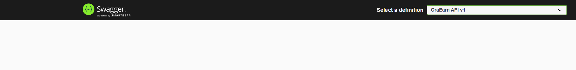
Figure 12. DEF-03 as found: 'Failed to load API definition - Internal Server Error /swagger/v1/swagger.json'. The API log named the cause: [FromForm] used with IFormFile on AuthController.Register.

Review of the fixes
Written by: Dharma Bahadur Budhathoki (S395172) - Scrum Master and lead developer
I read the three fixes before I accepted them, using the rules in section 4.5. The checks live in the services and throw ArgumentException, and the controller turns that into a 400. That is already how JobService works, so I did not want a second style of error. The Swagger change is only a binding attribute, and the 6 MB upload limit is still there. The Program.cs change still creates the database on a first run. It only waits when two starts hit the database at the same time. The diff is 532 lines added and 10 removed across 10 files, and nearly all of the new lines are tests.

8.6 Requirements coverage and traceability
Written by: Jenish Gurung (S395321) - Requirements analyst
I mapped Krishna's test IDs to the requirement modules in docs/OraEarn-Requirements.md and my Week 8 traceability matrix, to give the next team a picture of which requirements are supported by evidence and which are not.

Requirement module | Covered by | Coverage
1.1 Authentication and users (FR-1.1 to 1.7) | TC-AUTH-01 to 05, TC-REG-01 to 03, TC-ADM-01 to 02, API-09 to 12, existing AuthApiTests | Full
1.2 Jobs (FR-2.1 to 2.5) | Existing JobsApiTests and JobServiceValidationTests, API-06 | Full
1.3 Shifts (FR-3.1 to 3.10) | API-06 to 08, ShiftCalculateTests, TC-VISA-01. Clock-in/out and SignalR not executed | Partial - 3.4 to 3.6 and 3.9 open
1.4 Visa compliance (FR-4.1 to 4.4) | UT-01 to 06, TC-VISA-01 to 03 | Full
1.5 Expenses (FR-5.1 to 5.7) | UT-07 to 12, API-01 to 05, TC-EXP-01 to 04 | Full
1.6 Savings goals (FR-6.1 to 6.6) | SavingsGoalLogicTests, TC-GOAL-01. Create, contribute, and 100% warning not automated | Partial
1.7 Analytics (FR-7.1 to 7.6) | UserAnalyticsBuilderTests, TC-AUTH-01, TC-ADM-03, TC-PERF-01 | Full (export not checked)
1.8 Notifications (FR-8.1 to 8.5) | UT-06, TC-NOTIF-01 to 02 | Partial - no automated API test
1.9 Aura (FR-9.1 to 9.3) | TC-ADM-01 covers the offline fallback only | Open - needs Python
NFR security (NFR-2.1 to 2.7) | TC-SEC-01 to 06, TC-REG-02, UT-09, UT-12 | Full for 2.1 to 2.6; 2.7 is production only
NFR performance (NFR-1.1, 1.2) | TC-PERF-01 to 02 | Spot-checked on one machine

8.7 How to repeat this testing
Written by: Krishna Sapkota (S395795) - Tester
- Run dotnet test backend\OraEarn.Api.Tests\OraEarn.Api.Tests.csproj - expect 49 passed once the section 8.8 patch is applied (25 on an unpatched main). No database is needed.
- In frontend, run npm run lint (expect 0 errors) and npm run build.
- Start PostgreSQL, the API, and the frontend as in section 2.9, then work through the table in 8.4 with the demo accounts. Run TC-SEC-06 last: it locks carol@oraearn.local for 15 minutes.
- To reset to a clean state, drop the oraearn database and restart the API; it recreates and reseeds everything.

8.8 Where the new tests and fixes are
The new tests and the three fixes are saved as one patch next to this report, at Assessment4/code-changes/krishna-testing-and-defect-fixes.patch, so the team can review the change before it enters main. Copy the patch into the root of the team repository (the folder containing backend and frontend), apply it on a branch, and open a pull request:
git switch -c test/handover-tests-and-fixes
git apply --check krishna-testing-and-defect-fixes.patch
git apply krishna-testing-and-defect-fixes.patch
dotnet test backend/OraEarn.Api.Tests/OraEarn.Api.Tests.csproj
git add backend
git commit -m "test: add 24 tests; fix expense validation, Swagger upload binding, settings copy race"

9. Application walkthrough - screenshots with comments
Screenshots captured by Krishna Sapkota (S395795) on 13 October 2026 from the running application. Each comment is written by the member whose role owns that part.
These screens follow the demo path in the sprint plan: a pending user is refused, a student worker hits the visa rule, money is tracked, and the admin approves the pending user. Figures 7 to 9 in section 2.9 show the login page, dashboard, and Swagger.
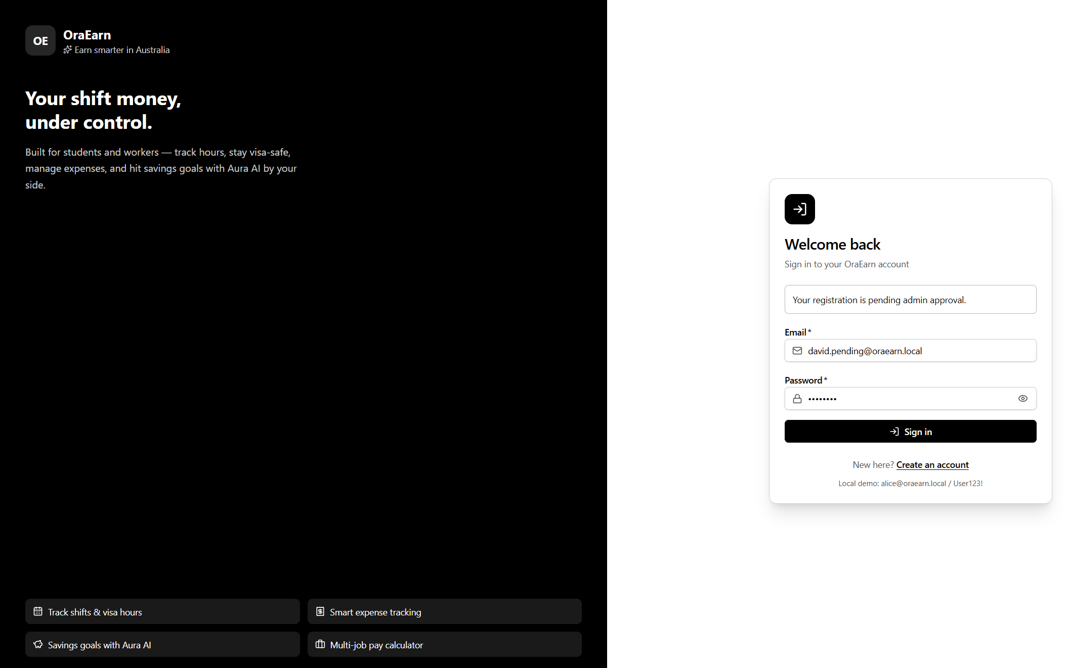
Figure 13. Pending user refused (TC-AUTH-02). Comment (Jenish): this is NFR-7.3 - admin approval is required before a new user can access the system. The message tells the user why, instead of a generic login failure.
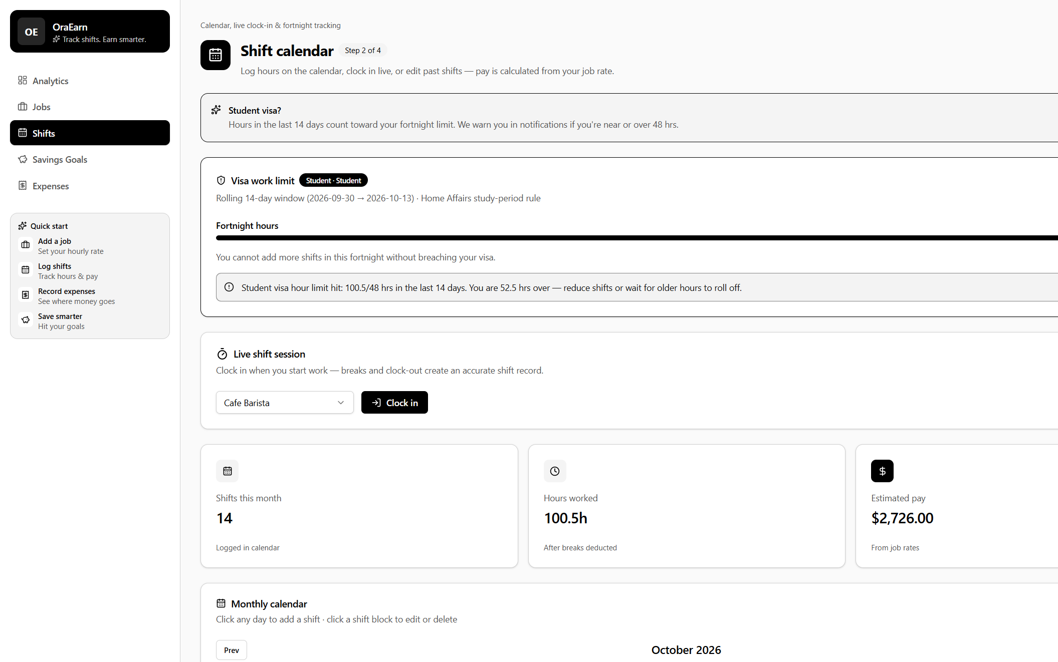
Figure 14. Shift calendar for a student-visa user. Comment (Dharma): the visa panel, the live clock-in bar, and the monthly summary all read from the same ShiftService and VisaComplianceService data, so they cannot disagree.
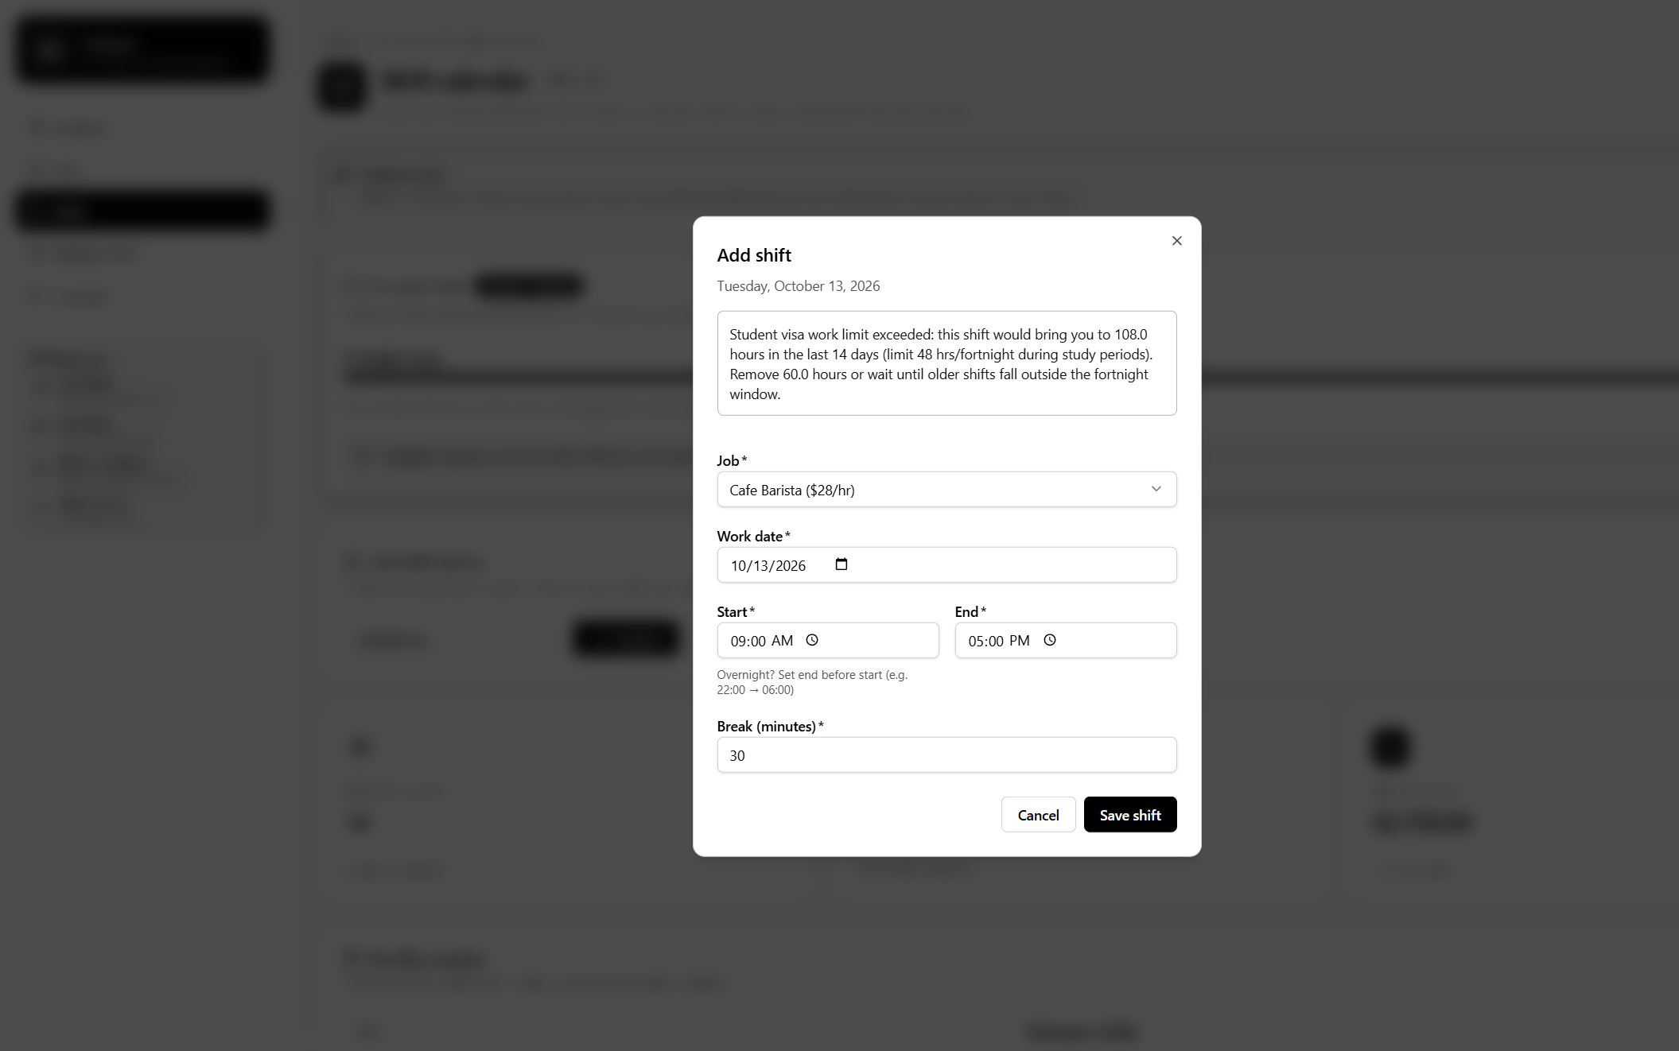
Figure 15. 48-hour rule enforced on save (TC-VISA-01). Comment (Krishna): the server rejects the shift, not just the form - the API returns 400 and the dialog keeps the user's input with the reason, which satisfies NFR-4.2.
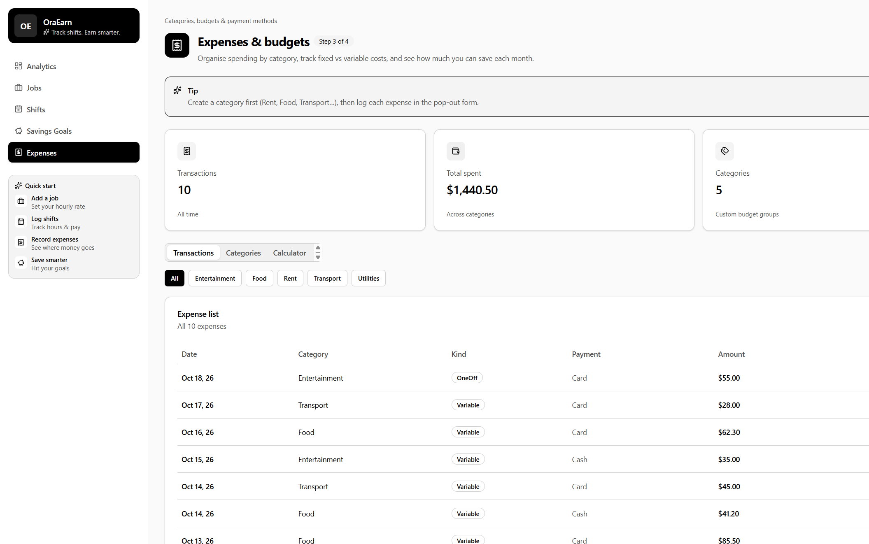
Figure 16. Expenses with category filters (TC-EXP-03). Comment (Krishna, DBA): the payment method column comes from the shared PaymentMethods lookup table introduced by the third normal form migration.
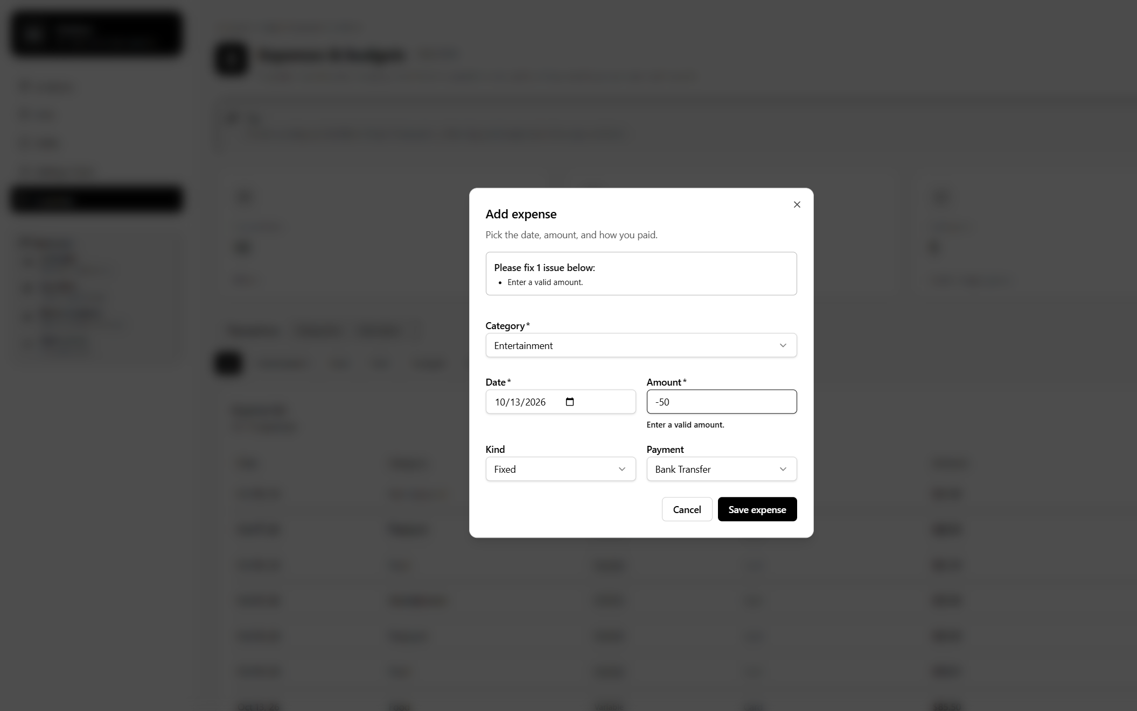
Figure 17. Client-side validation (TC-EXP-01). Comment (Krishna): the form already blocked -50, which is why DEF-02 was invisible in normal use. The API now enforces the same rule, so the data stays valid whichever client calls it.
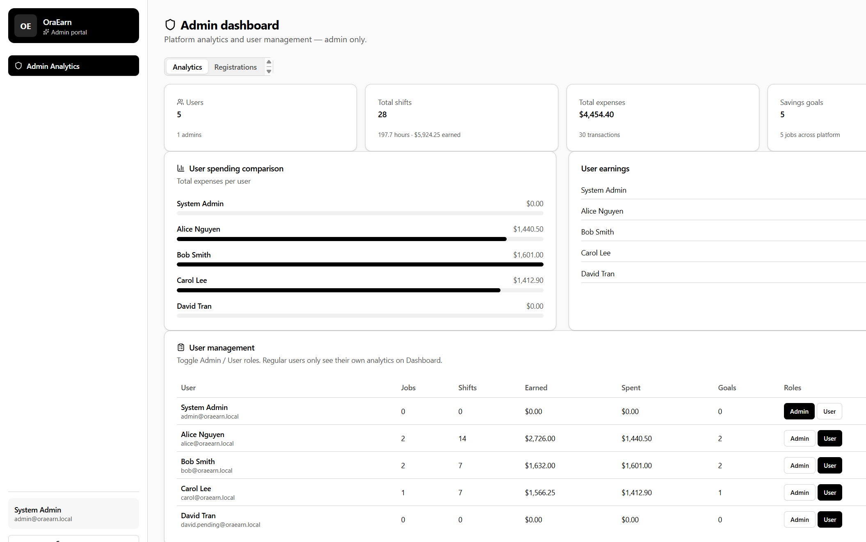
Figure 18. Admin dashboard (TC-ADM-03). Comment (Jenish): this covers FR-7.6 and NFR-8.1 - platform-wide analytics and role assignment, visible only to the Admin role.
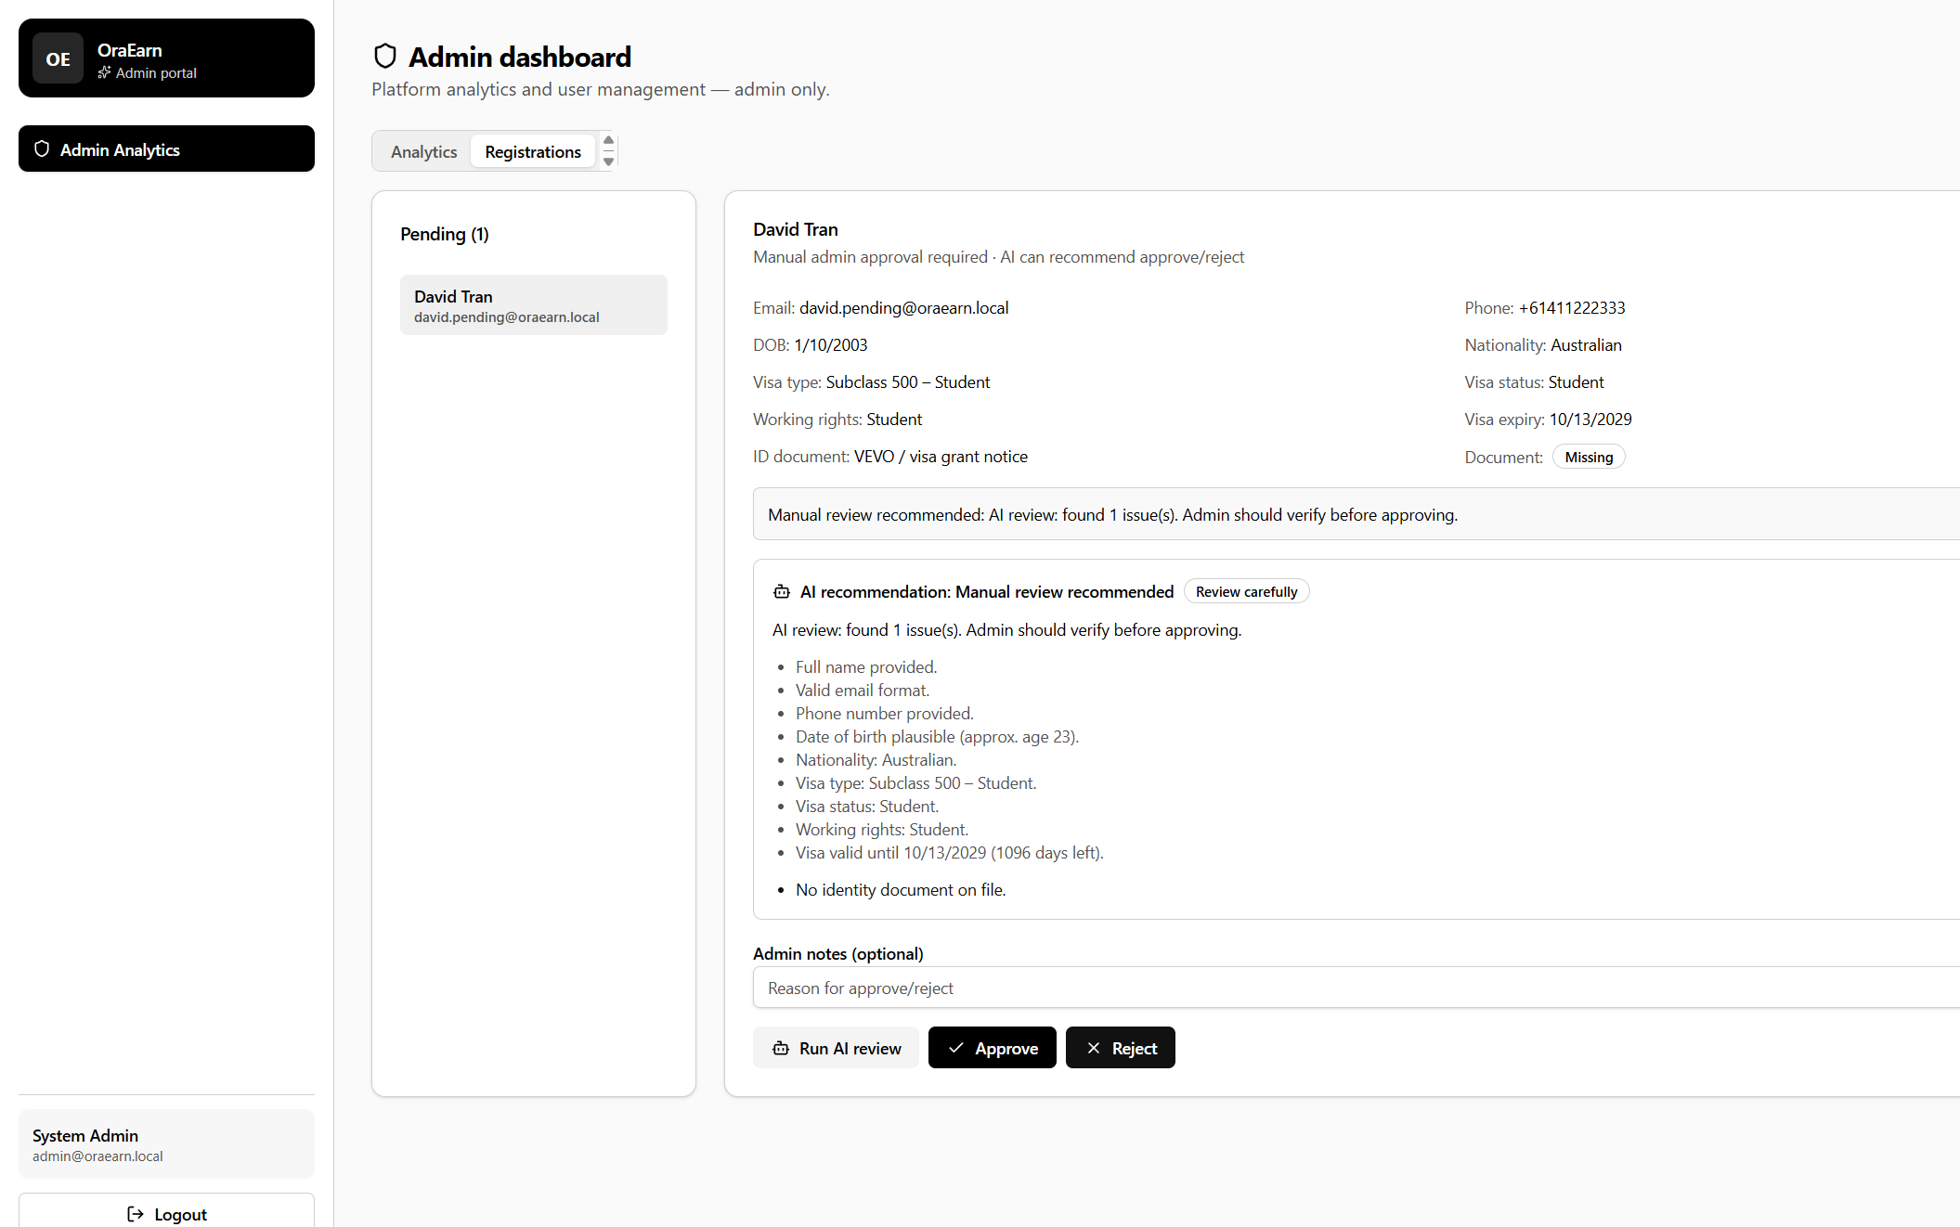
Figure 19. AI registration review with Aura offline (TC-ADM-01). Comment (Dharma): RegistrationApprovalAdvisorService fell back to its local rules, so the admin still got a checklist and a flag for the missing ID document. The final decision stays manual.
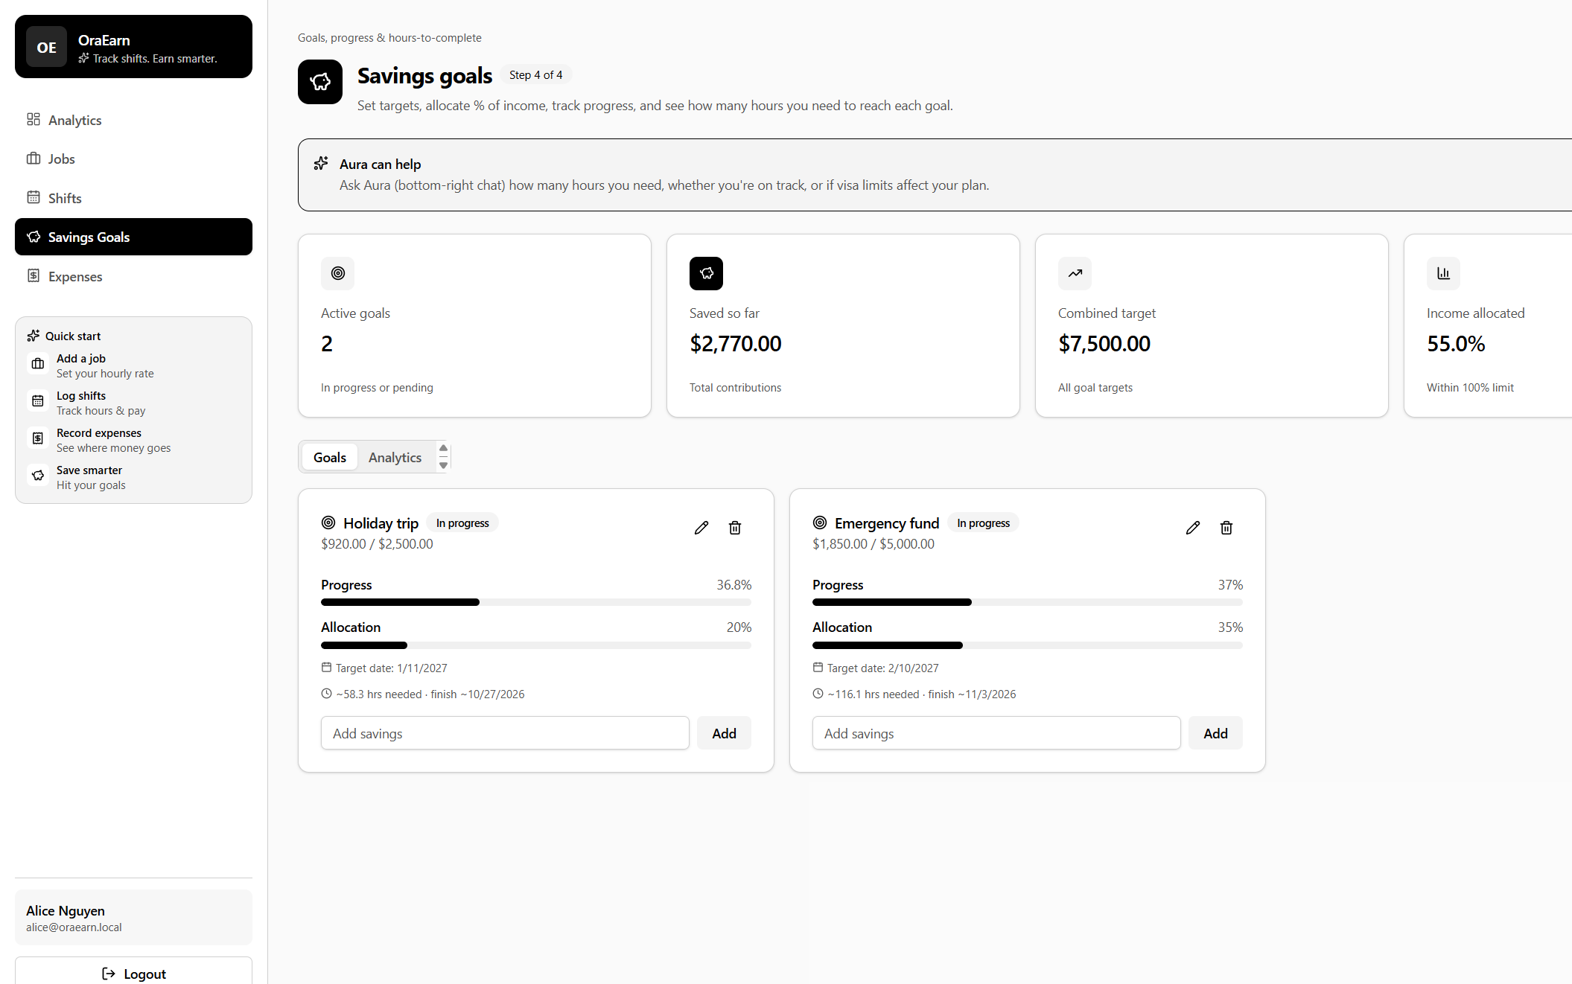
Figure 20. Savings goals (TC-GOAL-01). Comment (Jenish): FR-6.4 and FR-6.5 - progress, remaining amount, and the hours of work needed to reach each goal, calculated from the user's job rates.
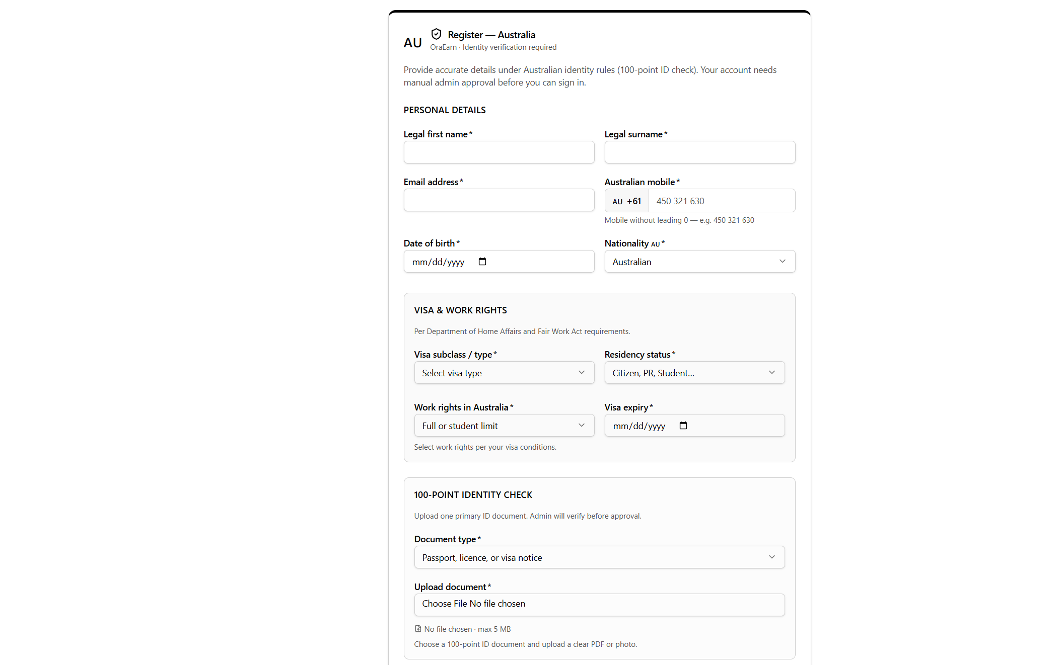
Figure 21. Registration form (TC-REG-03). Comment (Jenish): the form captures every field NFR-7.2 lists - visa type, residency status, work rights, and expiry - plus the identity document the admin reviews.

References
Compiled by: Jenish Gurung (S395321) - Business analyst. APA 7th style.
Group 4. (2026). PRT_681_SYDNEY_GROUP-4 [Source code]. https://github.com/itsmekrishnaaaaaa/PRT_681_SYDNEY_GROUP-4
Group 4. (2026). EARN board [Project board]. https://students-team-dh8zehye.atlassian.net/jira/core/projects/EARN/board
Atlassian. (n.d.). Jira Software Cloud support. Retrieved 15 October 2026, from https://support.atlassian.com/jira-software-cloud/
Conventional Commits. (n.d.). Conventional Commits 1.0.0. Retrieved 15 October 2026, from https://www.conventionalcommits.org/en/v1.0.0/
FastAPI. (n.d.). FastAPI documentation. Retrieved 15 October 2026, from https://fastapi.tiangolo.com/
Fowler, M. (2015). MonolithFirst. https://martinfowler.com/bliki/MonolithFirst.html
Jones, M., Bradley, J., & Sakimura, N. (2015). JSON Web Token (JWT) (RFC 7519). Internet Engineering Task Force. https://datatracker.ietf.org/doc/html/rfc7519
Meta Platforms. (n.d.). React documentation. Retrieved 15 October 2026, from https://react.dev
Microsoft. (n.d.-a). ASP.NET Core documentation. Retrieved 15 October 2026, from https://learn.microsoft.com/aspnet/core
Microsoft. (n.d.-b). Entity Framework Core documentation. Retrieved 15 October 2026, from https://learn.microsoft.com/ef/core
Microsoft. (n.d.-c). Dependency injection in ASP.NET Core. Retrieved 15 October 2026, from https://learn.microsoft.com/aspnet/core/fundamentals/dependency-injection
Microsoft. (n.d.-d). Overview of ASP.NET Core SignalR. Retrieved 15 October 2026, from https://learn.microsoft.com/aspnet/core/signalr/introduction
Microsoft. (n.d.-e). Introduction to Identity on ASP.NET Core. Retrieved 15 October 2026, from https://learn.microsoft.com/aspnet/core/security/authentication/identity
OWASP Foundation. (n.d.). OWASP cheat sheet series. Retrieved 15 October 2026, from https://cheatsheetseries.owasp.org/
PostgreSQL Global Development Group. (n.d.). PostgreSQL documentation. Retrieved 15 October 2026, from https://www.postgresql.org/docs/
Tailwind Labs. (n.d.). Tailwind CSS documentation. Retrieved 15 October 2026, from https://tailwindcss.com/docs
Tertiary Education Quality and Standards Agency. (2023). Student visa holder work restrictions. https://www.teqsa.gov.au/about-us/news-and-events/latest-news/student-visa-holder-work-restrictions
Vite. (n.d.). Vite documentation. Retrieved 15 October 2026, from https://vite.dev/guide/
xUnit.net. (n.d.). xUnit.net documentation. Retrieved 15 October 2026, from https://xunit.net/

Appendix A. Full commit history
Generated with git log --pretty=format:"%h | %an | %ad | %s" --date=short on branch main. 78 commits, newest first. Format: short hash | author | date | message.
b965e23 | Dharma001 | 2026-10-16 | added read me
74fdfc7 | Dharma001 | 2026-10-16 | added report and fixed the report formates
5efd631 | Dharma001 | 2026-10-16 | added week 12 time sheet
e2756cd | Dharma001 | 2026-10-16 | added indivisual meeting week11
79823a5 | Dharma001 | 2026-10-16 | fixed docs
8f64849 | Dharma001 | 2026-10-16 | Merge remote changes
c21681b | Dharma001 | 2026-10-16 | added :resume
576e465 | Dharma001 | 2026-10-13 | feat:updated home page and style with backed improvemenst
6631be9 | krishna sapkota | 2026-10-13 | Add files via upload
4f87c55 | krishna sapkota | 2026-10-13 | Add files via upload
0bdbc6c | krishna sapkota | 2026-10-13 | Delete Individual_timesheet_Krishna_S395795.xlsx
f94b646 | krishna sapkota | 2026-10-06 | Add files via upload
b8a5f2e | krishna sapkota | 2026-10-06 | Add files via upload
92a8f82 | krishna sapkota | 2026-10-06 | Add files via upload
99497f1 | krishna sapkota | 2026-10-06 | Add files via upload
4e4c989 | krishna sapkota | 2026-10-06 | Add files via upload
0dfe252 | krishna sapkota | 2026-09-29 | Delete Individual_timesheet_Krishna_S395795_Timesheet_Weeks_4-8.xlsx
22dd501 | krishna sapkota | 2026-09-29 | Add files via upload
220471c | krishna sapkota | 2026-09-29 | Add files via upload
fd165be | krishna sapkota | 2026-09-29 | Add files via upload
dad0890 | krishna sapkota | 2026-09-29 | Create ok
59a9e2b | krishna sapkota | 2026-09-29 | Delete Krishna_sapkota_S395795/Week-6
cd3d587 | krishna sapkota | 2026-09-29 | Create Week-6
2956838 | krishna sapkota | 2026-09-29 | Delete Individual_timesheet_Krishna_S395795_Timesheet.xlsx
f4f5cb1 | krishna sapkota | 2026-09-29 | Add files via upload
86e00e1 | Dharma001 | 2026-09-28 | feat:updated documents (timesheet proff of work ) with app fronted features
d4d5b91 | Dharma Bahadur Budhathoki | 2026-09-18 | Merge pull request #3 from itsmekrishnaaaaaa/app-s395172
3603d85 | Dharma001 | 2026-09-18 | feat: added week 8 time sheet
edb54f1 | Dharma Bahadur Budhathoki | 2026-09-18 | Merge pull request #2 from itsmekrishnaaaaaa/app-s395172
b6bbc20 | Dharma001 | 2026-09-18 | fix: fixed curd ui of bobs expeosnees and saving goals made it more userfriendly
c523e0b | Dharma001 | 2026-09-18 | feat: addded password see button on login page
a5ae67d | Dharma001 | 2026-09-18 | feat: fixed reponsive of application
00ab4e2 | Dharma001 | 2026-09-18 | feat: changed color of in frontend centralized the color
aa8df40 | Jenish Gurung | 2026-09-17 | Add files via upload
dead2f3 | Jenish Gurung | 2026-09-17 | Create week8
020ea7a | Jenish Gurung | 2026-09-17 | Add files via upload
b24965d | Jenish Gurung | 2026-09-17 | Create week7
9aa5f3b | Dharma001 | 2026-09-15 | feat: updated timesheet
d60cba0 | Dharma001 | 2026-09-08 | feat: added application
6ace869 | Dharma001 | 2026-09-08 | feat: added application
5b8f040 | krishna sapkota | 2026-09-07 | Delete Krishna_sapkota_S395795/Week-5/readme.md
9c68758 | krishna sapkota | 2026-09-07 | Add files via upload
9730323 | krishna sapkota | 2026-09-07 | Create readme.md
7e4f86d | krishna sapkota | 2026-09-07 | Delete Krishna_sapkota_S395795/Week-5
9c2b339 | krishna sapkota | 2026-09-07 | Create Week-5
ef95f05 | krishna sapkota | 2026-09-07 | Add files via upload
99bead3 | Jenish Gurung | 2026-09-07 | Delete Jenish_Gurung_s395321/week6/week6
4d4c554 | Jenish Gurung | 2026-09-07 | added week6 reports for BA and RA
a01965f | Jenish Gurung | 2026-09-07 | Create week6
90c9d13 | Jenish Gurung | 2026-09-02 | Add files via upload
680e49e | Jenish Gurung | 2026-09-02 | Delete Jenish_Gurung_s395321/week5/OraEarn_UML_EndToEnd.png
65f5f81 | Dharma001 | 2026-09-01 | feat: added Auth Dto and User and started database connection setup
e9c023a | Jenish Gurung | 2026-09-01 | Add files via upload
8b235f7 | Jenish Gurung | 2026-09-01 | Delete Individual_Timesheets_-_Jenish_Gurung_S395321_.xlsx
088cb5a | Jenish Gurung | 2026-09-01 | Delete Jenish_Gurung_s395321/week5/now
784c55f | Jenish Gurung | 2026-09-01 | Add files via upload
34212d2 | Jenish Gurung | 2026-09-01 | Create week5
0445e9d | Jenish Gurung | 2026-08-26 | Add files via upload
26a3ad9 | Jenish Gurung | 2026-08-26 | Create week4
867ecd2 | Jenish Gurung | 2026-08-26 | Add files via upload
8d1afa2 | Jenish Gurung | 2026-08-26 | Create readme.txt
5a321a8 | Jenish Gurung | 2026-08-26 | Delete Jenish_Gurung_s395321
83cdae2 | Jenish Gurung | 2026-08-26 | Create Jenish_Gurung_s395321
826b599 | Jenish Gurung | 2026-08-26 | Delete Jenish_Gurung_s395321
f150024 | Jenish Gurung | 2026-08-25 | Create Jenish_Gurung_s395321
03bfdeb | Dharma001 | 2026-08-23 | feat:added week 5 reserch and work done screenshort proffs and individual meeting log
64bec00 | Dharma001 | 2026-08-23 | feat:added frontend and intalled required package (swagger, postgresh sql and enity framework
b7b6ed9 | krishna sapkota | 2026-08-17 | Add files via upload
14d1547 | krishna sapkota | 2026-08-17 | Add files via upload
43c05ed | krishna sapkota | 2026-08-17 | Delete Week-4/Week_04_Krishna_S395795_Timesheet.xlsx
2c26fa8 | krishna sapkota | 2026-08-17 | Delete Krishna_sapkota_S395795/week-5
46317c8 | krishna sapkota | 2026-08-17 | Delete Krishna_sapkota_S395795/Week-4/DBA
9c150a4 | krishna sapkota | 2026-08-17 | Create week-5
6f0f22c | krishna sapkota | 2026-08-17 | Add files via upload
4082349 | krishna sapkota | 2026-08-17 | Create DBA
d158a52 | Dharma001 | 2026-08-17 | moved timesheet
efdea1e | Dharma001 | 2026-08-17 | Added proposal , solution and problem with research on the tech stack
92d2397 | krishna sapkota | 2026-08-11 | first commit

Appendix B. Application screens
Written by: Dharma Bahadur Budhathoki (S395172) - Scrum Master and lead developer
These are the screens of the application I built, and my own timesheet. Each picture has the comment under it. Login, registration, the dashboard, jobs, shifts, expenses, and savings are here, on a wide screen and on a phone where I had both.
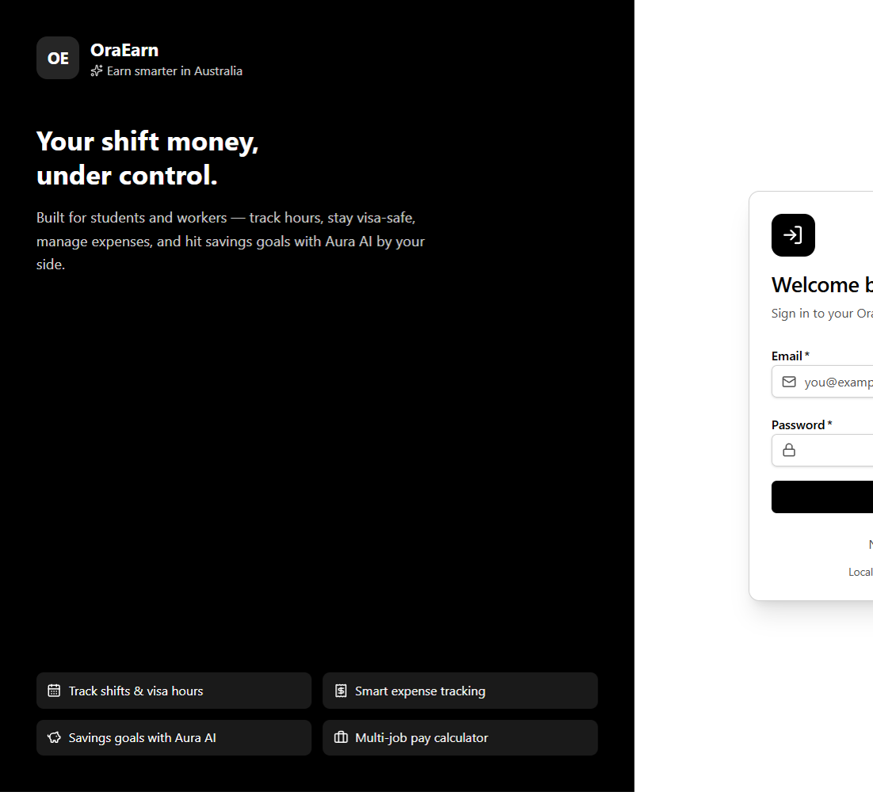
Figure 33. Login. This is the only public screen. The demo account is written under the button.
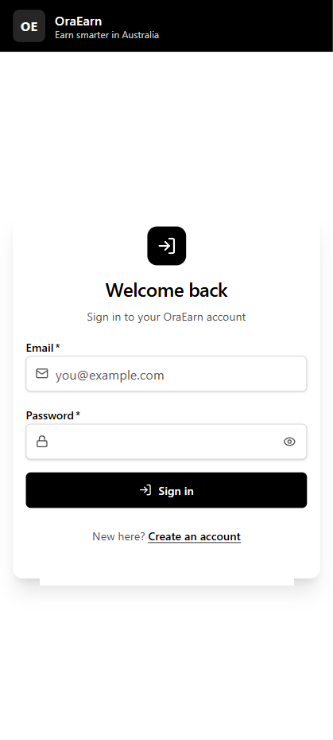
Figure 34. Show password on the login form. I added it so a user can check what they typed before signing in.
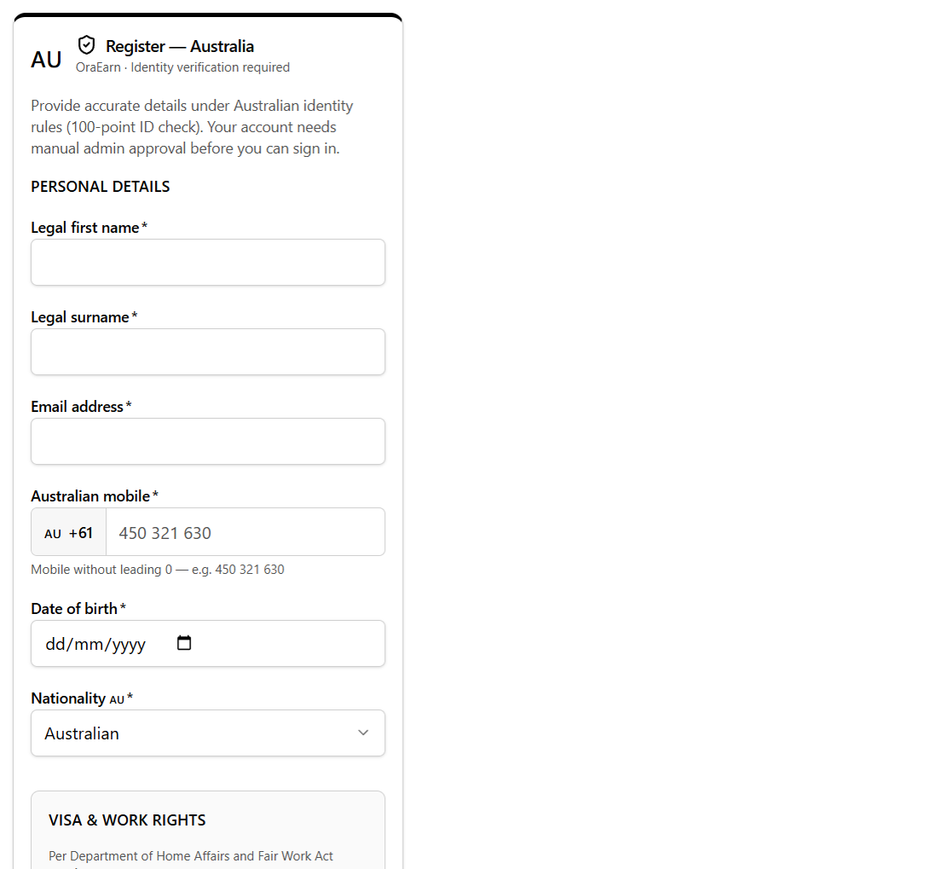
Figure 35. Registration. A new account stays pending until an administrator approves it.
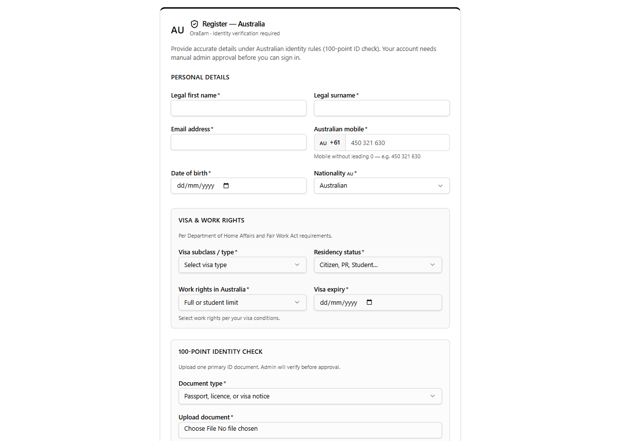
Figure 36. Visa fields on the registration form: visa type, work rights, expiry, and the document upload.
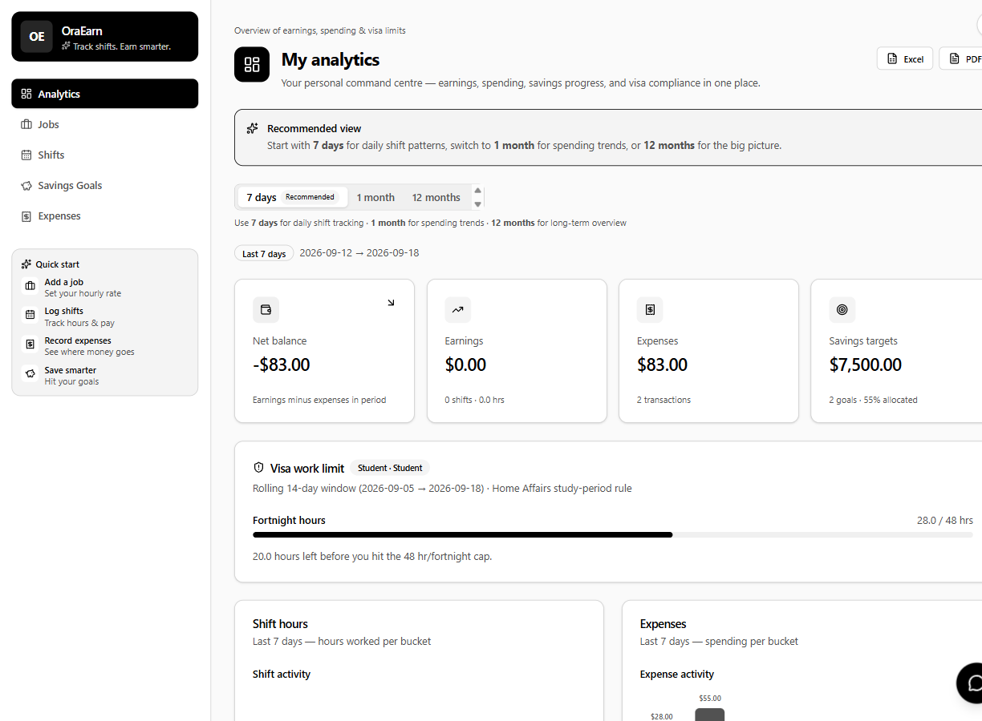
Figure 37. Dashboard for alice@oraearn.local. Earnings, expenses, savings, and the visa-hour panel are on one page.
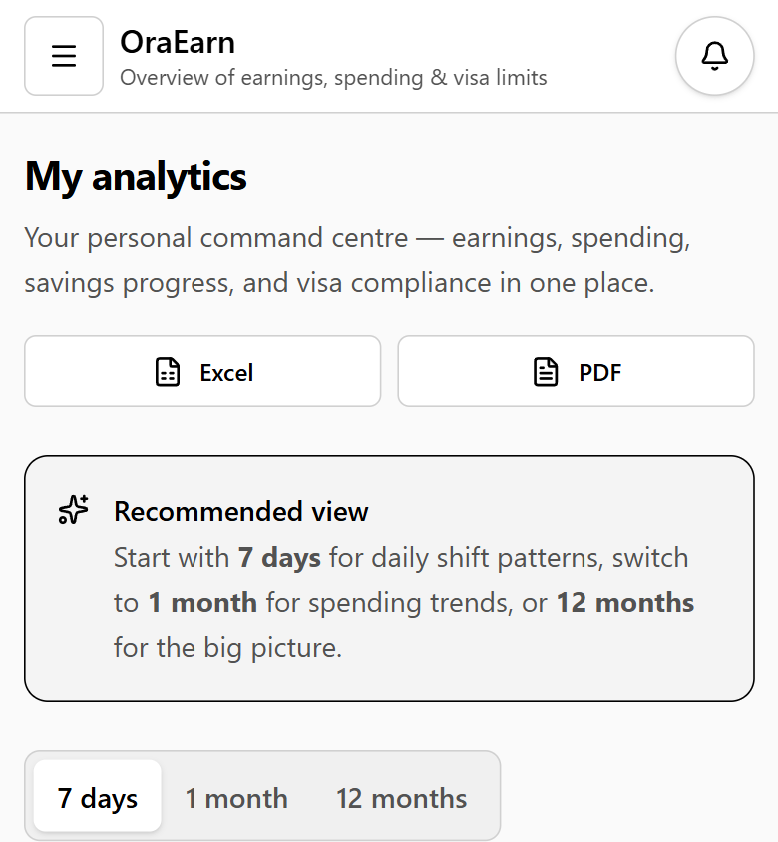
Figure 38. The same dashboard on a phone. The cards stack, and the menu is the button at the top.
Figure 39. Jobs on a wide screen. The hourly rate stored here is what a later shift is paid.
Figure 40. Jobs on a phone. Same screen, one column.
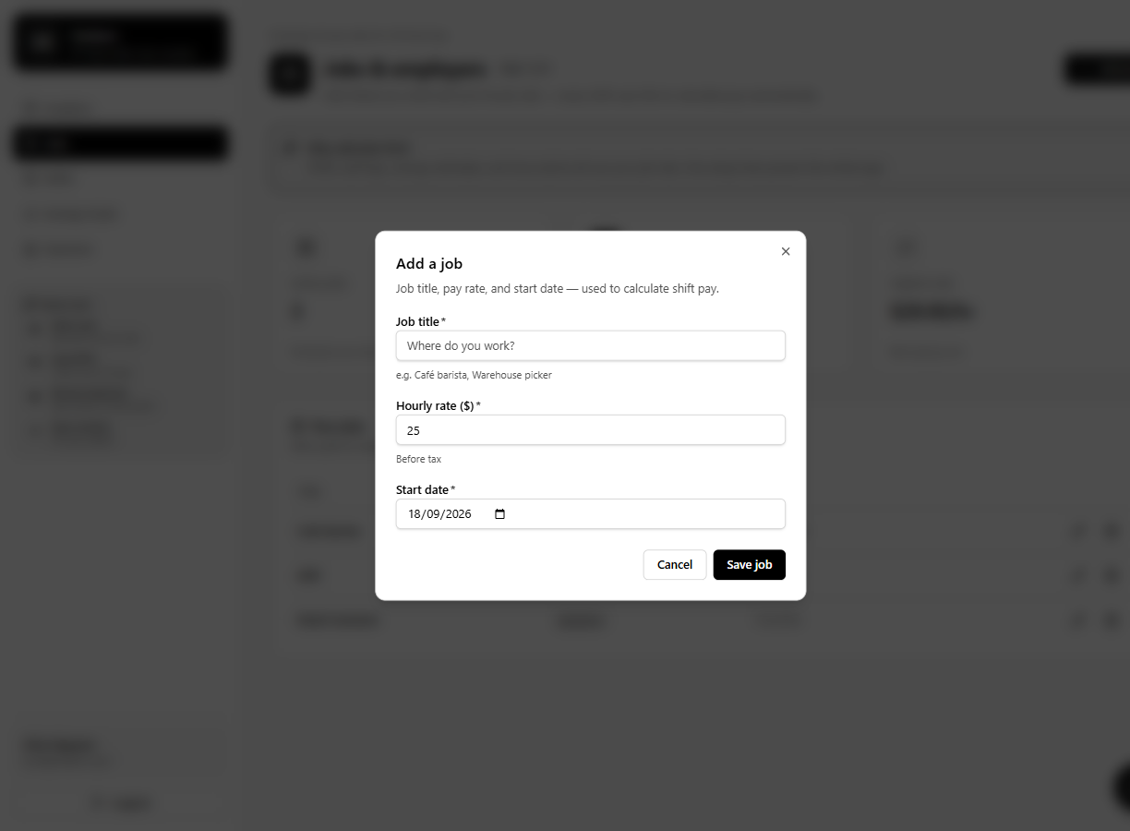
Figure 41. Add a job. Title, employer, and hourly rate. An empty rate does not save.
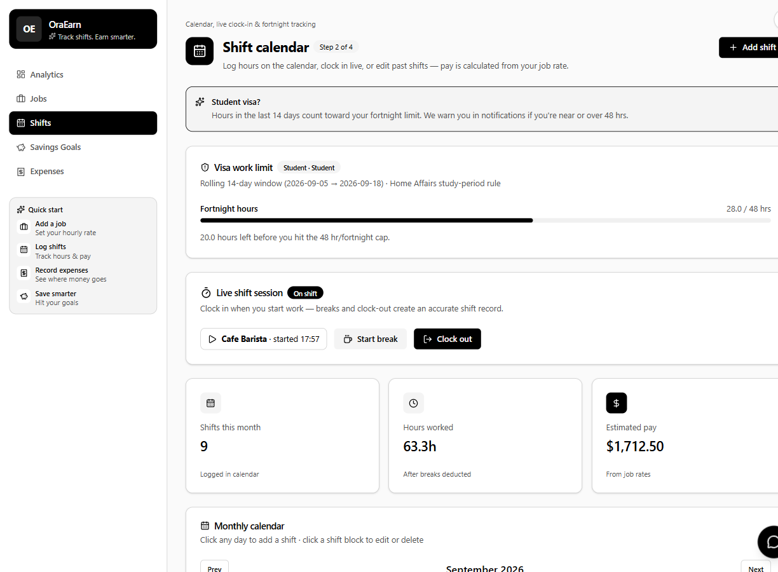
Figure 42. Shift calendar. The visa panel, the live clock-in, and the month summary read the same shifts.
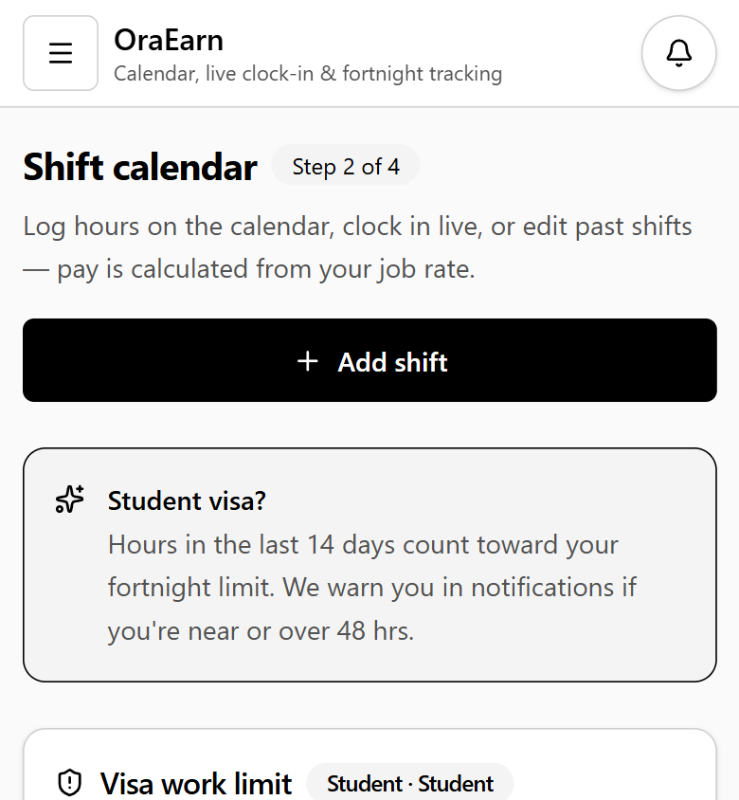
Figure 43. Shifts on a phone.
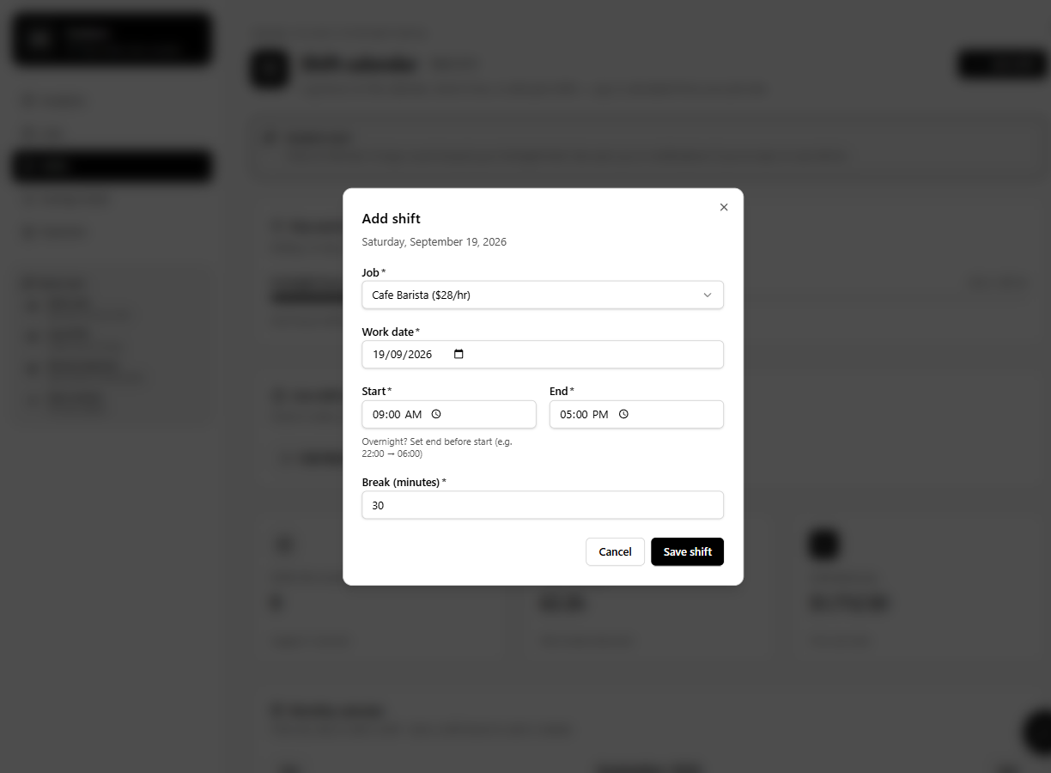
Figure 44. Logging a shift. A student-visa user who would pass 48 hours is rejected before the row is stored.
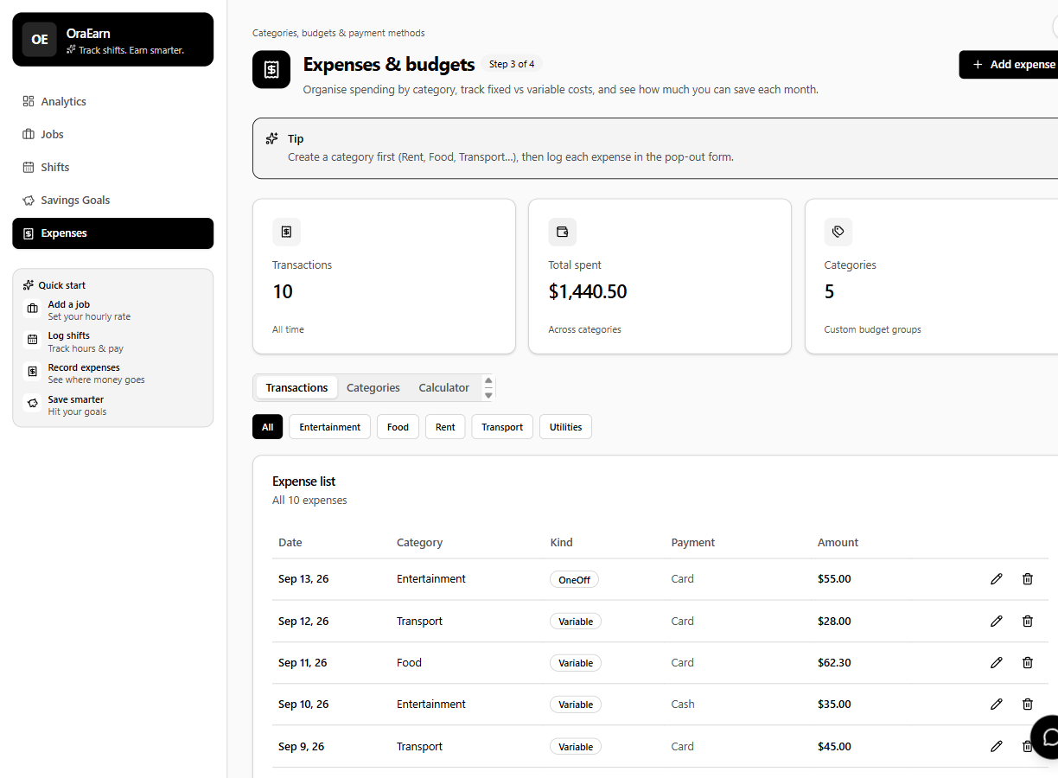
Figure 45. Expenses. Categories and payment methods come from the lookup tables, not free text.
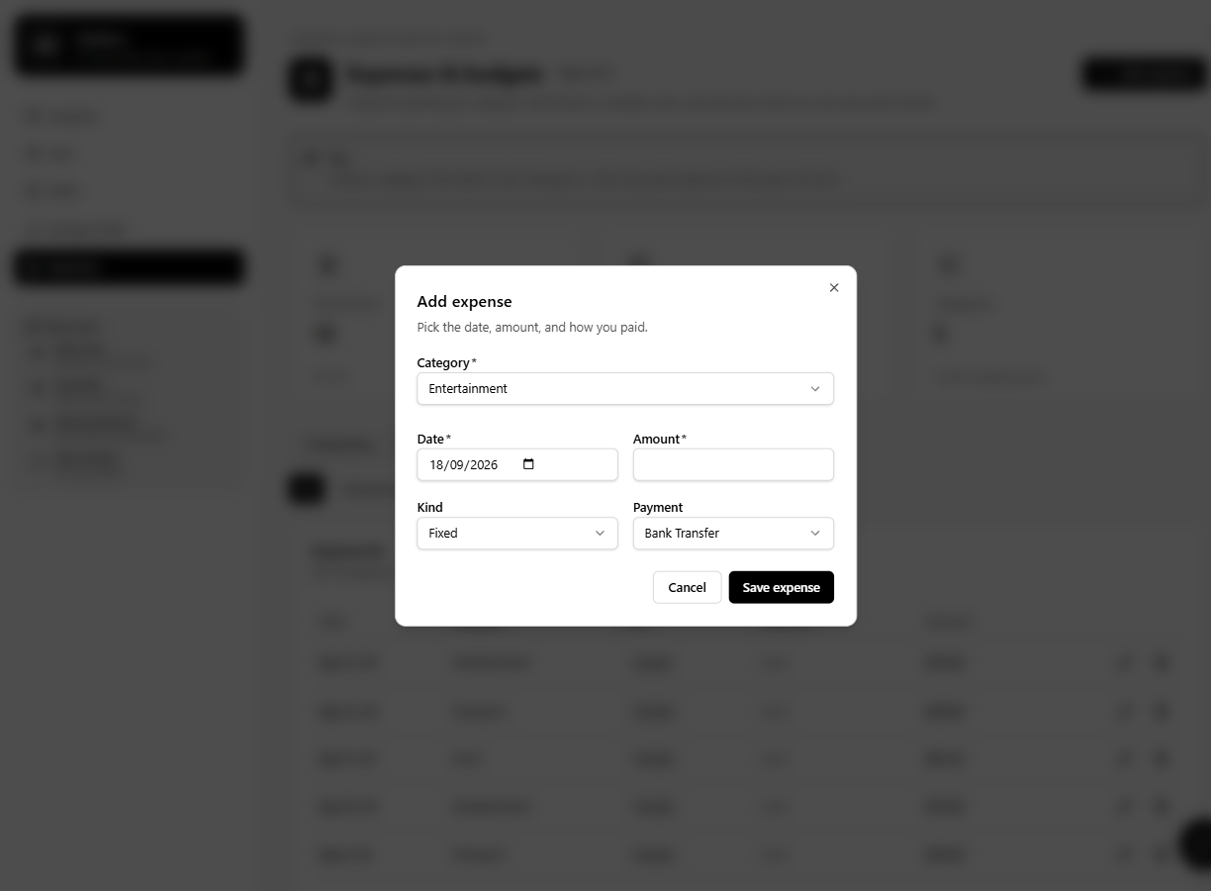
Figure 46. Add an expense. A negative amount is blocked on the form.
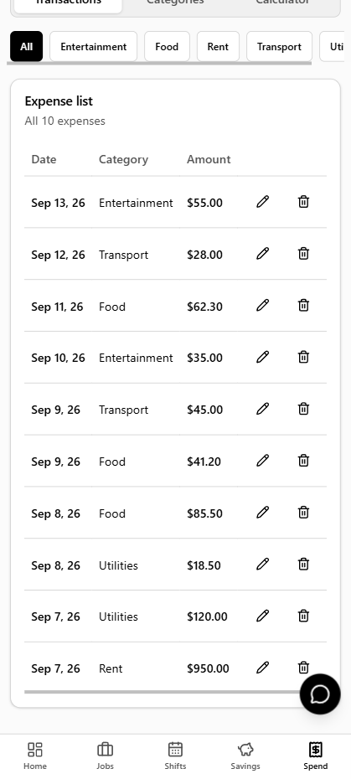
Figure 47. Expense list after the rows are saved. The category filter is on this screen.
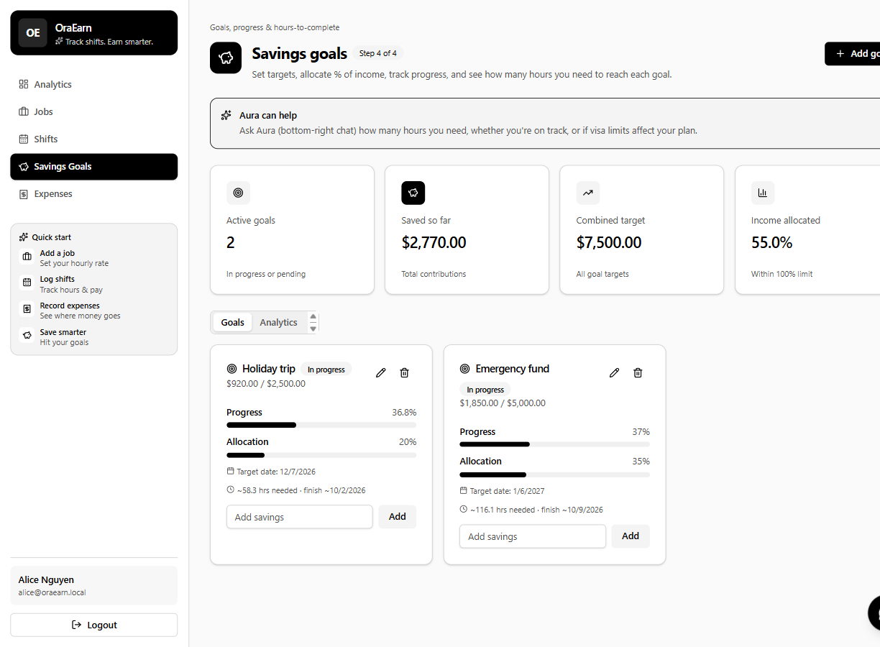
Figure 48. Savings goals. Each card shows progress and how much is still to save.
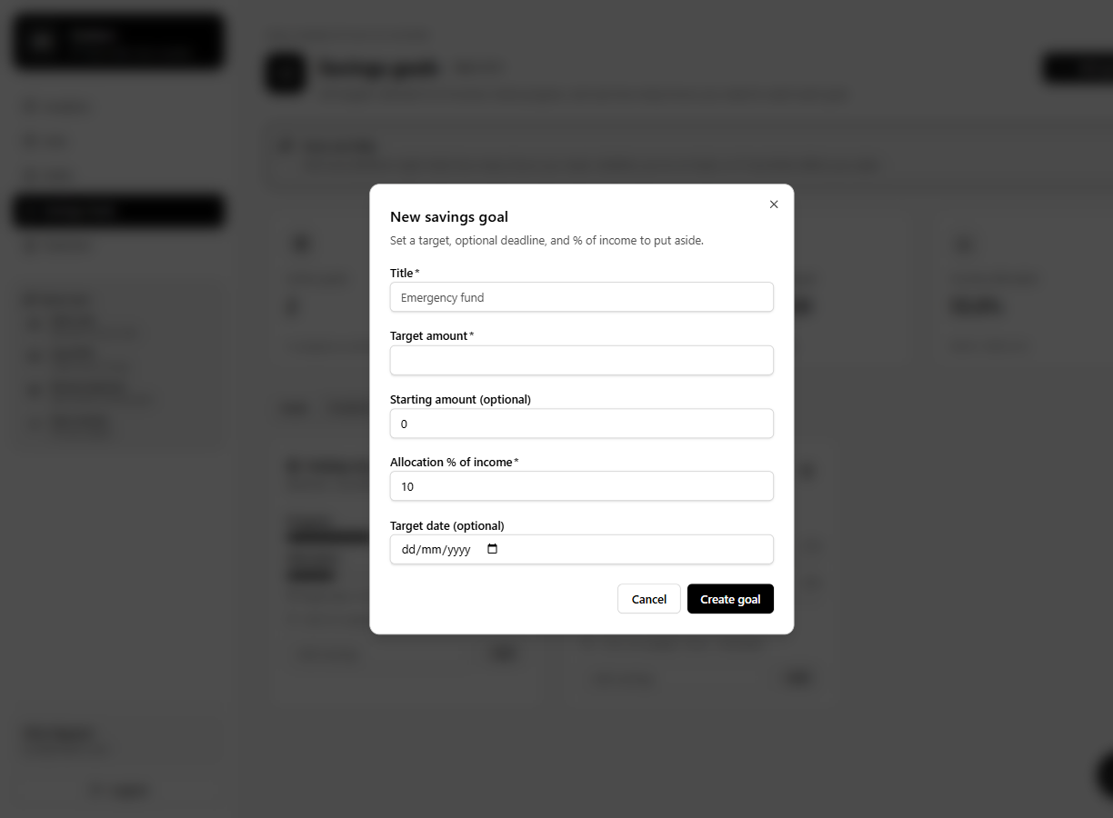
Figure 49. Add a savings goal. The name and the target amount are required.
Figure 50. My timesheet, Dharma Bahadur Budhathoki (S395172). Week 4 is 5.5 hours and each later week on this sheet is 6 hours. The workbook in my folder runs through week 12.

Appendix C. Code proof
Written by: Dharma Bahadur Budhathoki (S395172) - Scrum Master and lead developer
These shots are the source behind the screens in Appendix B. The database model is already Figure 32, so it is not repeated here.
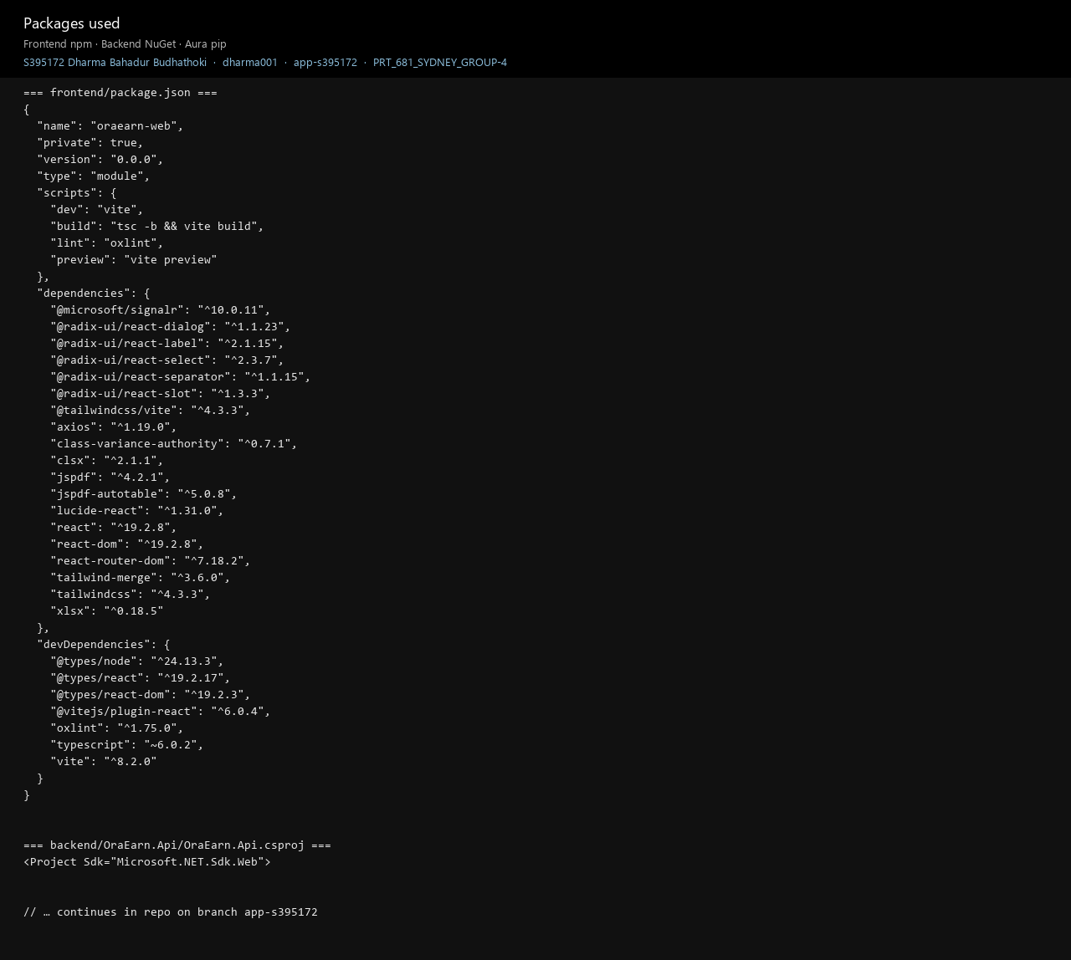
Figure 51. Packages used. Proof of the stack I installed. frontend/package.json lists React 19, Vite, Tailwind, Axios, and SignalR. The API project is an ASP.NET Core web SDK.
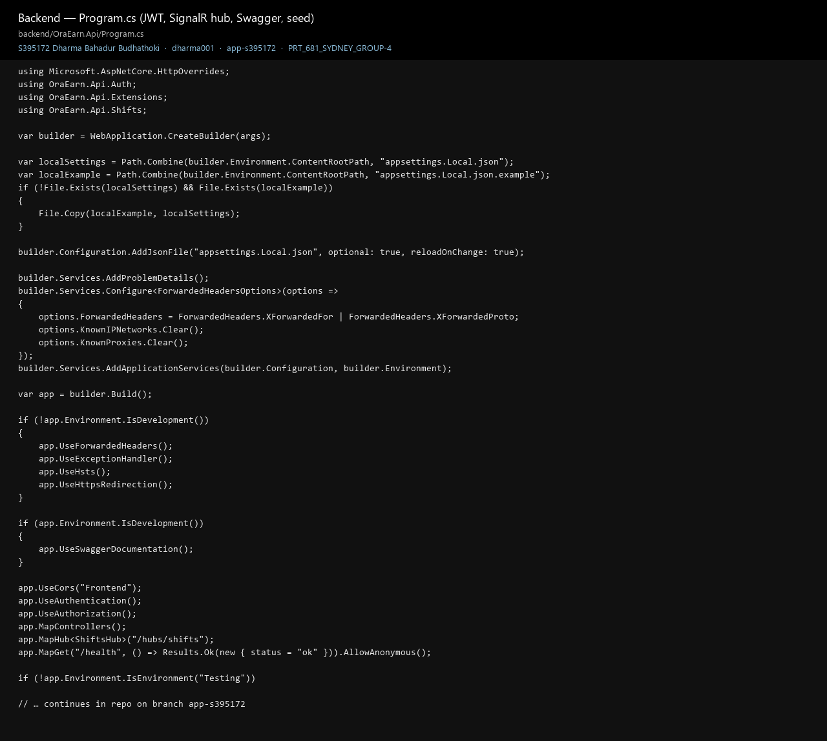
Figure 52. Program.cs, the API startup. Proof of how the parts are wired. Local settings are copied in if they are missing, the services are registered in one place, and the pipeline turns on CORS, authentication, the controllers, the SignalR hub at /hubs/shifts, and /health. Swagger is only switched on in Development.
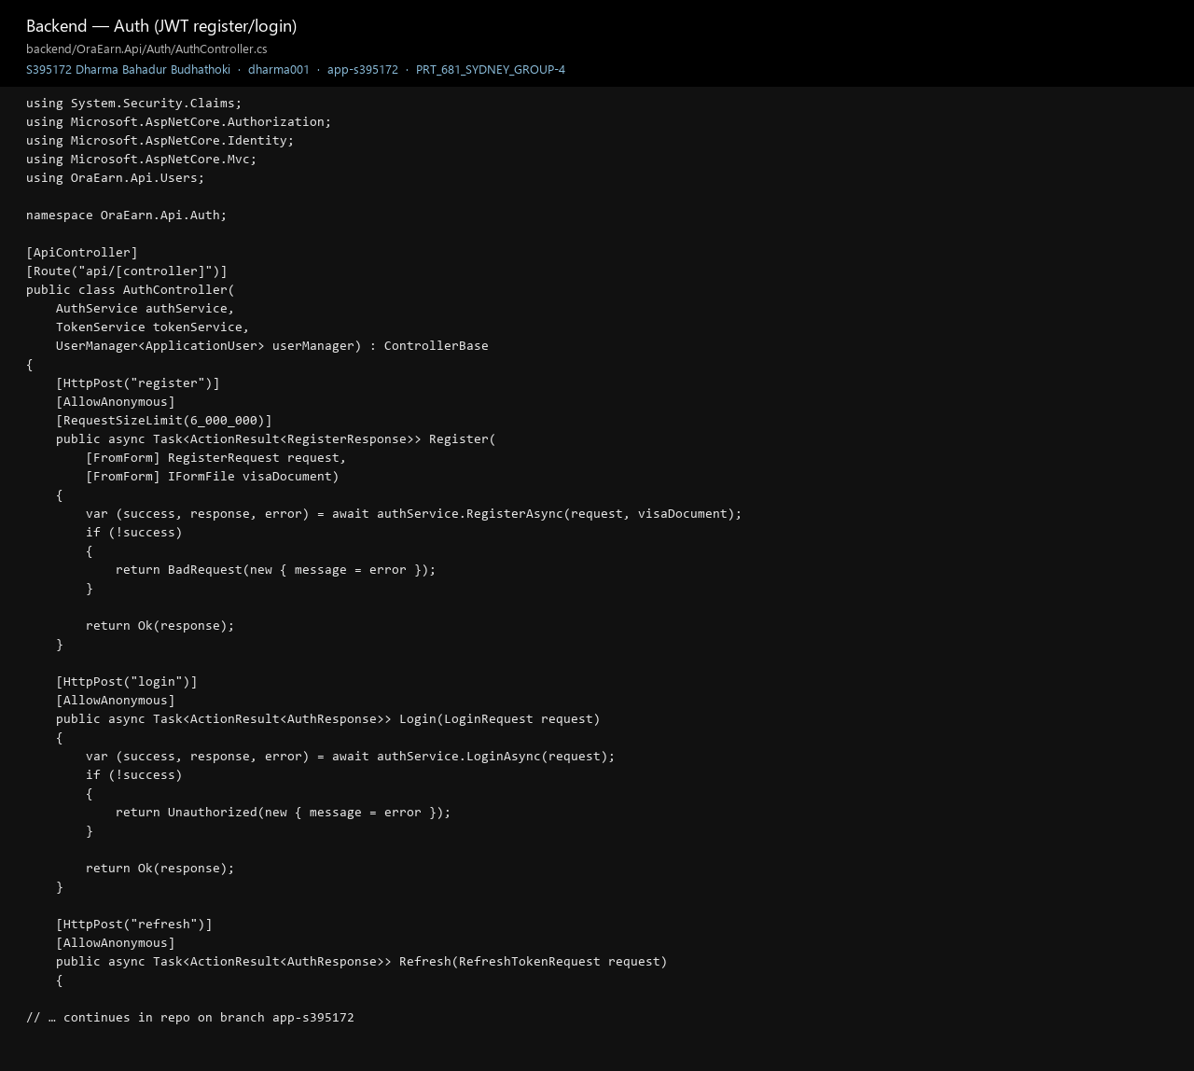
Figure 53. AuthController, register and login. Proof of the account gate. Register takes the form and the visa file, with a 6 MB limit. Login returns 401 when the account is not allowed in. The controller receives AuthService, TokenService, and UserManager through its constructor.
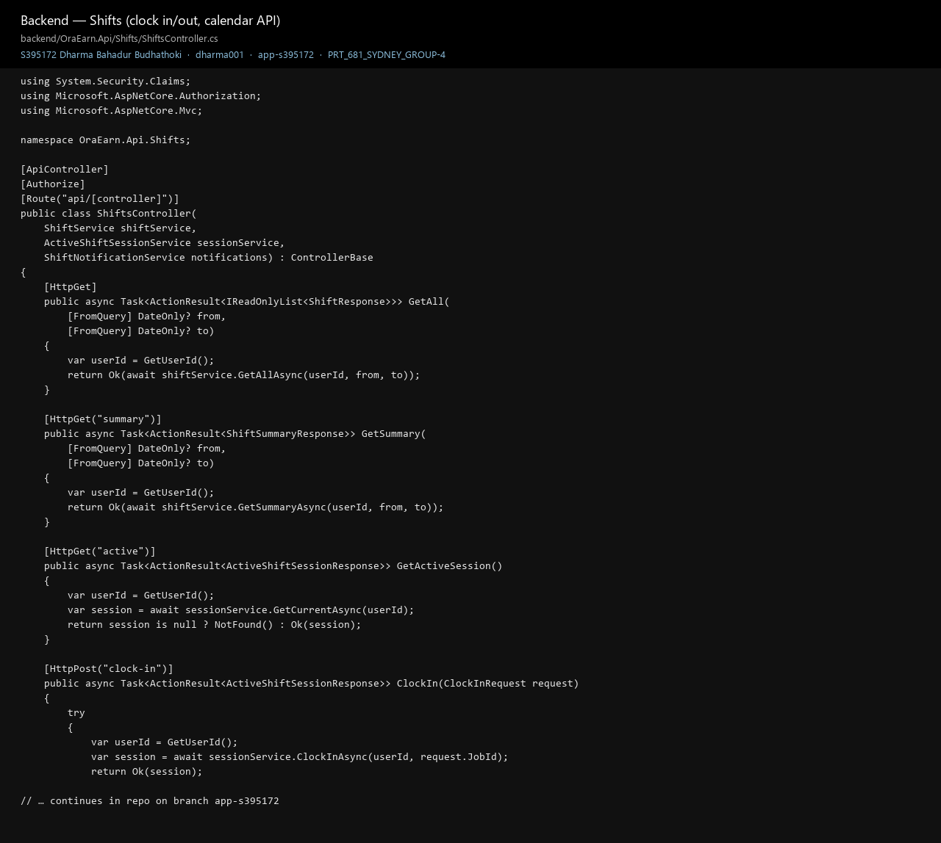
Figure 54. ShiftsController, clock-in and the calendar. Proof that shift actions require a signed-in user. The class is marked Authorize. The list, the summary, and clock-in take the user id from the token and pass it to ShiftService.
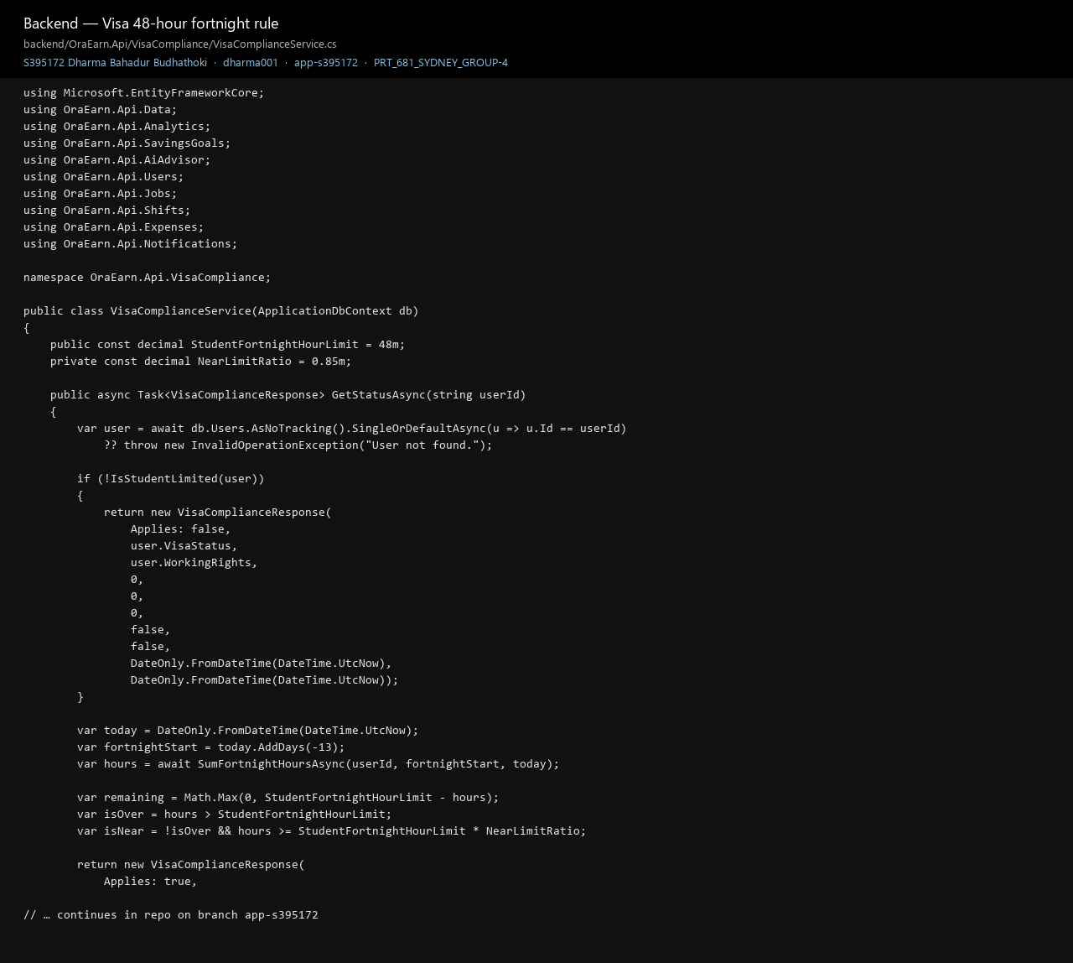
Figure 55. VisaComplianceService, the 48-hour rule. Proof the visa cap is in the service, not only on the form. StudentFortnightHourLimit is 48. A user who is not on a limited visa is told the rule does not apply.
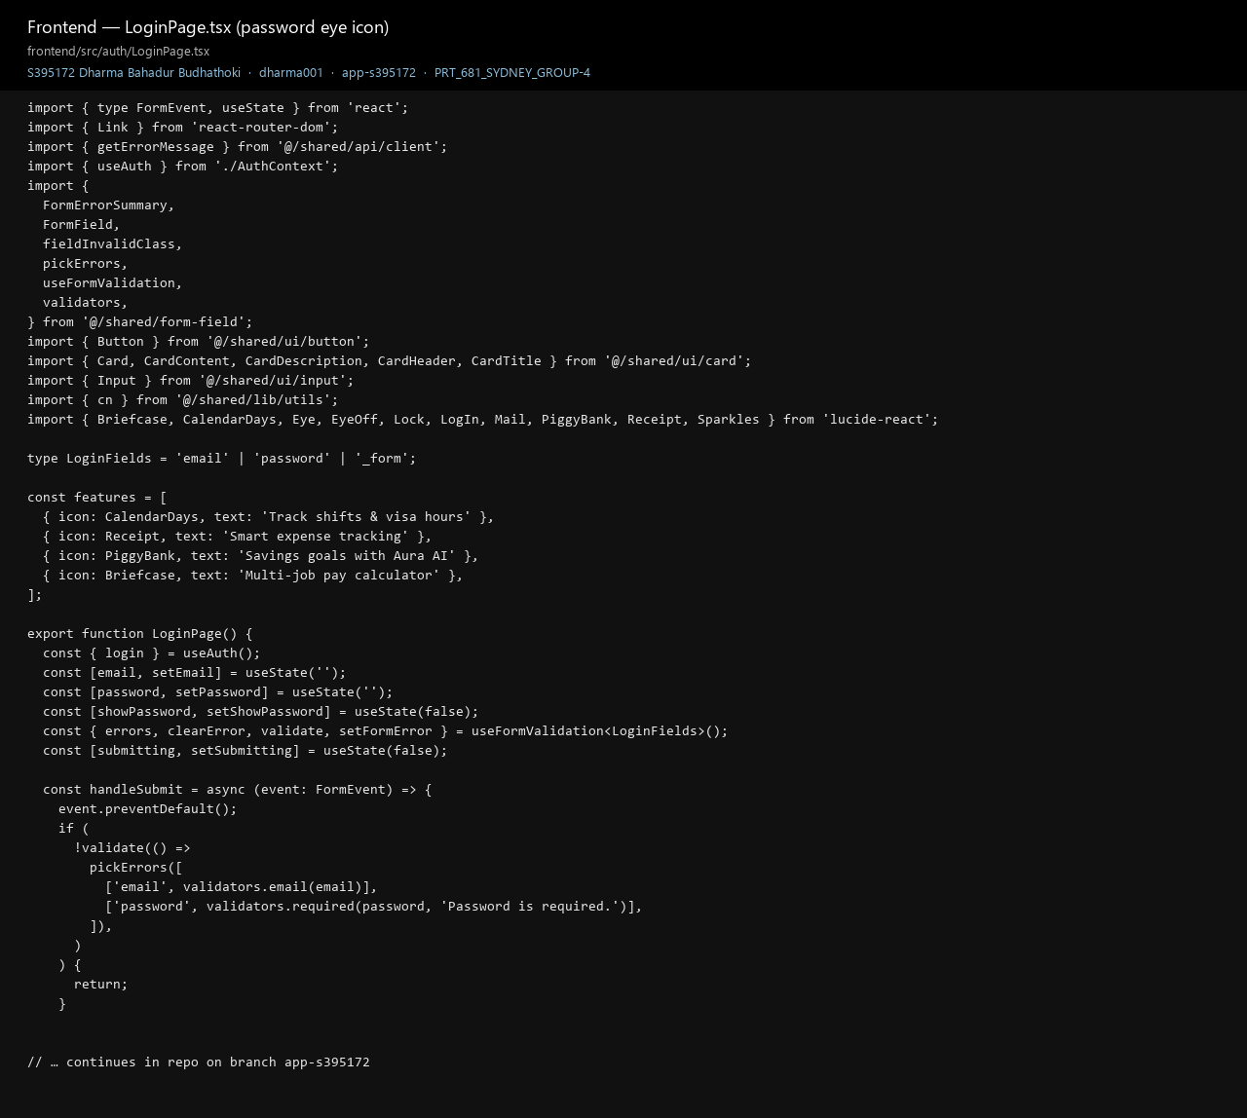
Figure 56. LoginPage.tsx, the show-password control. Proof of the login screen I built. The password state and the eye toggle live here, and the form checks that email and password are filled in before it calls login.

Appendix D. More proof
Written by: Dharma Bahadur Budhathoki (S395172) - Scrum Master and lead developer
These are extra shots of the running API, Aura, the demo data, and the shift rule. They sit with the code in Appendix C.
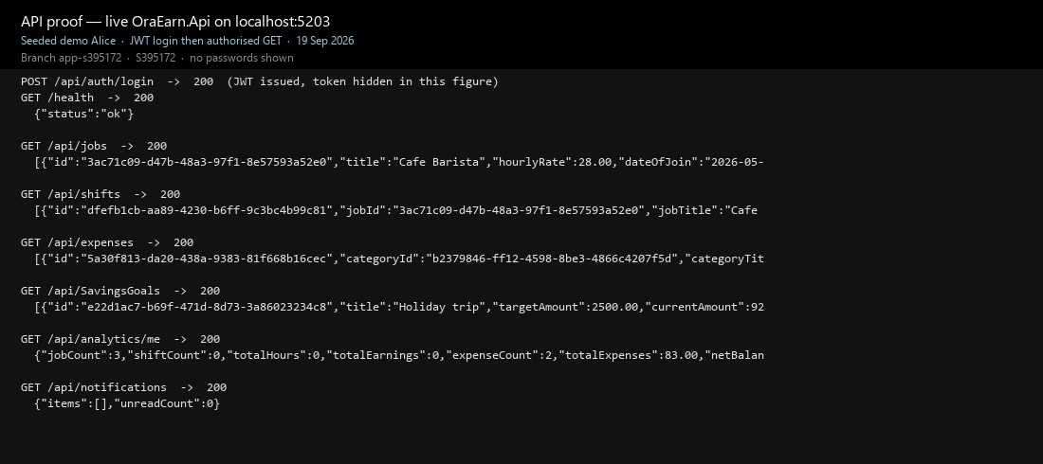
Figure 57. Live API calls. Proof the API answered on localhost:5203. Login, health, jobs, shifts, expenses, savings goals, and notifications each returned 200. The token is hidden.
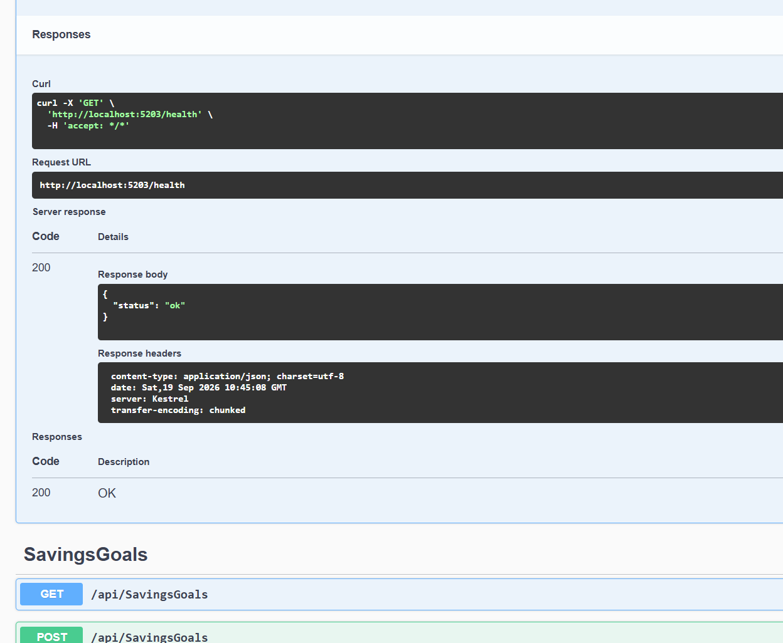
Figure 58. Health check in Swagger. GET /health returned 200 and {"status":"ok"}. The server header is Kestrel.
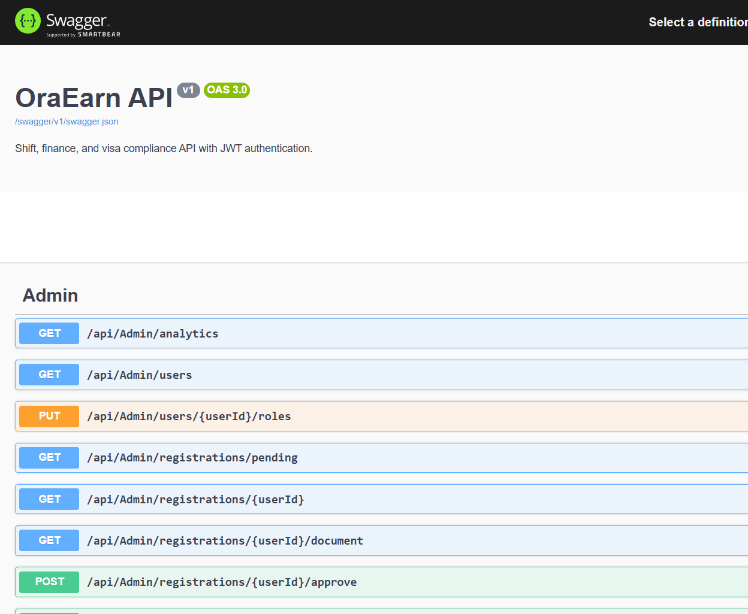
Figure 59. Admin routes in Swagger. The admin area lists analytics, users, pending registrations, the visa document, and approve. A signed-in admin is who these calls are for.
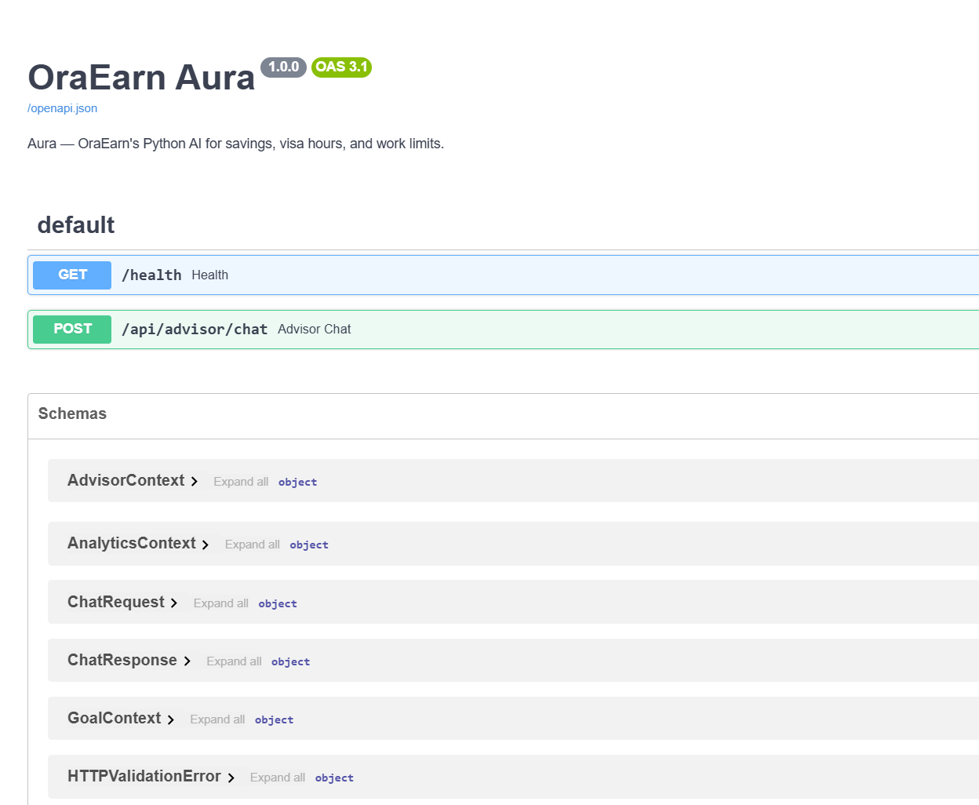
Figure 60. Aura, the Python advisor. Aura's own docs show GET /health and POST /api/advisor/chat. The browser does not call this port. The API does.
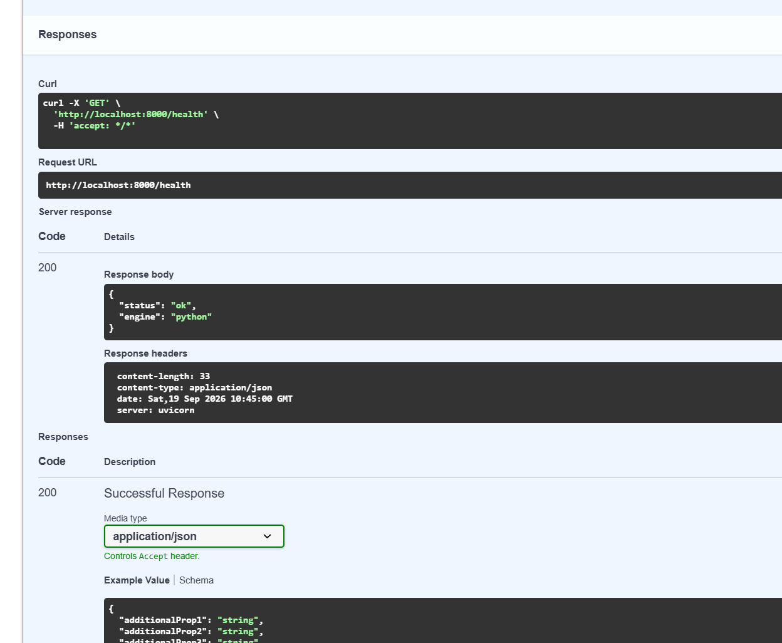
Figure 61. Aura health check. GET http://localhost:8000/health returned 200 with engine set to python, so the advisor process was up.
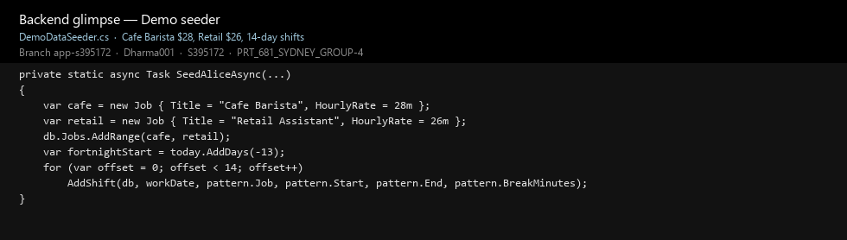
Figure 62. Demo data for Alice. The seeder creates Cafe Barista at $28 an hour and Retail Assistant at $26, then adds 14 days of shifts. That is the data on the dashboard screenshots.
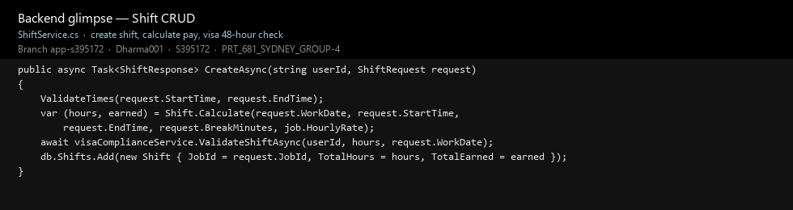
Figure 63. ShiftService.CreateAsync. Pay is worked out from the job's hourly rate, the visa check runs next, and the shift row is saved only after that check passes.
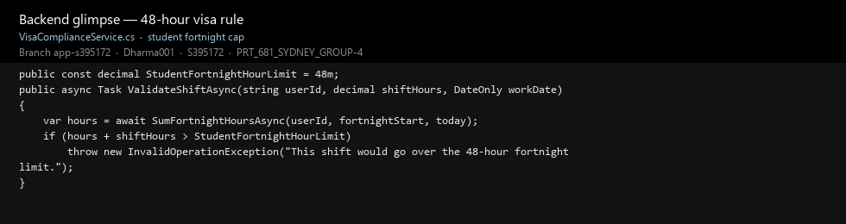
Figure 64. The 48-hour reject in code. ValidateShiftAsync adds the new hours to the fortnight total and throws if that would pass 48. The message is: This shift would go over the 48-hour fortnight limit.
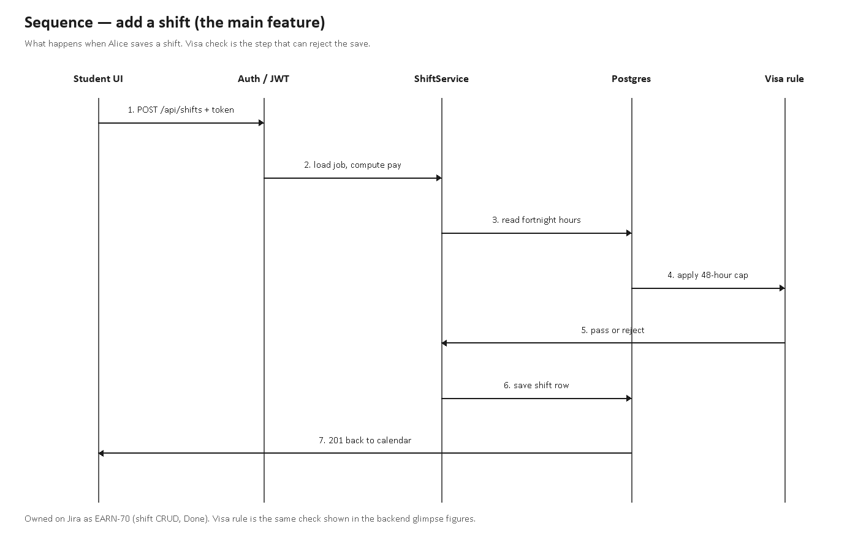
Figure 65. Sequence for saving a shift. The screen posts with the token, ShiftService loads the job and works out the pay, the visa rule can reject the save, and a pass is written to PostgreSQL.
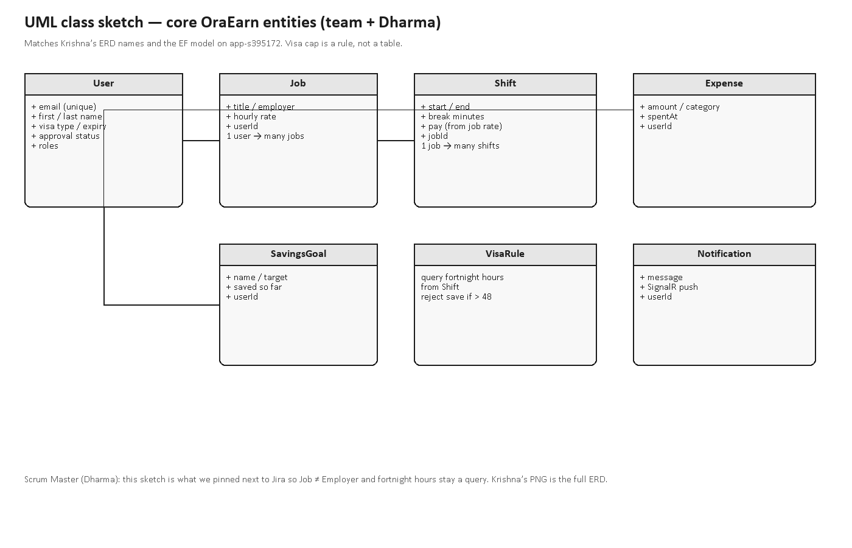
Figure 66. Class sketch of the main tables. User, Job, Shift, Expense, SavingsGoal, and Notification. A shift belongs to a job. The 48-hour cap is a rule on the service, not its own table.

